UNITED STATES

SECURITIES AND EXCHANGE COMMISSION

Washington, D.C. 20549

FORM 8-K

CURRENT REPORT

Pursuant to Section 13 or 15(d) of the Securities Exchange Act of 1934

March 11, 2021

Date of Report (Date of earliest event reported)

MARKER THERAPEUTICS, INC.

(Exact name of registrant as specified in its charter)

 |  | Delaware |  |  | 001-37939 |  |  | 45-4497941
(State or other jurisdiction of incorporation) |  |  |  |  | (Commission File Number) |  |  | (IRS Employer Identification No.)
3200 Southwest Freeway
 | Suite 2500
 | Houston, Texas |  |  |  |  |  |  | 77027
(Address of principal executive offices) |  |  |  |  |  |  |  |  | (Zip Code)
 |  |  |  |  | (713) 400-6400
 |  |  |  |  | Registrant’s telephone number, including area code

N/A

(Former name or former address, if changed since last report)

Check the appropriate box below if the Form 8-K is intended to simultaneously satisfy the filing obligation of the registrant under any of the following provisions:

- Written communications pursuant to Rule 425 under the Securities Act (17 CFR 230.425)

- Soliciting material pursuant to Rule 14a-12 under the Exchange Act (17 CFR 240.14a-12)

- Pre-commencement communications pursuant to Rule 14d-2(b) under the Exchange Act (17 CFR 240.14d-2(b))

- Pre-commencement communications pursuant to Rule 13e-4(c) under the Exchange Act (17 CFR 240.13e-4(c))

Securities registered pursuant to Section 12(b) of the Act:
 | Trading
Title of each class | Symbol(s) | Name of each exchange on which registered
Common Stock, par value $0.001 per share | MRKR | The Nasdaq Stock Market LLC

Indicate by check mark whether the registrant is an emerging growth company as defined in Rule 405 of the Securities Act of 1933 (§230.405 of this chapter) or Rule 12b-2 of the Securities Exchange Act of 1934 (§240.12b-2 of this chapter).

Emerging growth company ☐

If an emerging growth company, indicate by check mark if the registrant has elected not to use the extended transition period for complying with any new or revised financial accounting standards provided pursuant to Section 13(a) of the Exchange Act. ☐

Item 1.01. Entry into a Material Definitive Agreement.

On March 11, 2021, Marker Therapeutics, Inc. (the “Company”) entered into an underwriting agreement (the “Underwriting Agreement”) with Piper Sandler & Co., as representative of the several underwriters named on Schedule I thereto (the “Underwriters”), to issue and sell 28,572,000 shares of common stock of the Company (the “Shares”) in an underwritten public offering (the “Offering”) pursuant to a Registration Statement on Form S-3 (File No. 333-232122) and a related prospectus and prospectus supplement, in each case filed with the Securities and Exchange Commission (the “SEC”). The offering price to the public is $1.75 per Share. In addition, the Company granted the Underwriters an option to purchase, for a period of 30 days, up to an additional 4,285,800 shares of common stock (the “Option”), which such option was partially exercised with respect to 3,710,857 Shares. The Company estimates that the gross proceeds from the Offering will be approximately $56.5 million, before deducting underwriting discounts and commissions and estimated offering expenses. The Offering closed on March 16, 2021.

The Underwriting Agreement contains customary representations, warranties, covenants and agreements by the Company, customary conditions to closing, indemnification obligations of the Company and the Underwriters, including for liabilities under the Securities Act of 1933, as amended, other obligations of the parties and termination provisions. The representations, warranties and covenants contained in the Underwriting Agreement were made only for purposes of such agreement and as of specific dates, were solely for the benefit of the parties to such agreement, and may be subject to limitations agreed upon by the contracting parties. A copy of the Underwriting Agreement is filed as Exhibit 1.1 to this Current Report on Form 8-K and is incorporated herein by reference. The foregoing description of the Underwriting Agreement is qualified in its entirety by reference to such exhibit. A copy of the legal opinion of Cooley LLP as to the legality of the Shares (including the Option) to be issued and sold in the Offering is filed as Exhibit 5.1 to this Current Report on Form 8-K.

Item 7.01. Regulation FD Disclosure.

On March 11, 2021, the Company updated its corporate presentation for use in meetings with investors, analysts and others. The presentation is available through the Company’s website and a copy is attached as Exhibit 99.2 to this Current Report on Form 8-K.

The information in this Item 7.01 of this Current Report on 8-K (including Exhibit 99.1) is furnished and shall not be deemed “filed” for purposes of Section 18 of the Securities Exchange Act of 1934, as amended, or subject to the liabilities of that section or Sections 11 and 12(a)(2) of the Securities Act of 1933, as amended. The information shall not be deemed incorporated by reference into any other filing with the Securities and Exchange Commission made by the Company, whether made before or after today’s date, regardless of any general incorporation language in such filing, except as shall be expressly set forth by specific references in such filing.

Item 8.01. Other Events.

On March 12, 2021, the Company issued a press release announcing the pricing of the Offering. A copy of the press release is filed with this Current Report on Form 8-K as Exhibit 99.2 and is incorporated herein by reference.

Item 9.01. | Financial Statements and Exhibits.
(d) Exhibits.
Exhibit No. |  |  | Description
1.1 |  |  | Underwriting Agreement, dated March 11, 2021
5.1 |  |  | Opinion of Cooley LLP
23.1 |  |  | Consent of Cooley LLP (included in Exhibit 5.1)
99.1 |  |  | Corporate Presentation, dated March 2021
99.2 |  |  | Press Release, dated March 12, 2021

SIGNATURES

Pursuant to the requirements of the Securities Exchange Act of 1934, as amended, the Registrant has duly caused this report to be signed on its behalf by the undersigned hereunto duly authorized.

 | Marker Therapeutics, Inc.
Dated: March 16, 2021 | By: | /s/ Anthony Kim
 |  | Anthony Kim
 |  | Chief Financial Officer

Exhibit 1.1

28,572,000 Shares¹

Marker Therapeutics, Inc.

Common Stock

PURCHASE AGREEMENT

March 11, 2021

PIPER SANDLER & CO.

As Representative of the several

Underwriters named in Schedule I hereto

c/o Piper Sandler & Co.

U.S. Bancorp Center

800 Nicollet Mall

Minneapolis, Minnesota 55402

Ladies and Gentlemen:

Marker Therapeutics, Inc., a Delaware corporation (the “Company”), proposes to sell to the several Underwriters named in Schedule I hereto (the “Underwriters”) an aggregate of 28,572,000 shares (the “Firm Shares”) of Common Stock, $0.001 par value per share (the “Common Stock”), of the Company. The Firm Shares consist of 28,572,000 authorized but unissued shares of Common Stock to be issued and sold by the Company. The Company has also granted to the several Underwriters an option to purchase up to 4,285,800 additional shares of Common Stock on the terms and for the purposes set forth in Section 3 hereof (the “Option Shares”). The Firm Shares and any Option Shares purchased pursuant to this Purchase Agreement (this “Agreement”) are herein collectively called the “Securities.”

The Company hereby confirms its agreement with respect to the sale of the Securities to the several Underwriters, for whom Piper Sandler & Co. is acting as representative (the “Representative”).

- Registration Statement and Prospectus. The Company has prepared and filed with the Securities and Exchange Commission (the “Commission”) a registration statement on Form S-3 (File No. 333-232122) under the Securities Act of 1933, as amended (the “Securities Act” or “Act”), and the rules and regulations (the “Rules and Regulations”) of the Commission thereunder, and such amendments to such registration statement as may have been required to the date of this Agreement. Such registration statement has been declared effective by the Commission. Each part of such registration statement, including the amendments, exhibits and any schedules thereto, the documents incorporated by reference therein pursuant to Item 12 of Form S-3 under the Securities Act and the documents and information otherwise deemed to be a part thereof or included therein by Rule 430B under the Securities Act (the “Rule 430B Information”) or otherwise pursuant to the Rules and Regulations, as of the time the Registration Statement became effective, is herein called the “Registration Statement.” Any registration statement filed by the Company pursuant to Rule 462(b) under the Securities Act is called the “Rule 462(b) Registration Statement” and, from and after the date and time of filing of the Rule 462(b) Registration Statement, the term “Registration Statement” shall include the Rule 462(b) Registration Statement.

- Plus an option to purchase up to 4,285,800 additional shares to cover over-allotments.

The prospectus in the form in which it has most recently been filed with the Commission on or prior to the date of this Agreement is herein called the “Base Prospectus.” Each preliminary prospectus supplement to the Base Prospectus (including the Base Prospectus as so supplemented), that describes the Securities and the offering thereof, that omitted the Rule 430B Information and that was used prior to the filing of the final prospectus supplement referred to in the following sentence is herein called a “Preliminary Prospectus.” Promptly after execution and delivery of this Agreement, the Company will prepare and file with the Commission a final prospectus supplement to the Base Prospectus relating to the Securities and the offering thereof in accordance with the provisions Rule 430B and Rule 424(b) of the Rules and Regulations. Such final supplemental form of prospectus (including the Base Prospectus as so supplemented), in the form filed with the Commission pursuant to Rule 424(b) is herein called the “Prospectus.” Any reference herein to the Base Prospectus, any Preliminary Prospectus or the Prospectus shall be deemed to include the documents incorporated by reference therein pursuant to Item 12 of Form S-3 under the Securities Act as of the date of such prospectus.

For purposes of this Agreement, all references to the Registration Statement, the Rule 462(b) Registration Statement, the Base Prospectus, any Preliminary Prospectus, the Prospectus or any amendment or supplement to any of the foregoing shall be deemed to include the copy filed with the Commission pursuant to its Electronic Data Gathering, Analysis and Retrieval System or any successor system thereto (“EDGAR”). All references in this Agreement to financial statements and schedules and other information which is “described,” “contained,” “included” or “stated” in the Registration Statement, the Base Prospectus, any Preliminary Prospectus or the Prospectus (or other references of like import) shall be deemed to mean and include all such financial statements and schedules and other information which is incorporated by reference in or otherwise deemed by the Rules and Regulations to be a part of or included in the Registration Statement, the Base Prospectus, any Preliminary Prospectus or the Prospectus, as the case may be; and all references in this Agreement to amendments or supplements to the Registration Statement, the Base Prospectus, any Preliminary Prospectus or the Prospectus shall be deemed to mean and include the subsequent filing of any document under the Securities Exchange Act of 1934, as amended (the “Exchange Act”), and which is deemed to be incorporated therein by reference therein or otherwise deemed by the Rules and Regulations to be a part thereof.

- Representations and Warranties of the Company.

  - Representations and Warranties of the Company. The Company represents and warrants to, and agrees with, the several Underwriters as

follows:

-2-

- Registration Statement and Prospectuses. No order preventing or suspending the use of any Preliminary Prospectus or the Prospectus (or any supplement thereto) has been issued by the Commission and no proceeding for that purpose has been initiated or is pending or, to the knowledge of the Company, threatened by the Commission. As of the time each part of the Registration Statement (or any post-effective amendment thereto) became or becomes effective (including each deemed effective date with respect to the Underwriters pursuant to Rule 430B or otherwise under the Securities Act), such part conformed or will conform in all material respects to the requirements of the Act and the Rules and Regulations. Upon the filing or first use within the meaning of the Rules and Regulations, each Preliminary Prospectus and the Prospectus (or any supplement to either) conformed or will conform in all material respects to the requirements of the Act and the Rules and Regulations. The Registration Statement and any post-effective amendment thereto has become effective under the Securities Act. The Company has complied to the Commission’s satisfaction with all requests of the Commission for additional or supplemental information. No stop order suspending the effectiveness of the Registration Statement, any post-effective amendment or any part thereof is in effect and no proceedings for such purpose have been instituted or are pending or, to the knowledge of the Company, are threatened by the Commission.

- Accurate Disclosure. Each Preliminary Prospectus, at the time of filing thereof or the time of first use within the meaning of the Rules and Regulations, did not contain an untrue statement of a material fact or omit to state a material fact required to be stated therein or necessary to make the statements therein, in the light of the circumstances under which they were made, not misleading. Neither the Registration Statement nor any amendment thereto, at the effective time of each part thereof, at the First Closing Date (as defined below) or at the Second Closing Date (as defined below), contained, contains or will contain an untrue statement of a material fact or omitted, omits or will omit to state a material fact required to be stated therein or necessary to make the statements therein not misleading. As of the Time of Sale (as defined below), neither (A) the Time of Sale Disclosure Package (as defined below) nor (B) any issuer free writing prospectus (as defined below), when considered together with the Time of Sale Disclosure Package, included an untrue statement of a material fact or omitted to state a material fact necessary in order to make the statements therein, in light of the circumstances under which they were made, not misleading. Neither the Prospectus nor any supplement thereto, as of its issue date, at the time of any filing with the Commission pursuant to Rule 424(b) of the Rules and Regulations, at the First Closing Date or at the Second Closing, included, includes or will include an untrue statement of a material fact or omitted, omits or will omit to state a material fact necessary in order to make the statements therein, in light of the circumstances under which they were made, not misleading. The representations and warranties in this Section 2(a)(ii) shall not apply to statements in or omissions from any Preliminary Prospectus, the Registration Statement (or any amendment thereto), the Time of Sale Disclosure Package or the Prospectus (or any supplement thereto) made in reliance upon, and in conformity with, written information furnished to the Company by you, or by any Underwriter through you, specifically for use in the preparation of such document, it being understood and agreed that the only such information furnished by any Underwriter consists of the information described as such in Section 6(e).

-3-

Each reference to an “issuer free writing prospectus” herein means an issuer free writing prospectus as defined in Rule 433 of the Rules and Regulations.

“Time of Sale Disclosure Package” means the Preliminary Prospectus dated March 11, 2021, any free writing prospectus set forth on Schedule II and the information on Schedule III, all considered together.

Each reference to a “free writing prospectus” herein means a free writing prospectus as defined in Rule 405 of the Rules and Regulations.

“Time of Sale” means 7:00 p.m. (Eastern time) on the date of this Agreement.

- Issuer Free Writing Prospectuses. (A) Each issuer free writing prospectus does not include any information that conflicts with the information contained in the Registration Statement, any Preliminary Prospectus or the Prospectus. The foregoing sentence does not apply to statements in or omissions from any issuer free writing prospectus based upon and in conformity with written information furnished to the Company by you or by any Underwriter through you specifically for use therein; it being understood and agreed that the only such information furnished by any Underwriter consists of the information described as such in Section 6(e).

- (1) At the earliest time after the filing of the Registration Statement that the Company or another offering participant made a bona fide offer (within the meaning of Rule 164(h)(2) under the Securities Act) of the Securities and (2) at the date hereof, the Company was not and is not an “ineligible issuer,” as defined in Rule 405 under the Securities Act, including the Company or any subsidiary in the preceding three years not having been convicted of a felony or misdemeanor or having been made the subject of a judicial or administrative decree or order as described in Rule 405 of the Rules and Regulations (without taking account of any determination by the Commission pursuant to Rule 405 of the Rules and Regulations that it is not necessary that the Company be considered an ineligible issuer), nor an “excluded issuer” as defined in Rule 164 under the Securities Act.

- Each issuer free writing prospectus satisfied, as of its issue date and at all subsequent times to the Time of Sale, all other conditions to use thereof as set forth in Rules 164 and 433 under the Securities Act.

- Testing-the-Waters Materials. The Company (i) has not alone engaged in any Testing-the-Waters Communications, other than Testing-the-Waters Communications with the prior consent of the Representative with entities that are qualified institutional buyers within the meaning of Rule 144A under the Act or institutions that are accredited investors within the meaning of Rule 501 under the Act and (ii) has not authorized anyone other than the Representative to engage in Testing-the-Waters Communications. The Company reconfirms that the Representative has been authorized to act on its behalf in undertaking Testing-the-Waters Communications. The Company has not distributed any Written Testing-the-Waters Communications (as defined below) other than those listed on Schedule V hereto. “Testing-the-Waters Communication” means any oral or written communication with potential investors undertaken in reliance on either Section 5(d) of, or Rule 163B under, the Act. “Written Testing-the-Waters Communication” means any Testing-the-Waters Communication that is a written communication within the meaning of Rule 405 under the Act. Any individual Written Testing-the-Waters Communication does not conflict with the information contained in the Registration Statement or the Time of Sale Disclosure Package, complied in all material respects with the Act, and when taken together with the Time of Sale Disclosure Package as of the Applicable Time, did not contain any untrue statement of a material fact or omit to state a material fact necessary in order to make the statements therein, in the light of the circumstances under which they were made, not misleading.

-4-

- No Other Offering Materials. The Company has not distributed and will not distribute any prospectus or other offering material in connection with the offering and sale of the Securities other than any Preliminary Prospectus, the Time of Sale Disclosure Package or the Prospectus or other materials permitted by the Act to be distributed by the Company, including any Testing-the-Waters Communication; provided, however, that, except as set forth on Schedule II, the Company has not made and will not make any offer relating to the Securities that would constitute a free writing prospectus, except in accordance with the provisions of Section 4(a)(xv) of this Agreement and, except as set forth on Schedule V, the Company has not made and will not make any communication relating to the Securities that would constitute a Testing-the-Waters Communication, except in accordance with the provisions of Section 2(a)(iv) of this Agreement.

  - Financial Statements. The financial statements of the Company, together with the related notes, set forth or incorporated by reference in the Registration Statement, the Time of Sale Disclosure Package and the Prospectus comply in all material respects with the requirements of the Securities Act and the Exchange Act and fairly present the financial condition of the Company and its consolidated subsidiaries as of the dates indicated and the results of operations and changes in cash flows for the periods therein specified in conformity with generally accepted accounting principles in the United States (“GAAP”) consistently applied throughout the periods involved; the supporting schedules, if any, included in, or incorporated by reference into, the Registration Statement present fairly the information required to be stated therein; all non-GAAP financial information included in, or incorporated by reference into, the Registration Statement, the Time of Sale Disclosure Package and the Prospectus complies in all material respects with the requirements of Regulation G and Item 10 of Regulation S-K under the Act; and, except as disclosed in the Time of Sale Disclosure Package and the Prospectus, there are no material off-balance sheet arrangements (as defined in Regulation S-K under the Act, Item 303(a)(4)(ii)) or any other relationships with unconsolidated entities or other persons, that may have a material current or, to the Company’s knowledge, material future effect on the Company’s financial condition, results of operations, liquidity, capital expenditures, capital resources or significant components of revenue or expenses. No other financial statements or schedules are required to be included in the Registration Statement, the Time of Sale Disclosure Package or the Prospectus. To the Company’s knowledge, Marcum LLP, which has expressed its opinion with respect to the financial statements and schedules filed as, or incorporated by reference into, a part of the Registration Statement and included in the Registration Statement, the Time of Sale Disclosure Package and the Prospectus, is (x) an independent public accounting firm within the meaning of the Act and the Rules and Regulations, (y) a registered public accounting firm (as defined in Section 2(a)(12) of the Sarbanes-Oxley Act of 2002 (the “Sarbanes-Oxley Act”)) and (z) not in violation of the auditor independence requirements of the Sarbanes-Oxley Act.

-5-

  - Organization and Good Standing. Each of the Company and its subsidiaries has been duly organized and is validly existing as a corporation in good standing under the laws of its jurisdiction of incorporation. Each of the Company and its subsidiaries has full corporate power and authority to own its properties and conduct its business as currently being carried on and as described in the Registration Statement, the Time of Sale Disclosure Package and the Prospectus, and is duly qualified to do business as a foreign corporation in good standing in each jurisdiction in which it owns or leases real property or in which the conduct of its business makes such qualification necessary and in which the failure to so qualify would have a material adverse effect upon the business, prospects, management, properties, operations, condition (financial or otherwise) or results of operations of the Company and its subsidiaries, taken as a whole (“Material Adverse Effect”).

  - Absence of Certain Events. Except as contemplated in the Time of Sale Disclosure Package and in the Prospectus, subsequent to the respective dates as of which information is given in the Time of Sale Disclosure Package, neither the Company nor any of its subsidiaries has incurred any material liabilities or obligations, direct or contingent, or entered into any material transactions, or declared or paid any dividends or made any distribution of any kind with respect to its capital stock; and there has not been any change in the capital stock (other than a change in the number of outstanding shares of Common Stock due to the issuance of shares upon the exercise of outstanding options or warrants or conversion of convertible securities), or any material change in the short-term or long-term debt (other than as a result of the conversion of convertible securities), or any issuance of options, warrants, convertible securities or other rights to purchase the capital stock, of the Company or any of its subsidiaries, or any material adverse change in the general affairs, condition (financial or otherwise), business, prospects, management, properties, operations or results of operations of the Company and its subsidiaries, taken as a whole (“Material Adverse Change”) or any development which could reasonably be expected to result in any Material Adverse Change.

  - Absence of Proceedings. Except as set forth or incorporated by reference in the Time of Sale Disclosure Package and in the Prospectus, there is not pending or, to the knowledge of the Company, threatened or contemplated, any action, suit or proceeding (a) to which the Company or any of its subsidiaries is a party or (b) which has as the subject thereof any officer or director of the Company or any subsidiary, any employee benefit plan sponsored by the Company or any subsidiary or any property or assets owned or leased by the Company or any subsidiary before or by any court or Governmental Authority (as defined below), or any arbitrator, which, individually or in the aggregate, might reasonably be expected to result in any Material Adverse Change, or would materially and adversely affect the ability of the Company to perform its obligations under this Agreement or which are otherwise material in the context of the sale of the Securities. There are no current or, to the knowledge of the Company, pending, legal, governmental or regulatory actions, suits or proceedings (x) to which the Company or any of its subsidiaries is subject or

- which has as the subject thereof any officer or director of the Company or any subsidiary, any employee plan sponsored by the Company or any subsidiary or any property or assets owned or leased by the Company or any subsidiary, that are required to be described in the Registration Statement, Time of Sale Disclosure Package and Prospectus by the Act or by the Rules and Regulations and that have not been so described.

-6-

- Disclosure of Legal Matters. There are no statutes, regulations, contracts or documents that are required to be described in the Registration Statement, in the Time of Sale Disclosure Package and in the Prospectus or required to be filed as exhibits to the Registration Statement by the Securities Act or by the Rules and Regulations that have not been so described or filed.

- Authorization; No Conflicts; Authority. This Agreement has been duly authorized, executed and delivered by the Company, and constitutes a valid, legal and binding obligation of the Company, enforceable in accordance with its terms, except as rights to indemnity hereunder may be limited by federal or state securities laws and except as such enforceability may be limited by bankruptcy, insolvency, reorganization or similar laws affecting the rights of creditors generally and subject to general principles of equity. The execution, delivery and performance of this Agreement and the consummation of the transactions herein contemplated will not (A) conflict with or result in a breach or violation of any of the terms or provisions of, or constitute a default under, or result in the creation or imposition of any lien, charge or encumbrance upon any property or assets of the Company or any of its subsidiaries pursuant to any indenture, mortgage, deed of trust, loan agreement or other agreement or instrument to which the Company or any of its subsidiaries is a party or by which the Company or any of its subsidiaries is bound or to which any of the property or assets of the Company or any of its subsidiaries is subject, (B) result in any violation of the provisions of the Company’s charter or by-laws or (C) result in the violation of any law or statute or any judgment, order, rule, regulation or decree of any court or arbitrator or federal, state, local or foreign governmental agency or regulatory authority having jurisdiction over the Company or any of its subsidiaries or any of their properties or assets (each, a “Governmental Authority”), except in the case of clauses (A) and (C) as would not reasonably be expected to result in a Material Adverse Effect. No consent, approval, authorization or order of, or registration or filing with any Governmental Authority is required for the execution, delivery and performance of this Agreement or for the consummation of the transactions contemplated hereby, including the issuance or sale of the Securities by the Company, except such as may be required under the Act, the rules of the Financial Industry Regulatory Authority (“FINRA”) or state securities or blue sky laws; and the Company has full power and authority to enter into this Agreement and to consummate the transactions contemplated hereby, including the authorization, issuance and sale of the Securities as contemplated by this Agreement.

- Capitalization; the Securities; Registration Rights. All of the issued and outstanding shares of capital stock of the Company, including the outstanding shares of Common Stock, are duly authorized and validly issued, fully paid and nonassessable, have been issued in compliance with all federal and state and foreign securities laws, were not issued in violation of or subject to any preemptive rights or other rights to subscribe for or purchase securities that have not been waived in writing (a copy of which has been delivered to counsel to the Representative), and the holders thereof are not subject to personal liability by reason of being such holders; the Securities which may be sold hereunder by the Company have been duly authorized and, when issued, delivered and paid for in accordance with the terms of this Agreement, will have been validly issued and will be fully paid and nonassessable, and the holders thereof will not be subject to personal liability by reason of being such holders; and the capital stock of the Company, including the Common Stock, conforms to the description thereof in the Registration Statement, in the Time of Sale Disclosure Package and in the Prospectus. Except as otherwise stated in the Registration Statement, in the Time of Sale Disclosure Package and in the Prospectus, (A) there are no preemptive rights or other rights to subscribe for or to purchase, or any restriction upon the voting or transfer of, any shares of Common Stock pursuant to the Company’s charter, by-laws or any agreement or other instrument to which the Company or any of its subsidiaries is a party or by which the Company or any of its subsidiaries is bound; (B) neither the filing of the Registration Statement nor the offering or sale of the Securities as contemplated by this Agreement gives rise to any rights for or relating to the registration of any shares of Common Stock or other securities of the Company (collectively “Registration Rights”); and (C) any person to whom the Company has granted Registration Rights has agreed not to exercise such rights until after expiration of the Lock-Up Period (as defined below). All of the issued and outstanding shares of capital stock of each of the Company’s subsidiaries have been duly and validly authorized and issued and are fully paid and nonassessable, and, except as otherwise described in the Registration Statement, in the Time of Sale Disclosure Package and in the Prospectus, the Company owns of record and beneficially, free and clear of any security interests, claims, liens, proxies, equities or other encumbrances, all of the issued and outstanding shares of such stock. The Company has an authorized and outstanding capitalization as set forth in the Registration Statement, in the Time of Sale Disclosure Package and in the Prospectus under the caption “Capitalization.” The Common Stock (including the Securities) conforms in all material respects to the description thereof contained in the Time of Sale Disclosure Package and the Prospectus.

-7-

- Stock Options. Except as described in the Registration Statement, in the Time of Sale Disclosure Package and in the Prospectus, there are no options, warrants, agreements, contracts or other rights in existence to purchase or acquire from the Company or any subsidiary of the Company any shares of the capital stock of the Company or any subsidiary of the Company. The description of the Company’s stock option, stock bonus and other stock plans or arrangements (the “Company Stock Plans”), and the options (the “Options”) or other rights granted thereunder, set forth in the Time of Sale Disclosure Package and the Prospectus accurately and fairly presents in all material respects the information required to be shown with respect to such plans, arrangements, options and rights. Each grant of an Option (A) was duly authorized no later than the date on which the grant of such Option was by its terms to be effective by all necessary corporate action, including, as applicable, approval by the board of directors of the Company (or a duly constituted and authorized committee thereof) and any required stockholder approval by the necessary number of votes or written consents, and the award agreement governing such grant (if any) was duly executed and delivered by each party thereto and (B) was made in accordance with the terms of the applicable Company Stock Plan, and all applicable laws and regulatory rules or requirements, including all applicable federal securities laws.

- Compliance with Laws. Except as would not reasonably be expected to result in a Material Adverse Effect, whether singularly or in the aggregate: (A) the Company and each of its subsidiaries holds, and is operating in compliance with, all franchises, grants, authorizations, licenses, permits, easements, consents, certificates and orders of any Governmental Authority or self-regulatory body required for the conduct of its business and all such franchises, grants, authorizations, licenses, permits, easements, consents, certifications and orders are valid and in full force and effect; (B) neither the Company nor any of its subsidiaries has received notice of any revocation or modification of any such franchise, grant, authorization, license, permit, easement, consent, certification or order or has reason to believe that any such franchise, grant, authorization, license, permit, easement, consent, certification or order will not be renewed in the ordinary course; and (C) the Company and each of its subsidiaries is in compliance with all applicable federal, state, local and foreign laws, regulations, orders and decrees.

- Ownership of Assets. The Company and its subsidiaries have good and marketable title to all property (whether real or personal) described in the Registration Statement, in the Time of Sale Disclosure Package and in the Prospectus as being owned by them, in each case free and clear of all liens, claims, security interests, other encumbrances or defects except such as are described in the Registration Statement, in the Time of Sale Disclosure Package and in the Prospectus or as do not materially affect the value of such property and do not materially interfere with the use made and proposed to be made of such property by the Company. The property held under lease by the Company and its subsidiaries is held by them under valid, subsisting and enforceable leases with only such exceptions with respect to any particular lease as do not interfere in any material respect with the conduct of the business of the Company or its subsidiaries.

- Intellectual Property. The Company owns or has valid, binding and enforceable licenses or other rights to practice and use all patents and patent applications, copyrights, trademarks, trademark registrations, service marks, service mark registrations, trade names, service names and know-how (including trade secrets and other unpatented and/or unpatentable proprietary or confidential information, systems or procedures) and all other technology and intellectual property rights necessary for, or used in the conduct, or the proposed conduct, of the business of the Company in the manner described in the Registration Statement, the Time of Sale Disclosure Package and the Prospectus (collectively, the “Company Intellectual Property”), and, to the Company’s knowledge, the conduct of its business (including the development and commercialization of the product candidates described in the Registration Statement, the Time of Sale Disclosure Package and the Prospectus) has not and will not infringe or misappropriate any intellectual property rights of others; there are no rights of third parties to any of the intellectual property owned by the Company, and such intellectual property is owned by the Company free and clear of all material liens, security interests, or encumbrances; to the knowledge of the Company, the patents, trademarks and copyrights held or licensed by the Company included within the Company Intellectual Property are valid, enforceable and subsisting; to the Company’s knowledge, there is no infringement by third parties of any of the Company Intellectual Property; other than as disclosed in the Registration Statement, the Time of Sale Disclosure Package and the Prospectus, (i) the Company is not obligated to pay a material royalty, grant a license, or provide other material consideration to any third party in connection with the Company Intellectual Property, (ii) no action, suit, claim or other proceeding is pending or, to the knowledge of the Company, is threatened, alleging that the Company is infringing, misappropriating, diluting or otherwise violating any rights of others with respect to any of the Company’s product candidates, processes or intellectual property, and the Company is unaware of any facts which could form a reasonable basis for any such action, suit, proceeding or claim, (iii) no action, suit, claim or other proceeding is pending or, to the knowledge of the Company, is threatened, challenging the validity, enforceability, scope, registration, ownership or use of any of the Company’s Intellectual Property, and the Company is unaware of any facts which could form a reasonable basis for any such action, suit, proceeding or claim, (iv) no action, suit, claim or other proceeding is pending or, to the knowledge of the Company, is threatened, challenging the Company’s rights in or to any Company Intellectual Property, and the Company is unaware of any facts which could form a reasonable basis for any such action, suit, proceeding or claim, (v) the Company has not received written notice of any claim of infringement, misappropriation or conflict with any asserted rights of others with respect to any of the Company’s products, proposed products, processes or Company Intellectual Property, (vi) to the knowledge of the Company, the development, manufacture, sale, and any currently proposed use of any of the products, proposed products or processes of the Company referred to in the Registration Statement, the Time of Sale Disclosure Package and the Prospectus, in the current or proposed conduct of the business of the Company, do not currently, and will not upon commercialization, to the knowledge of the Company, infringe any right or valid patent claim of any third party, (vii) to the knowledge of the Company, no third party has any ownership right in or to any Company Intellectual Property in any field of use that is exclusively licensed to the Company, other than any licensor to the Company of such Company Intellectual Property, (viii) to the knowledge of the Company, no employee, consultant or independent contractor of the Company is in or has ever been in violation in any material respect of any term of any employment contract, patent disclosure agreement, invention assignment agreement, non-competition agreement, non-solicitation agreement nondisclosure agreement or any restrictive covenant to or with a former employer or independent contractor where the basis of such violation relates to such employee’s employment or independent contractor’s engagement with the Company or actions undertaken while employed or engaged with the Company, (ix) the Company has taken reasonable measures to protect its confidential information and trade secrets and to maintain and safeguard the Company’s Intellectual Property, including the execution of appropriate nondisclosure and confidentiality agreements, and to the Company’s knowledge, no employee of the Company is in or has been in violation of any term of any employment contract, patent disclosure agreement, invention assignment agreement, non-competition agreement, non-solicitation agreement, nondisclosure agreement, or any restrictive covenant to or with a former employer where the basis of such violation relates to such employee’s employment with the Company, and (x) the Company has complied with the terms of each agreement pursuant to which the Company’s Intellectual Property has been licensed to the Company, and all such agreements are in full force and effect. All patents and patent applications owned by or licensed to the Company or under which the Company has rights have, to the knowledge of the Company, been duly and properly filed and maintained; to the knowledge of the Company, there are no material defects in any of the patents or patent applications disclosed in the Registration Statement and the Prospectus as being owned by the Company; to the knowledge of the Company, the parties prosecuting such applications have complied with their duty of candor and disclosure to the United States Patent and Trademark Office (the “USPTO”) in connection with such applications; and the Company is not aware of any facts required to be disclosed to the USPTO that were not disclosed to the USPTO and which would preclude the grant of a patent in

connection with any such application or could form the basis of a finding of invalidity with respect to any patents that have issued with respect to such applications.

-8-

  - Health Care Authorizations. The Company possesses, and is in compliance with the terms of, all applications, certificates, approvals, clearances, registrations, exemptions, franchises, licenses, permits, consents and other authorizations necessary to conduct its business, as currently conducted (collectively, “Licenses”), issued by the appropriate Governmental Authorities, including, without limitation, all Licenses required by the Food and Drug Administration (“FDA”), or any component thereof, the National Institutes of Health and/or by any other U.S., state, local or foreign government or drug regulatory agency (collectively, the “Regulatory Agencies”), other than for such instances of non-compliance which would not reasonably be expected to result in a Material Adverse Effect. All Licenses are in full force and effect and, to the Company’s knowledge, the Company is not in violation of any term or conditions of any License. The Company has fulfilled and performed all of its respective obligations with respect to the Licenses and, to the Company’s knowledge, no event has occurred which allows, or after notice or lapse of time would allow, revocation or termination thereof or results in any other impairment of the rights of the holder of any License. The Company has not received any written notice of proceedings relating to the revocation or modification of any Licenses and no Regulatory Agency has taken any action to limit, suspend or revoke any License possessed by the Company.

  - Clinical Trials. The pre-clinical studies and clinical trials that are described in the Registration Statement, the Time of Sale Disclosure Package and the Prospectus were and, if still pending, are being, conducted in all material respects in accordance with the protocols submitted to FDA or any foreign governmental body exercising comparable authority, procedures and controls pursuant to, where applicable, accepted professional and scientific standards, and all applicable laws and regulations; the descriptions of the pre-clinical studies and clinical trials conducted by or, to the Company’s knowledge, on behalf of the Company, and the results thereof, contained in the Registration Statement, the Time of Sale Disclosure Package and the Prospectus are accurate and complete in all material respects; the Company is not aware of any other pre-clinical studies or clinical trials, the results of which reasonably call into question the results described in the Registration Statement, the Time of Sale Disclosure Package and the Prospectus; and the Company has not received any notices or correspondence from the FDA, any foreign, state or local governmental body exercising comparable authority or any Institutional Review Board requiring the termination, suspension, material modification or clinical hold of any pre-clinical studies or clinical trials conducted by or on behalf of the Company.

  - Compliance with Health Care Laws. The Company and its directors, officers and employees, and to the Company’s knowledge, its respective agents, affiliates and representatives, are, and at all times have been, in compliance with all Health Care Laws (defined herein), including, but not limited to, the rules and regulations of the FDA, the U.S. Department of Health and Human Services Office of Inspector General, the Centers for Medicare & Medicaid Services, and has not engaged in any activities which are, as applicable, cause for false claims liability, civil penalties, or mandatory or permissive exclusion from Medicare, Medicaid, or any other local, state or federal healthcare program, other than for such instances of non-compliance which would not reasonably be expected to result in a Material Adverse Effect. For purposes of this Agreement, “Health Care Laws” shall mean the federal Anti-kickback Statute (42 U.S.C. § 1320a-7b(b)), the Physician Payments Sunshine Act (42 U.S.C. § 1320a-7h), the civil False Claims Act (31 U.S.C. §§ 3729 et seq.), the criminal False Claims Act (42 U.S.C. § 1320a-7b(a)), all criminal laws relating to health care fraud and abuse, including but not limited to 18 U.S.C. Sections 286 and 287, and the health care fraud criminal provisions under the Health Insurance Portability and Accountability Act of 1996 (42 U.S.C. §§ 1320d et seq.) (“HIPAA”), the exclusion laws (42 U.S.C. § 1320a-7), the civil monetary penalties law (42 U.S.C. § 1320a-7a), HIPAA, as amended by the Health Information Technology for Economic and Clinical Health Act (42 U.S.C. §§ 17921 et seq.), the Federal Food, Drug, and Cosmetic Act (21 U.S.C. §§ 301 et seq.), Medicare statute (Title XVIII of the Social Security Act), Medicaid statute (Title XIX of the Social Security Act), Medicaid Drug Rebate Program (42 U.S.C.

- 1396r-8), Medicare average sales price reporting (42 U.S.C. § 1395w-3a), the Public Health Service Act (42 U.S.C. § 256b), the VA Federal Supply Schedule (38 U.S.C § 8126) or the rules and regulations of any other federal, state or local governmental or regulatory body or authority. The Company is not a party to or has any ongoing reporting obligations pursuant to any corporate integrity agreement, deferred prosecution agreement, monitoring agreement, consent decree, settlement order, plan of correction or similar agreement imposed by any governmental authority. The Company has not received any notification, correspondence or any other written or oral communication, including, without limitation, any FDA Form 483, notice of adverse finding, warning letter, untitled letter or other correspondence or notice from the FDA or any similar regulatory authority, or any notification of any pending or threatened claim, suit, proceeding, hearing, enforcement, investigation, arbitration or other action, from any governmental authority of non-compliance by, or liability of, the Company or its subsidiaries under any Health Care Laws.

-9-

- No Violations or Defaults. Neither the Company nor any of its subsidiaries is (i) in violation of its respective charter, by-laws or other organizational documents, or (ii) in breach of or otherwise in default, and no event has occurred which, with notice or lapse of time or both, would constitute such a default in the performance of any material obligation, agreement or condition contained in any bond, debenture, note, indenture, loan agreement or any other material contract, lease or other instrument to which it is subject or by which any of them may be bound, or to which any of the material property or assets of the Company or any of its subsidiaries is subject, except as would not reasonably be expected to result in a Material Adverse Effect.

- Taxes. The Company and its subsidiaries have timely filed all federal, state, local and foreign income and franchise tax returns required to be filed and are not in default in the payment of any taxes which were payable pursuant to said returns or any assessments with respect thereto, other than any which the Company or any of its subsidiaries is contesting in good faith, except where such dispute or liability would not reasonably be expected to result in a Material Adverse Effect. There is no pending dispute with any taxing authority relating to any of such returns, and the Company has no knowledge of any proposed liability for any tax to be imposed upon the properties or assets of the Company for which there is not an adequate reserve reflected in the Company’s financial statements incorporated by reference in the Registration Statement, the Time of Sale Disclosure Package and the Prospectus, except where such dispute or liability would not reasonably be expected to result in a Material Adverse Effect.

- Exchange Listing and Exchange Act Registration. The Common Stock is registered pursuant to Section 12(b) of the Exchange Act and is included or approved for listing on the Nasdaq Capital Market and the Company has taken no action designed to, or likely to have the effect of, terminating the registration of the Common Stock under the Exchange Act or delisting the Common Stock from the Nasdaq Capital Market nor has the Company received any notification that the Commission or the Nasdaq Capital Market is contemplating terminating such registration or listing. The Company has complied in all material respects with the applicable requirements of the Nasdaq Capital Market for maintenance of inclusion of the Common Stock thereon. The Company has filed an application to include the Securities on the Nasdaq Capital Market. Except as previously disclosed to counsel for the Underwriters or as set forth in the Time of Sale Disclosure Package and the Prospectus, to the knowledge of the Company, no beneficial owners of the Company’s capital stock or subordinated debt who, together with their associated persons and affiliates, hold in the aggregate 10% or more of such capital stock or subordinated debt, have any direct or indirect association or affiliate with a FINRA member.

- Ownership of Other Entities. Other than the subsidiaries of the Company listed in Exhibit 21 to the Company’s Annual Report on Form 10-K for the fiscal year ended December 31, 2019, the Company, directly or indirectly, owns no capital stock or other equity or ownership or proprietary interest in any corporation, partnership, association, trust or other entity.

- Internal Controls. The Company and its subsidiaries maintain a system of internal accounting controls sufficient to provide reasonable assurances that (i) transactions are executed in accordance with management’s general or specific authorization; (ii) transactions are recorded as necessary to permit preparation of financial statements in conformity with GAAP and to maintain accountability for assets; (iii) access to assets is permitted only in accordance with management’s general or specific authorization; and (iv) the recorded accountability for assets is compared with existing assets at reasonable intervals and appropriate action is taken with respect to any differences; and (v) interactive data in eXtensible Business Reporting Language included or incorporated by reference in the Registration Statement, the Prospectus and the Pricing Disclosure Package fairly presents the information called for in all material respects and is prepared in accordance with the Commission’s rules and guidelines applicable thereto. Except as disclosed in the Registration Statement, in the Time of Sale Disclosure Package and in the Prospectus, the Company’s internal control over financial reporting is effective and none of the Company, its board of directors and audit committee is aware of any “significant deficiencies” or “material weaknesses” (each as defined by the Public Company Accounting Oversight Board) in its internal control over financial reporting, or any fraud, whether or not material, that involves management or other employees of the Company and its subsidiaries who have a significant role in the Company’s internal controls; and since the end of the latest audited fiscal year, there has been no change in the Company’s internal control over financial reporting (whether or not remediated) that has materially affected, or is reasonably likely to materially affect, the Company’s internal control over financial reporting. The Company’s board of directors has, subject to the exceptions, cure periods and the phase in periods specified in the applicable stock exchange rules (“Exchange Rules”), validly appointed an audit committee to oversee internal accounting controls whose composition satisfies the applicable requirements of the Exchange Rules and the Company’s board of directors and/or the audit committee has adopted a charter that satisfies the requirements of the Exchange Rules.

-10-

- No Brokers or Finders. Other than as contemplated by this Agreement, the Company has not incurred any liability for any finder’s or broker’s fee or agent’s commission in connection with the execution and delivery of this Agreement or the consummation of the transactions contemplated hereby.

- Insurance. The Company and each of its subsidiaries carries, or is covered by, insurance from reputable insurers in such amounts and covering such risks as is adequate for the conduct of its business and the value of its properties and the properties of its subsidiaries and as is reasonable and customary for companies engaged in similar businesses in similar industries; all policies of insurance and any fidelity or surety bonds insuring the Company or any of its subsidiaries or its business, assets, employees, officers and directors are in full force and effect; the Company and its subsidiaries are in compliance with the terms of such policies and instruments in all material respects; there are no claims by the Company or any of its subsidiaries under any such policy or instrument as to which any insurance company is denying liability or defending under a reservation of rights clause; neither the Company nor any of its subsidiaries has been refused any insurance coverage sought or applied for; and neither the Company nor any of its subsidiaries has reason to believe that it will not be able to renew its existing insurance coverage as and when such coverage expires or to obtain similar coverage from similar insurers as may be necessary to continue its business at a cost that would not reasonably be expected to result in a Material Adverse Effect.

- Investment Company Act. The Company is not and, after giving effect to the offering and sale of the Securities in accordance with this Agreement and the application of proceeds as described in the Prospectus under the caption “Use of Proceeds,” will not be an “investment company,” within the meaning of the Investment Company Act of 1940, as amended.

- Eligibility to use Form S-3. The conditions for use of Form S-3, set forth in the General Instructions thereto, have been

satisfied.

- Incorporated Documents. The documents incorporated by reference in the Time of Sale Disclosure Package and in the Prospectus, when they became effective or were filed with the Commission, as the case may be, conformed in all material respects to the requirements of the Securities Act or the Exchange Act, as applicable, and were filed on a timely basis with the Commission and none of such documents contained an untrue statement of a material fact or omitted to state a material fact necessary to make the statements therein, in the light of the circumstances under which they were made, not misleading; any further documents so filed and incorporated by reference in the Time of Sale Disclosure Package or in the Prospectus, when such documents are filed with the Commission, will conform in all material respects to the requirements of the Exchange Act, and will not contain an untrue statement of a material fact or omit to state a material fact necessary to make the statements therein, in the light of the circumstances under which they were made, not misleading; provided, however, that this representation and warranty shall not apply to any statements or omissions made in reliance upon and in conformity with any information furnished to the Company by an Underwriter described in Section 6(e).

- Sarbanes-Oxley Act. The Company is in compliance with all applicable provisions of the Sarbanes-Oxley Act and the rules and regulations of the Commission thereunder.

- Disclosure Controls. The Company has established and maintains disclosure controls and procedures (as defined in Rules 13a-14 and 15d-14 under the Exchange Act) and such controls and procedures are effective in ensuring that material information relating to the Company, including its subsidiaries, is made known to the principal executive officer and the principal financial officer. The Company has utilized such controls and procedures in preparing and evaluating the disclosures in the Registration Statement, in the Time of Sale Disclosure Package and in the Prospectus.

- Anti-Bribery and Anti-Money Laundering Laws. Each of the Company, its subsidiaries, its affiliates and, to the knowledge of the Company, any of their respective officers, directors, supervisors, managers, agents, or employees, has not violated, its participation in the offering will not violate, and the Company and each of its subsidiaries has instituted and maintains policies and procedures designed to ensure continued compliance with, each of the following laws: anti-bribery laws, including but not limited to, any applicable law, rule, or regulation of any locality, including but not limited to any law, rule, or regulation promulgated to implement the OECD Convention on Combating Bribery of Foreign Public Officials in International Business Transactions, signed December 17, 1997, including the U.S. Foreign Corrupt Practices Act of 1977, as amended, the U.K. Bribery Act 2010, or any other law, rule or regulation of similar purposes and scope, or anti-money laundering laws, including but not limited to, applicable federal, state, international, foreign or other laws, regulations or government guidance regarding anti-money laundering, including, without limitation, Title 18 US. Code section 1956 and 1957, the Patriot Act, the Bank Secrecy Act, and international anti-money laundering principles or procedures by an intergovernmental group or organization, such as the Financial Action Task Force on Money Laundering, of which the United States is a member and with which designation the United States representative to the group or organization continues to concur, all as amended, and any Executive order, directive, or regulation pursuant to the authority of any of the foregoing, or any orders or licenses issued thereunder.

-11-

- OFAC.

  - Neither the Company nor any of its subsidiaries, nor, to the Company’s knowledge, any or their directors, officers or employees, nor, to the Company’s knowledge, any agent, affiliate or representative of the Company or its subsidiaries, is an individual or entity that is, or is owned or controlled by an individual or entity that is:

    - the subject of any sanctions administered or enforced by the U.S. Department of Treasury’s Office of Foreign Assets Control, the United Nations Security Council, the European Union, Her Majesty’s Treasury, or other relevant sanctions authority (collectively, “Sanctions”), nor

    - located, organized or resident in a country or territory that is the subject of Sanctions (including, without limitation, Crimea, Cuba, Iran, North Korea and Syria).

  - Neither the Company nor any of its subsidiaries will, directly or indirectly, use the proceeds of the offering, or lend, contribute or otherwise make available such proceeds to any subsidiary, joint venture partner or other individual or entity:

    - to fund or facilitate any activities or business of or with any individual or entity or in any country or territory that, at the time of such funding or facilitation, is the subject of Sanctions; or

    - in any other manner that will result in a violation of Sanctions by any individual or entity (including any individual or entity participating in the offering, whether as underwriter, advisor, investor or otherwise).

  - For the past five years, neither the Company nor any of its subsidiaries has knowingly engaged in, and is not now knowingly engaged in, any dealings or transactions with any individual or entity, or in any country or territory, that at the time of the dealing or transaction is or was the subject of Sanctions.

-12-

- Compliance with Environmental Laws. Except as disclosed in the Time of Disclosure Package and the Prospectus, neither the Company nor any of its subsidiaries is in violation of any statute, any rule, regulation, decision or order of any Governmental Authority or any court, domestic or foreign, relating to the use, disposal or release of hazardous or toxic substances or relating to the protection or restoration of the environment or human exposure to hazardous or toxic substances (collectively, “Environmental Laws”), owns or operates any real property contaminated with any substance that is subject to any Environmental Laws, is liable for any off-site disposal or contamination pursuant to any Environmental Laws, or is subject to any claim relating to any Environmental Laws, which violation, contamination, liability or claim would individually or in the aggregate, not reasonably be expected to result in a Material Adverse Effect; and the Company is not aware of any pending investigation which might lead to such a claim. Neither the Company nor any of its subsidiaries anticipates incurring any material capital expenditures relating to compliance with Environmental Laws.

- Compliance with Occupational Laws. The Company and each of its subsidiaries (A) is in compliance, in all material respects, with any and all applicable foreign, federal, state and local laws, rules, regulations, treaties, statutes and codes promulgated by any and all Governmental Authorities (including pursuant to the Occupational Health and Safety Act) relating to the protection of human health and safety in the workplace (“Occupational Laws”); (B) has received all material permits, licenses or other approvals required of it under applicable Occupational Laws to conduct its business as currently conducted; and (C) is in compliance, in all material respects, with all terms and conditions of such permit, license or approval. No action, proceeding, revocation proceeding, writ, injunction or claim is pending or, to the Company’s knowledge, threatened against the Company or any of its subsidiaries relating to Occupational Laws, and the Company does not have knowledge of any facts, circumstances or developments relating to its operations or cost accounting practices that could reasonably be expected to form the basis for or give rise to such actions, suits, investigations or proceedings.

- ERISA and Employee Benefits Matters. (A) To the knowledge of the Company, no “prohibited transaction” as defined under Section 406 of ERISA or Section 4975 of the Code and not exempt under ERISA Section 408 and the regulations and published interpretations thereunder has occurred with respect to any Employee Benefit Plan. At no time has the Company or any ERISA Affiliate maintained, sponsored, participated in, contributed to or has or had any liability or obligation in respect of any Employee Benefit Plan subject to Part 3 of Subtitle B of Title I of ERISA, Title IV of ERISA, or Section 412 of the Code or any “multiemployer plan” as defined in Section 3(37) of ERISA or any multiple employer plan for which the Company or any ERISA Affiliate has incurred or would reasonably be expected to incur liability under Section 4063 or 4064 of ERISA. No Employee Benefit Plan provides or promises, or at any time provided or promised, retiree health, life insurance, or other retiree welfare benefits except as may be required by the Consolidated Omnibus Budget Reconciliation Act of 1985, as amended, or similar state law. Each Employee Benefit Plan is and has been operated in material compliance with its terms and all applicable laws, including but not limited to ERISA and the Code and, to the knowledge of the Company, no event has occurred (including a “reportable event” as such term is defined in Section 4043 of ERISA) and no condition exists that would subject the Company or any ERISA Affiliate to any material tax, fine, lien, penalty or liability imposed by ERISA, the Code or other applicable law. Each Employee Benefit Plan intended to be qualified under Code Section 401(a) is so qualified and has a favorable determination or opinion letter from the IRS upon which it can rely, and any such determination or opinion letter remains in effect and has not been revoked; to the knowledge of the Company, nothing has occurred since the date of any such determination or opinion letter that is reasonably likely to adversely affect such qualification; (B) with respect to each Foreign Benefit Plan, such Foreign Benefit Plan (1) if intended to qualify for special tax treatment, meets, in all material respects, the requirements for such treatment, and (2) if required to be funded, is funded to the extent required by applicable law, and with respect to all other Foreign Benefit Plans, adequate reserves therefor have been established on the accounting statements of the applicable Company or subsidiary; (C) the Company does not have any obligations under any collective bargaining agreement with any union and no organization efforts are underway with respect to Company employees. As used in this Agreement, “Code” means the Internal Revenue Code of 1986, as amended; “Employee Benefit Plan” means any “employee benefit plan” within the meaning of Section 3(3) of ERISA, including, without limitation, all stock purchase, stock option, stock-based severance, employment, change-in-control, medical, disability, fringe benefit, bonus, incentive, deferred compensation, employee loan and all other employee benefit plans, agreements, programs, policies or other arrangements, whether or not subject to ERISA, under which (1) any current or former employee, director or independent contractor of the Company or its subsidiaries has any present or future right to benefits and which are contributed to, sponsored by or maintained by the Company or any of its respective subsidiaries or (2) the Company or any of its subsidiaries has had or has any present or future obligation or liability; “ERISA” means the Employee Retirement Income Security Act of 1974, as amended; “ERISA Affiliate” means any member of the company’s controlled group as defined in Code Section 414(b), (c), (m) or (o); and “Foreign Benefit Plan” means any Employee Benefit Plan established, maintained or contributed to outside of the United States of America or which covers any employee working or residing outside of the United States.

-13-

- Business Arrangements. Except as disclosed in the Registration Statement, the Time of Sale Disclosure Package and the Prospectus, neither the Company nor any of its subsidiaries has granted rights to develop, manufacture, produce, assemble, distribute, license, market or sell its products to any other person and is not bound by any agreement that materially affects the exclusive right of the Company or such subsidiary to develop, manufacture, produce, assemble, distribute, license, market or sell its products.

  - Labor Matters. No labor problem or dispute with the employees of the Company or any of its subsidiaries exists or, to the Company’s knowledge, is threatened or imminent, and the Company is not aware of any existing or imminent labor disturbance by the employees of any of its or its subsidiaries’ principal suppliers, contractors or customers, that would reasonably be expected to result in a Material Adverse Effect.

  - Restrictions on Subsidiary Payments to the Company. No subsidiary of the Company is currently prohibited, directly or indirectly, from paying any dividends to the Company, from making any other distribution on such subsidiary’s capital stock, from repaying to the Company any loans or advances to such subsidiary from the Company or from transferring any of such subsidiary’s property or assets to the Company or any other subsidiary of the Company, except as described in or contemplated by the Time of Sale Disclosure Package and the Prospectus.

(xl) Statistical Information. Any third-party statistical and market-related data included in the Registration Statement, the Time of Sale Disclosure Package and the Prospectus are based on or derived from sources that the Company believes, after reasonable inquiry, to be reliable and accurate in all material respects.

(xli) Forward-looking Statements. No forward-looking statement (within the meaning of Section 27A of the Act and Section 21E of the Exchange Act) contained in the Registration Statement, the Time of Sale Disclosure Package or the Prospectus has been made or reaffirmed without a reasonable basis or has been disclosed other than in good faith.

(xlii) Cybersecurity. The Company and its subsidiaries’ information technology assets and equipment, computers, systems, networks, hardware, software, websites, applications, and databases (collectively, “IT Systems”) are adequate for, and operate and perform in all material respects as required in connection with the operation of the business of the Company and its subsidiaries as currently conducted, free and clear of all material bugs, errors, defects, Trojan horses, time bombs, malware and other corruptants. The Company and its subsidiaries have implemented and maintained commercially reasonable physical, technical and administrative controls, policies, procedures, and safeguards to maintain and protect their material confidential information and the integrity, continuous operation, redundancy and security of all IT Systems and data, including “Personal Data,” used in connection with their businesses. “Personal Data” means (i) a natural person’s name, street address, telephone number, e-mail address, photograph, social security number or tax identification number, driver’s license number, passport number, credit card number, bank information, or customer or account number; (ii) any information which would qualify as “personally identifying information” under the Federal Trade Commission Act, as amended; (iii) “personal data” as defined by GDPR (as defined below); (iv) any information which would qualify as “protected health information” under the Health Insurance Portability and Accountability Act of 1996, asamended by the Health Information Technology for Economic and Clinical Health Act (collectively, “HIPAA”); and (v) any other piece of information that allows the identification of such natural person, or his or her family, or permits the collection or analysis of any data related to an identified person’s health or sexual orientation. There have been no breaches, violations, outages or unauthorized uses of or accesses to same, except for those that have been remedied without material cost or liability or the duty to notify any other person, nor any incidents under internal review or investigations relating to the same. The Company and its subsidiaries are presently in material compliance with all applicable laws or statutes and all judgments, orders, rules and regulations of anycourt or arbitrator or governmental or regulatory authority, internal policies and contractual obligations relating to the privacy and security of IT Systems and Personal Data and to the protection of such IT Systems and Personal Data from unauthorized use, access, misappropriation or modification.

-14-

(xliii) Compliance with Data Privacy Laws. The Company and its subsidiaries are, and at all prior times were, in material compliance with all applicable state and federal data privacy and security laws and regulations, including without limitation HIPAA, and the Company and its subsidiaries have taken commercially reasonable actions to prepare to comply with, and since May 25, 2018, have been and currently are in compliance with, the European Union General Data Protection Regulation (“GDPR”) (EU 2016/679) (collectively, the “Privacy Laws”). To ensure compliance with the Privacy Laws, the Company and its subsidiaries have in place, comply with, and take appropriate steps reasonably designed to ensure compliance in all material respects with their policies and procedures relating to data privacy and security and the collection, storage, use, disclosure, handling, and analysis of Personal Data (the “Policies”). The Company and its subsidiaries have at all times made all disclosures to users or customers required by applicable laws and regulatory rules or requirements, and none of such disclosures made or contained in any Policy have, to the knowledge of the Company, been inaccurate or in violation of any applicable laws and regulatory rules or requirements in any material respect. The Company further certifies that neither it nor any subsidiary: (i) has received notice of any actual or potential material liability under or relating to, or actual or potential violation of, any of the Privacy Laws, and has no knowledge of any event or condition that would reasonably be expected to result in any such notice; (ii) is currently conducting or paying for, in whole or in part, any investigation, remediation, or other corrective action pursuant to any Privacy Law; or (iii) is a party to any order, decree, or agreement that imposes any obligation or liability under any Privacy Law.

  - Effect of Certificates. Any certificate signed by any officer of the Company and delivered to you or to counsel for the Underwriters shall be deemed a representation and warranty by the Company to each Underwriter as to the matters covered thereby.

- Purchase, Sale and Delivery of Securities.

  - Firm Shares. On the basis of the representations, warranties and agreements herein contained, but subject to the terms and conditions herein set forth, the Company agrees to issue and sell the Firm Shares, and each Underwriter agrees, severally and not jointly, to purchase from the Company the number of Firm Shares set forth opposite the name of such Underwriter in Schedule I hereto. The purchase price for each Firm Share shall be $1.631875 per share. In making this Agreement, each Underwriter is contracting severally and not jointly; except as provided in paragraph (c) of this Section 3 and in Section 8 hereof, the agreement of each Underwriter is to purchase only the respective number of Firm Shares specified in Schedule I.

The Firm Shares will be delivered by the Company to you for the accounts of the several Underwriters against payment of the purchase price therefor by wire transfer of same day funds payable to the order of the Company at the offices of Piper Sandler & Co., U.S. Bancorp Center, 800 Nicollet Mall, Minneapolis, Minnesota, or such other location as may be mutually acceptable, at 9:00 a.m. Central time on the second (or if the Securities are priced, as contemplated by Rule 15c6-1(c) under the Exchange Act, after 4:30 p.m. Eastern time, the third) full business day following the date hereof, or at such other time and date as you and the Company determine pursuant to Rule 15c6-1(a) under the Exchange Act, such time and date of delivery being herein referred to as the “First Closing Date.”

-15-

- Option Shares. On the basis of the representations, warranties and agreements herein contained, but subject to the terms and conditions herein set forth, the Company, with respect to 4,285,800 of the Option Shares, hereby grant to the several Underwriters an option to purchase all or any portion of the Option Shares at the same purchase price as the Firm Shares, for use solely in covering any over-allotments made by the Underwriters in the sale and distribution of the Firm Shares. The option granted hereunder may be exercised in whole or in part at any time (but not more than once) within 30 days after the effective date of this Agreement upon notice (confirmed in writing) by the Representative to the Company setting forth the aggregate number of Option Shares as to which the several Underwriters are exercising the option, and the date and time, as determined by you, when the Option Shares are to be delivered, such time and date being herein referred to as the “Second Closing” and “Second Closing Date”, respectively; provided, however, that the Second Closing Date shall not be earlier than the First Closing Date nor earlier than the second business day after the date on which the option shall have been exercised. The number of Option Shares to be purchased by each Underwriter shall be the same percentage of the total number of Option Shares to be purchased by the several Underwriters as the number of Firm Shares to be purchased by such Underwriter is of the total number of Firm Shares to be purchased by the several Underwriters, as adjusted by the Representative in such manner as the Representative deems advisable to avoid fractional shares. No Option Shares shall be sold and delivered unless the Firm Shares previously have been, or simultaneously are, sold and delivered.

The Option Shares will be delivered by the Company to you for the accounts of the several Underwriters against payment of the purchase price therefor by wire transfer of same day funds payable to the order of the Company at the offices of Piper Sandler & Co., U.S. Bancorp Center, 800 Nicollet Mall, Minneapolis, Minnesota, or such other location as may be mutually acceptable at 9:00 a.m., Central time, on the Second Closing Date.

- Delivery. If the Representative so elects, delivery of the Firm Shares or the Option Shares may be made by credit through full fast transfer to the accounts at DTC designated by the Representative. Certificates representing the Firm Shares and the Option Shares in definitive form and in such denominations and registered in such names as you have set forth in your notice of option exercise, or evidence of their issuance, will be made available for checking at a reasonable time preceding the First Closing Date or the Second Closing Date, as applicable, at the office of Piper Sandler & Co., 800 Nicollet Mall, Minneapolis, Minnesota, or such other location as may be mutually acceptable. In the event that the Firm Shares (and Option Shares, if elected by the Representative) are not delivered to the Representative by 2:30 p.m., New York City time, on the First Closing Date (and the Second Closing Date, if elected by the Representative), the Company will return (or will instruct its custodian to return) payment of the full purchase price to the Representative’s agent, Pershing LLC, via same day funds by 4:30 p.m., New York City time. The Company shall remain liable to Pershing LLC for the full amount of the purchase price and any costs associated with recovering the purchase price until the full amount has been received by Pershing LLC.

-16-

  - Purchase by Representative on Behalf of Underwriters. It is understood that you, individually and not as Representative of the several Underwriters, may (but shall not be obligated to) make payment to the Company, on behalf of any Underwriter for the Securities to be purchased by such Underwriter. Any such payment by you shall not relieve any such Underwriter of any of its obligations hereunder. Nothing herein contained shall constitute any of the Underwriters an unincorporated association or partner with the Company.

- Covenants.

  - Covenants of the Company. The Company covenants and agrees with the several Underwriters as follows:

    - Required Filings. During the period beginning on the date hereof and ending on the later of the Second Closing Date or such date, as in the opinion of counsel for the Underwriters, the Prospectus is no longer required by law to be delivered (assuming the absence of Rule

- under the Securities Act), in connection with sales by an Underwriter or dealer (the “Prospectus Delivery Period”), prior to amending or supplementing the Registration Statement including any Rule 462(b) Registration Statement), the Time of Sale Disclosure Package or the Prospectus, the Company shall furnish to the Representative for review a copy of each such proposed amendment or supplement, and the Company shall not file any such proposed amendment or supplement to which the Representative or counsel to the Underwriters reasonably object. Subject to this Section 4(a)(i), immediately following execution of this Agreement, the Company will prepare the Prospectus containing the Rule 430B Information and other selling terms of the Securities, the plan of distribution thereof and such other information as may be required by the Securities Act or the Rules and Regulations or as the Representative and the Company may deem appropriate, and if requested by the Representative, an issuer free writing prospectus containing the selling terms of the Securities and such other information as the Company and the Representative may deem appropriate, and will file or transmit for filing with the Commission, in accordance with Rule 424(b) or Rule 433, as the case may be, copies of the Prospectus and each issuer free writing prospectus.

    - Notification of Certain Commission Actions. After the date of this Agreement, the Company shall promptly advise the Representative in writing (A) of the receipt of any comments of, or requests for additional or supplemental information from, the Commission, (B) of the time and date of any filing of any post-effective amendment to the Registration Statement or any amendment or supplement to any Preliminary Prospectus, the Time of Sale Disclosure Package or the Prospectus, (C) of the time and date that any post-effective amendment to the Registration Statement becomes effective, (D) of the issuance by the Commission of any stop order suspending the effectiveness of the Registration Statement or any post-effective amendment thereto or of any order preventing or suspending its use or the use of any Preliminary Prospectus, the Time of Sale Disclosure Package, the Prospectus or any issuer free writing prospectus, or (E) of any proceedings to remove, suspend or terminate from listing or quotation the Common Stock from any securities exchange upon which it is listed for trading or included or designated for quotation, or of the threatening or initiation of any proceedings for any of such purposes. If the Commission shall enter any such stop order at any time, the Company will use its best efforts to obtain the lifting of such order at the earliest possible moment. Additionally, the Company agrees that it shall comply with the provisions of Rules 424(b), 430A and 430B, as applicable, under the Securities Act and will use its reasonable efforts to confirm that any filings made by the Company under Rule 424(b), Rule 433 or Rule 462 were received in a timely manner by the Commission (without reliance on Rule 424(b)(8) or Rule 164(b)).

-17-

- Continued Compliance with Securities Laws. (A) During the Prospectus Delivery Period, the Company will comply as far as it is able with all requirements imposed upon it by the Securities Act, as now and hereafter amended, and by the Rules and Regulations, as from time to time in force, and by the Exchange Act so far as necessary to permit the continuance of sales of or dealings in the Securities as contemplated by the provisions hereof, the Time of Sale Disclosure Package and the Prospectus. If during such period any event occurs as a result of which the Prospectus (or if the Prospectus is not yet available to prospective purchasers, the Time of Sale Disclosure Package) would include an untrue statement of a material fact or omit to state a material fact necessary to make the statements therein, in the light of the circumstances then existing, not misleading, or if during such period it is necessary or appropriate in the opinion of the Company or its counsel or the Representative or counsel to the Underwriters to amend the Registration Statement or supplement the Prospectus (or, if the Prospectus is not yet available to prospective purchasers, the Time of Sale Disclosure Package) to comply with the Securities Act or to file under the Exchange Act any document which would be deemed to be incorporated by reference in the Prospectus in order to comply with the Securities Act or the Exchange Act, the Company promptly will (x) notify you of such untrue statement or omission, (y) amend the Registration Statement or supplement the Prospectus (or, if the Prospectus is not yet available to prospective purchasers, the Time of Sale Disclosure Package) or file such document (at the expense of the Company) so as to correct such statement or omission or effect such compliance, and (z) notify you when any amendment to the Registration Statement is filed or becomes effective or when any supplement to the Prospectus (or, if the Prospectus is not yet available to prospective purchasers, the Time of Sale Disclosure Package) is filed.

- If at any time following issuance of an issuer free writing prospectus there occurred or occurs an event or development as a result of which such issuer free writing prospectus conflicted or would conflict with the information contained in the Registration Statement, the Preliminary Prospectus or the Prospectus or included or would include an untrue statement of a material fact or omitted or would omit to state a material fact necessary in order to make the statements therein, in the light of the circumstances prevailing at that subsequent time, not misleading, the Company (x) has promptly notified or promptly will notify the Representative of such conflict, untrue statement or omission, (y) has promptly amended or will promptly amend or supplement, at its own expense, such issuer free writing prospectus to eliminate or correct such conflict, untrue statement or omission, and (z) has notified or promptly will notify you when such amendment or supplement was or is filed with the Commission to the extent required to be filed by the Rules and Regulations.

-18-

- If immediately prior to the third anniversary of the initial effective date of the Registration Statement, any of the Securities remain unsold by the Underwriters, the Company will prior to that third anniversary file, if it has not already done so, a new shelf registration statement relating to the Securities, in a form satisfactory to the Representative, will use its best efforts to cause such registration statement to be declared effective within 180 days after that third anniversary, and will take all other action necessary or appropriate to permit the public offering and sale of the Securities to continue as contemplated in the expired registration statement relating to the Securities. Reference herein to the Registration Statement shall include such new shelf registration statement.

- Blue Sky Qualifications. The Company shall take or cause to be taken all necessary action to qualify the Securities for sale under the securities laws of such jurisdictions as you reasonably designate and to continue such qualifications in effect so long as required for the distribution of the Securities, except that the Company shall not be required in connection therewith to qualify as a foreign corporation (where not otherwise required), to subject itself to taxation (where not otherwise required) or to execute a general consent to service of process in any jurisdiction (where not otherwise required).

- Provision of Documents. The Company will furnish, at its own expense, to the Underwriters and counsel for the Underwriters copies of the Registration Statement (which will include three complete manually signed copies of the Registration Statement and all consents and exhibits filed therewith), and to the Underwriters and any dealer each Preliminary Prospectus, the Time of Sale Disclosure Package, the Prospectus, any issuer free writing prospectus, and all amendments and supplements to such documents, in each case as soon as available and in such quantities as you may from time to time reasonably request.

- Rule 158. The Company will make generally available to its security holders as soon as practicable, but in no event later than 15 months after the end of the Company’s current fiscal quarter, an earnings statement (which need not be audited) covering a 12-month period that shall satisfy the provisions of Section 11(a) of the Securities Act and Rule 158 of the Rules and Regulations.

- Payment and Reimbursement of Expenses. The Company, whether or not the transactions contemplated hereunder are consummated or this Agreement is terminated, will pay or cause to be paid (A) all expenses (including transfer taxes allocated to the respective transferees) incurred in connection with the delivery to the Underwriters of the Securities, (B) all expenses and fees (including, without limitation, fees and expenses of the Company’s accountants and counsel but, except as otherwise provided below, not including fees of the Underwriters’ counsel) in connection with the preparation, printing, filing, delivery, and shipping of the Registration Statement (including the financial statements therein and all amendments, schedules, and exhibits thereto), the Securities, each Preliminary Prospectus, the Time of Sale Disclosure Package, the Prospectus, any issuer free writing prospectus and any amendment thereof or supplement thereto, and the printing, delivery, and shipping of this Agreement and other underwriting documents, including Blue Sky Memoranda (covering the states and other applicable jurisdictions), (C) all filing fees and reasonable fees and disbursements of the Underwriters’ counsel incurred in connection with the qualification of the Securities for offering and sale by the Underwriters or by dealers under the securities or blue sky laws of the states and other jurisdictions which you shall designate, (D) the fees and expenses of any transfer agent or registrar, (E) the filing fees and fees and disbursements of Underwriters’ counsel incident to any required review and approval by FINRA of the terms of the sale of the Securities, (F) listing fees, if any, (G) the cost and expenses of the Company relating to investor presentations or any “roadshow” undertaken in connection with marketing of the Securities, and (H) all other costs and expenses of the Company incident to the performance of its obligations hereunder that are not otherwise specifically provided for herein. The Company will reimburse the Representative for the Underwriters’ documented reasonable out-of-pocket expenses, including the reasonable fees and disbursements of counsel to the Underwriters, in connection with the purchase and sale of the Securities contemplated hereby up to an aggregate of $25,000 (including amounts payable pursuant to clauses (C) and (E) above) (the “Expense Cap”). If this Agreement is terminated by the Representative pursuant to Section 9 hereof or if the sale of the Securities provided for herein is not consummated by reason of any failure, refusal or inability on the part of the Company to perform any agreement on its part to be performed, or because any other condition of the Underwriters’ obligations hereunder required to be fulfilled by the Company is not fulfilled, the Company will reimburse the several Underwriters for all reasonable out-of-pocket accountable disbursements (including but not limited to fees and disbursements of counsel, printing expenses, travel expenses, postage, facsimile and telephone charges, subject to the Expense Cap) incurred by the Underwriters in connection with their investigation, preparing to market and marketing the Securities or in contemplation of performing their obligations hereunder.

-19-

  - Use of Proceeds. The Company will apply the net proceeds from the sale of the Securities to be sold by it hereunder for the purposes set forth in the Time of Sale Disclosure Package and in the Prospectus.

  - Company Lock Up. The Company will not, without the prior written consent of Piper Sandler & Co. from the date of execution of this Agreement and continuing to and including the date 90 days after the date of the Prospectus (the “Lock-Up Period”), (A) offer, pledge, announce the intention to sell, sell, contract to sell, sell any option or contract to purchase, purchase any option or contract to sell, grant any option, right or warrant to purchase, make any short sale or otherwise transfer or dispose of, directly or indirectly, any shares of Common Stock or any securities convertible into, exercisable or exchangeable for or that represent the right to receive Common Stock or (B) enter into any swap or other agreement that transfers, in whole or in part, any of the economic consequences of ownership of the Common Stock, whether any such transaction described in clause (A) or (B) above is to be settled by delivery of Common Stock or such other securities, in cash or otherwise, except

- to the Underwriters pursuant to this Agreement, (ii) the issuance by the Company of shares of Common Stock upon the exercise of any stock options or warrants, or upon the conversion of any shares of preferred stock of the Company, outstanding as of the date hereof and disclosed in the Registration Statement, the Time of Sale Disclosure Package and the Prospectus; (iii) the issuance by the Company of shares of Common Stock or securities convertible into shares of Common Stock pursuant to the Company’s equity incentive plans in effect on the date hereof and described in the Registration Statement, in the Time of Sale Disclosure Package and in the Prospectus; provided that prior to the issuance of any such shares of Common Stock or securities convertible into shares of Common Stock where such shares or securities vest within the Lock-Up Period, the Company shall cause each recipient of such grant or issuance to execute and deliver to you a lock-up agreement substantially in the form of Exhibit A hereto (a “Lock-Up Agreement”) and issue stop order restrictions to its transfer agent and registrant for the Common Stock with respect to any transaction or contemplated transaction that would constitute a breach or default under the applicable Lock-Up Agreement; (iv) the filing of a registration statement on Form S-8 with respect to the Company’s equity incentive plans in effect on the date hereof and described in the Registration Statement, the Time of Sale Disclosure Package and the Prospectus; or (v) the sale or issuance of or entry into an agreement providing for the issuance of shares of Common Stock, or any security convertible into or exercisable for shares of Common Stock, in connection with the acquisition by the Company of the securities, business or assets of another person or entity or pursuant to an employee benefit plan assumed by the Company in connection with such acquisition, or in connection with joint ventures, commercial relationships or other strategic transactions; provided, that the aggregate number of shares of Common Stock that the Company may sell or issue or agree to sell or issue pursuant to this clause

- shall not exceed 5% of the total number of shares of Common Stock issued and outstanding immediately following the completion of the transactions contemplated by this Agreement, and provided further, that the Company shall cause each recipient of such shares or other securities to execute and deliver to you, on or prior to such issuance, a Lock-Up Agreement and issue stop order restrictions to its transfer agent and registrar for the Common Stock with respect to any transaction or contemplated transaction that would constitute a breach of or default under the applicable Lock-Up Agreement.

  - Stockholder Lock-Ups. The Company has caused to be delivered to you prior to the date of this Agreement a letter, substantially in the form of Exhibit A hereto (the “Lock-Up Agreement”) from each individual or entity listed on Schedule IV. The Company will enforce the terms of each Lock-Up Agreement and issue stop-transfer instructions to the transfer agent for the Common Stock with respect to any transaction or contemplated transaction that would constitute a breach of or default under the applicable Lock-Up Agreement.

  - No Market Stabilization or Manipulation. The Company has not taken and will not take, directly or indirectly, any action designed to or which might reasonably be expected to cause or result in, or which has constituted, the stabilization or manipulation of the price of any security of the Company to facilitate the sale or resale of the Securities.

  - SEC Reports. During the Prospectus Delivery Period, the Company will file on a timely basis with the Commission such periodic and current reports as required by the Rules and Regulations.

  - Internal Controls. The Company and its subsidiaries will use reasonable best efforts to maintain such controls and other procedures, including without limitation those required by Sections 302 and 906 of the Sarbanes-Oxley Act and the applicable regulations thereunder, that are designed to ensure that information required to be disclosed by the Company in the reports that it files or submits under the Exchange Act is recorded, processed, summarized and reported within the time periods specified in the Commission's rules and forms, including without limitation, controls and procedures designed to ensure that information required to be disclosed by the Company in the reports that it files or submits under the Exchange Act is accumulated and communicated to the Company's management, including its principal executive officer and its principal financial officer, or persons performing similar functions, as appropriate to allow timely decisions regarding required disclosure, to ensure that material information relating to Company, including its subsidiaries, is made known to them by others within those entities.

-20-

    - [Reserved.]

    - Free Writing Prospectuses. The Company represents and agrees that, unless it obtains the prior written consent of the Representative, and each Underwriter severally represents and agrees that, unless it obtains the prior written consent of the Company and the Representative, it has not made and will not make any offer relating to the Securities that would constitute an issuer free writing prospectus or that would otherwise constitute a free writing prospectus required to be filed with the Commission; provided that the prior written consent of the parties hereto shall be deemed to have been given in respect of the free writing prospectuses included in Schedule II. Any such free writing prospectus consented to by the Company and the Representative is hereinafter referred to as a “Permitted Free Writing Prospectus.” The Company represents that it has treated or agrees that it will treat each Permitted Free Writing Prospectus as an issuer free writing prospectus, and has complied and will comply with the requirements of Rules 164 and 433 of the Rules and Regulations applicable to any Permitted Free Writing Prospectus. The Company agrees not to take any action that would result in the Company being required to file with the Commission under Rule 433(d) a free writing prospectus prepared by or on behalf of the Company that otherwise would not be required to be filed by the Company thereunder, but for the action of the Company. Each Underwriter severally represents and agrees that, (A) unless it obtains the prior written consent of the Company and the Representative, it has not distributed, and will not distribute any Written Testing-the-Waters Communication other than those listed on Schedule V, and (B) any Testing-the-Waters Communication undertaken by it was with entities that are qualified institutional buyers with the meaning of Rule 144A under the Act or institutions that are accredited investors within the meaning of Rule 501 under the Act.

- Conditions of Underwriters’ Obligations. The obligations of the several Underwriters hereunder are subject to the accuracy, as of the date hereof and at each of the First Closing Date and the Second Closing Date (as if made at such Closing Date), of and compliance with all representations, warranties and agreements of the Company contained herein, to the performance by the Company of its obligations hereunder and to the following additional conditions:

  - Required Filings; Absence of Certain Commission Actions. If filing of the Prospectus, or any amendment or supplement thereto, or any issuer free writing prospectus, is required under the Securities Act or the Rules and Regulations, the Company shall have filed the Prospectus (or such amendment or supplement) or such issuer free writing prospectus with the Commission in the manner and within the time period so required (without reliance on Rule 424(b)(8) or Rule 164(b)); the Registration Statement shall remain effective; no stop order suspending the effectiveness of the Registration Statement or any part thereof, any Rule 462(b) Registration Statement, or any amendment thereof, nor suspending or preventing the use of the Time of Sale Disclosure Package, the Prospectus or any issuer free writing prospectus shall have been issued; no proceedings for the issuance of such an order shall have been initiated or threatened; any request of the Commission for additional information (to be included in the Registration Statement, the Time of Sale Disclosure Package, the Prospectus, any issuer free writing prospectus or otherwise) shall have been complied with to your satisfaction.

-21-

- Continued Compliance with Securities Laws. No Underwriter shall have advised the Company that (i) the Registration Statement or any amendment thereof or supplement thereto contains an untrue statement of a material fact which, in your opinion, is material or omits to state a material fact which, in your opinion, is required to be stated therein or necessary to make the statements therein not misleading, or (ii) the Time of Sale Disclosure Package or the Prospectus, or any amendment thereof or supplement thereto, or any issuer free writing prospectus contains an untrue statement of fact which, in your opinion, is material, or omits to state a fact which, in your opinion, is material and is required to be stated therein, or necessary to make the statements therein, in light of the circumstances under which they are made, not misleading.

- Absence of Certain Events. Except as contemplated in the Time of Sale Disclosure Package and in the Prospectus, subsequent to the respective dates as of which information is given in the Time of Sale Disclosure Package and in the Prospectus, neither the Company nor any of its subsidiaries shall have incurred any material liabilities or obligations, direct or contingent, or entered into any material transactions, or declared or paid any dividends or made any distribution of any kind with respect to its capital stock; and there shall not have been any change in the capital stock (other than a change in the number of outstanding shares of Common Stock due to the issuance of shares upon the exercise of outstanding options or warrants or conversion of convertible securities), or any material change in the short-term or long-term debt of the Company (other than as a result of the conversion of convertible securities), or any issuance of options, warrants, convertible securities or other rights to purchase the capital stock of the Company or any of its subsidiaries, or any Material Adverse Change or any development that would reasonably be expected to result in a Material Adverse Change (whether or not arising in the ordinary course of business), or any loss by strike, fire, flood, earthquake, accident or other calamity, whether or not covered by insurance, incurred by the Company or any subsidiary, the effect of which, in any such case described above, in your judgment, makes it impractical or inadvisable to offer or deliver the Securities on the terms and in the manner contemplated in the Time of Sale Disclosure Package and in the Prospectus.

- No Downgrade. On or after the Time of Sale (i) no downgrading shall have occurred in the rating accorded any of the Company’s securities by any “nationally recognized statistical organization,” as that term is defined by the Commission for purposes of Rule 436(g)(2) under the Securities Act, and (ii) no such organization shall have publicly announced that it has under surveillance or review, with possible negative implications, its rating of any of the Company’s securities or;

-22-

- Opinion of Company Counsel. On each Closing Date, there shall have been furnished to you, as Representative of the several Underwriters, the opinion of Cooley LLP, counsel for the Company, dated such Closing Date and addressed to you, in form and substance satisfactory to you.

- Opinion of Company Intellectual Property Counsel. On each Closing Date, there shall have been furnished to you, as Representative of the several Underwriters, the opinion of Cooley LLP, intellectual property counsel for the Company, dated such Closing Date and addressed to you, in form and substance satisfactory to you.

- Opinion of Underwriters’ Counsel. On each Closing Date, there shall have been furnished to you, as Representative of the several Underwriters, the opinion and negative assurance letter from DLA Piper LLP (US), counsel for the several Underwriters, dated such Closing Date and addressed to you, with respect to the formation of the Company, the validity of the Securities, the Registration Statement, the Time of Sale Disclosure Package, the Prospectus and other related matters as you reasonably may request, and such counsel shall have received such papers and information as they request to enable them to pass upon such matters.

- Comfort Letter. On the date hereof, on the effective date of any post-effective amendment to the Registration Statement filed after the date hereof and on each Closing Date you, as Representative of the several Underwriters, shall have received an accountant’s “comfort” letter of Marcum LLP, dated such date and addressed to you, in form and substance satisfactory to you.

- Officers’ Certificate . On each Closing Date, there shall have been furnished to you, as Representative of the Underwriters, a certificate, dated such Closing Date and addressed to you, signed by the chief executive officer and by the chief financial officer of the Company, to the effect that:

  - The representations and warranties of the Company in this Agreement are true and correct as if made at and as of such Closing Date, and the Company has complied with all the agreements and satisfied all the conditions on its part to be performed or satisfied at or prior to such Closing Date;

  - No stop order or other order suspending the effectiveness of the Registration Statement or any part thereof or any amendment thereof or the qualification of the Securities for offering or sale nor suspending or preventing the use of the Time of Sale Disclosure Package, the Prospectus or any issuer free writing prospectus, has been issued, and no proceeding for that purpose has been instituted or, to the best of their knowledge, is contemplated by the Commission or any state or regulatory body; and

  - Affirms the accuracy of the matters set forth in subsection (c) of this Section 5.

- Lock-Up Agreement. The Underwriters shall have received all of the Lock-Up Agreements referenced in Section 4 and the Lock-Up Agreements shall remain in full force and effect.

-23-

(k) FINRA No Objections. FINRA shall have raised no objection to the fairness and reasonableness of the underwriting terms and

arrangements.

- CFO Certificate. On the date hereof and each Closing Date, there shall have been furnished to you, as Representative of the several Underwriters, a certificate, dated the date hereof or such Closing Date, as applicable, and addressed to you, signed by the chief financial officer of the Company, with respect to certain financial data contained in the Time of Sale Disclosure Package and in the Prospectus, providing “management comfort” with respect to such information, in form and substance reasonably satisfactory to you.

- Other Documents. The Company shall have furnished to you and counsel for the Underwriters such additional documents, certificates and evidence as you or they may have reasonably requested.

- Exchange Listing. The Securities to be delivered on such Closing Date have been approved for listing on the Nasdaq Capital Market, subject to official notice of issuance.

All such opinions, certificates, letters and other documents will be in compliance with the provisions hereof only if they are satisfactory in form and substance to you and counsel for the Underwriters. The Company will furnish you with such conformed copies of such opinions, certificates, letters and other documents as you shall reasonably request.

- Indemnification and Contribution.

  - Indemnification by the Company. The Company agrees to indemnify and hold harmless each Underwriter, its affiliates, directors and officers and each person, if any, who controls such Underwriter within the meaning of Section 15 of the Act or Section 20 of the Exchange Act, from and against any losses, claims, damages or liabilities, joint or several, to which such Underwriter may become subject, under the Act or otherwise (including in settlement of any litigation if such settlement is effected with the written consent of the Company), insofar as such losses, claims, damages or liabilities (or actions in respect thereof) arise out of or are based upon: (i) an untrue statement or alleged untrue statement of a material fact contained in the Registration Statement, including the 430A Information and any other information deemed to be a part of the Registration Statement at the time of effectiveness and at any subsequent time pursuant to the Rules and Regulations, if applicable, any Preliminary Prospectus, the Time of Sale Disclosure Package, the Prospectus, or any amendment or supplement thereto, any issuer free writing prospectus, any issuer information that the Company has filed or is required to file pursuant to Rule 433(d) of the Rules and Regulations, any roadshow materials or any Testing-the-Waters Communication, (ii) the omission or alleged omission to state therein a material fact required to be stated therein or necessary to make the statements therein not misleading, or (iii) any investigation or proceeding by any governmental authority, commenced or threatened (whether or not any Underwriter is a target of or party to such investigation or proceeding), and will reimburse each Underwriter for any legal or other expenses reasonably incurred by it in connection with investigating or defending against such loss, claim, damage, liability or action as such expenses are incurred; provided, however, that the Company will not be liable in any such case to the extent that any such loss, claim, damage, liability or action arises out of or is based upon an untrue statement or alleged untrue statement or omission or alleged omission made in reliance upon and in conformity with written information furnished to the Company by you, or by any Underwriter through you, specifically for use in the preparation thereof; it being understood and agreed that the only information furnished by an Underwriter consists of the information described as such in Section 6(e).

-24-

- Indemnification by the Underwriters. Each Underwriter will, severally and not jointly, indemnify and hold harmless the Company, its affiliates, directors and officers and each person, if any, who controls the Company within the meaning of Section 15 of the Act or Section 20 of the Exchange Act, from and against any losses, claims, damages or liabilities to which the Company may become subject, under the Act or otherwise (including in settlement of any litigation, if such settlement is effected with the written consent of such Underwriter), insofar as such losses, claims, damages or liabilities (or actions in respect thereof) arise out of or are based upon an untrue statement or alleged untrue statement of a material fact contained in the Registration Statement, any Preliminary Prospectus, the Time of Sale Disclosure Package, the Prospectus, or any amendment or supplement thereto, or any issuer free writing prospectus, or any issuer information that the Company has filed or is required to file pursuant to Rule 433(d) of the Rules and Regulations, or any roadshow materials, or arise out of or are based upon the omission or alleged omission to state therein a material fact required to be stated therein or necessary to make the statements therein not misleading, in each case to the extent, but only to the extent, that such untrue statement or alleged untrue statement or omission or alleged omission was made in reliance upon and in conformity with written information furnished to the Company by you, or by such Underwriter through you, specifically for use in the preparation thereof (it being understood and agreed that the only information furnished by an Underwriter consists of the information described as such in Section 6(e)), and will reimburse the Company for any legal or other expenses reasonably incurred by the Company in connection with investigating or defending against any such loss, claim, damage, liability or action as such expenses are incurred.

- Notice and Procedures. Promptly after receipt by an indemnified party under subsection (a) or (b) above of notice of the commencement of any action, such indemnified party shall, if a claim in respect thereof is to be made against the indemnifying party under such subsection, notify the indemnifying party in writing of the commencement thereof; but the omission so to notify the indemnifying party shall not relieve the indemnifying party from any liability that it may have to any indemnified party except to the extent such indemnifying party has been materially prejudiced by such failure (through the forfeiture of substantive rights or defenses). In case any such action shall be brought against any indemnified party, and it shall notify the indemnifying party of the commencement thereof, the indemnifying party shall be entitled to participate in, and, to the extent that it shall wish, jointly with any other indemnifying party similarly notified, to assume the defense thereof, with counsel reasonably satisfactory to such indemnified party, and after notice from the indemnifying party to such indemnified party of the indemnifying party’s election so to assume the defense thereof, the indemnifying party shall not be liable to such indemnified party under such subsection for any legal or other expenses subsequently incurred by such indemnified party in connection with the defense thereof other than reasonable costs of investigation; provided, however, that if, in the sole judgment of the Representative, it is advisable for the Underwriters to be represented as a group by separate counsel, the Representative shall have the right to employ a single counsel (in addition to local counsel) to represent the Representative and all Underwriters who may be subject to liability arising from any claim in respect of which indemnity may be sought by the Underwriters under subsection (a) or (b) of this Section 6, in which event the reasonable fees and expenses of such separate counsel shall be borne by the indemnifying party or parties and reimbursed to the Underwriters as incurred. An indemnifying party shall not be obligated under any settlement agreement relating to any action under this Section 6 to which it has not agreed in writing. In addition, no indemnifying party shall, without the prior written consent of the indemnified party (which consent shall not be unreasonably withheld or delayed), effect any settlement of any pending or threatened proceeding unless such settlement includes an unconditional release of such indemnified party for all liability on claims that are the subject matter of such proceeding and does not include a statement as to, or an admission of, fault, culpability or a failure to act by or on behalf of an indemnified party. Notwithstanding the foregoing, if at any time an indemnified party shall have requested an indemnifying party to reimburse the indemnified party for fees and expenses of counsel pursuant to this Section 6(c), such indemnifying party agrees that it shall be liable for any settlement effected without its written consent if (i) such settlement is entered into more than 45 days after receipt by such indemnifying party of the aforesaid request and (ii) such indemnifying party shall not have reimbursed such indemnified party in accordance with such request prior to the date of such settlement.

-25-

    - Contribution; Limitations on Liability; Non-Exclusive Remedy. If the indemnification provided for in this Section 6 is unavailable or insufficient to hold harmless an indemnified party under subsection (a) or (b) above, then each indemnifying party shall contribute to the amount paid or payable by such indemnified party as a result of the losses, claims, damages or liabilities referred to in subsection (a) or (b) above, (i) in such proportion as is appropriate to reflect the relative benefits received by the Company on the one hand and the Underwriters on the other from the offering of the Securities or

- if the allocation provided by clause (i) above is not permitted by applicable law, in such proportion as is appropriate to reflect not only the relative benefits referred to in clause (i) above but also the relative fault of the Company on the one hand and the Underwriters on the other in connection with the statements or omissions that resulted in such losses, claims, damages or liabilities, as well as any other relevant equitable considerations. The relative benefits received by the Company on the one hand and the Underwriters on the other shall be deemed to be in the same proportion as the total net proceeds from the offering (before deducting expenses) received by the Company bears to the total underwriting discounts and commissions received by the Underwriters, in each case as set forth in the table on the cover page of the Prospectus. The relative fault shall be determined by reference to, among other things, whether the untrue or alleged untrue statement of a material fact or the omission or alleged omission to state a material fact relates to information supplied by the Company or the Underwriters and the parties’ relevant intent, knowledge, access to information and opportunity to correct or prevent such untrue statement or omission. The Company and the Underwriters agree that it would not be just and equitable if contributions pursuant to this subsection (d) were to be determined by pro rata allocation (even if the Underwriters were treated as one entity for such purpose) or by any other method of allocation which does not take account of the equitable considerations referred to in the first sentence of this subsection (d). The amount paid by an indemnified party as a result of the losses, claims, damages or liabilities referred to in the first sentence of this subsection (d) shall be deemed to include any legal or other expenses reasonably incurred by such indemnified party in connection with investigating or defending against any action or claim which is the subject of this subsection (d). Notwithstanding the provisions of this subsection (d), no Underwriter shall be required to contribute any amount in excess of the amount by which the total underwriting discounts and commissions received by such Underwriter with respect to the Securities purchased by it hereunder exceeds the amount of any damages that such Underwriter has otherwise been required to pay by reason of such untrue or alleged untrue statement or omission or alleged omission. No person guilty of fraudulent misrepresentation (within the meaning of Section 11(f) of the Act) shall be entitled to contribution from any person who was not guilty of such fraudulent misrepresentation. The Underwriters’ obligations in this subsection (d) to contribute are several in proportion to their respective underwriting obligations and not joint. The remedies provided for in this Section 6 are not exclusive and shall not limit any rights or remedies that might otherwise be available to any indemnified party at law or in equity.

    - Information Provided by the Underwriters. The Underwriters severally confirm and the Company acknowledges that the statements with respect to the public offering of the Securities by the Underwriters set forth in the first paragraph under the caption “Discounts and Commissions” and the first and last paragraphs under the heading “Price Stabilization, Short Positions and Penalty Bids” in the Time of Sale Disclosure Package and in the Prospectus are correct and constitute the only information concerning such Underwriters furnished in writing to the Company by or on behalf of the Underwriters specifically for inclusion in the Registration Statement, any Preliminary Prospectus, the Time of Sale Disclosure Package, the Prospectus or any issuer free writing prospectus.

  - Representations and Agreements to Survive Delivery. All representations, warranties, and agreements of the Company herein or in certificates delivered pursuant hereto, including but not limited to the agreements of the several Underwriters and the Company contained in Section 6 hereof, shall remain operative and in full force and effect regardless of any investigation made by or on behalf of any Underwriter or any controlling person thereof, or the Company or any of its officers, directors, or controlling persons, or any controlling person thereof, and shall survive delivery of, and payment for, the Securities to and by the Underwriters hereunder and any termination of this Agreement.

  - Substitution of Underwriters.

    - Obligation to Purchase Under Certain Circumstances. If any Underwriter or Underwriters shall fail to take up and pay for the amount of Firm Shares agreed by such Underwriter or Underwriters to be purchased hereunder, upon tender of such Firm Shares in accordance with the terms hereof, and the amount of Firm Shares not purchased does not aggregate to more than 10% of the total amount of Firm Shares set forth in Schedule I hereto, the remaining Underwriters shall be obligated to take up and pay for (in proportion to their respective underwriting obligations hereunder as set forth in Schedule I hereto except as may otherwise be determined by you) the Firm Shares that the withdrawing or defaulting Underwriters agreed but failed to purchase.

    - Termination Under Certain Circumstances. If any Underwriter or Underwriters shall fail to take up and pay for the amount of Firm Shares agreed by such Underwriter or Underwriters to be purchased hereunder, upon tender of such Firm Shares in accordance with the terms hereof, and the amount of Firm Shares not purchased aggregates to more than 10% of the total amount of Firm Shares set forth in Schedule I hereto, and arrangements satisfactory to you for the purchase of such Firm Shares by other persons are not made within 36 hours thereafter, this Agreement shall terminate. In the event of any such termination the Company shall not be under any liability to any Underwriter (except to the extent provided in Section 4(a)(vii) and Section 6 hereof) nor shall any Underwriter (other than an Underwriter who shall have failed, otherwise than for some reason permitted under this Agreement, to purchase the amount of Firm Shares agreed by such Underwriter to be purchased hereunder) be under any liability to the Company (except to the extent provided in Section 6 hereof).

-26-

  - Postponement of Closing. If Firm Shares to which a default relates are to be purchased by the non-defaulting Underwriters or by any other party or parties, the Representative or the Company shall have the right to postpone the First Closing Date for not more than seven business days in order that the necessary changes in the Registration Statement, in the Time of Sale Disclosure Package, in the Prospectus or in any other documents, as well as any other arrangements, may be effected. As used herein, the term “Underwriter” includes any person substituted for an Underwriter under this Section 8.

  - No Relief from Liability. No action taken pursuant to this Section shall relieve any defaulting Underwriter from liability, if any, in respect of such default.

- Termination of this Agreement.

  - Right to Terminate. You, as Representative of the several Underwriters, shall have the right to terminate this Agreement by giving notice to the Company as hereinafter specified at any time at or prior to the First Closing Date, and the option referred to in Section 3(b), if exercised, may be cancelled at any time prior to the Second Closing Date, if (i) the Company shall have failed, refused or been unable, at or prior to such Closing Date, to perform any agreement on its part to be performed hereunder, (ii) any condition of the Underwriters’ obligations hereunder is not fulfilled, (iii) trading in the Company’s Common Stock shall have been suspended by the Commission or The Nasdaq Stock Market or trading in securities generally on the Nasdaq Stock Market or New York Stock Exchange shall have been suspended, (iv) minimum or maximum prices for trading shall have been fixed, or maximum ranges for prices for securities shall have been required, on the Nasdaq Stock Market or New York Stock Exchange, by such Exchange or by order of the Commission or any other Governmental Authority having jurisdiction, (v) a banking moratorium shall have been declared by federal or New York state authorities or a material disruption in commercial banking or securities settlement or clearance services in the United States, or (vi) there shall have occurred any attack on, outbreak or escalation of hostilities or act of terrorism involving the United States, any declaration by the United States of a national emergency or war, any change in financial markets, any substantial change or development involving a prospective substantial change in United States or international political, financial or economic conditions, or any other calamity or crisis that, in your judgment, is material and adverse and makes it impractical or inadvisable to proceed with the completion of the sale of and payment for the Securities. Any such termination shall be without liability of any party to any other party except that the provisions of Section 4(a)(vii) and Section 6 hereof shall at all times be effective and shall survive such termination.

  - Notice of Termination. If you elect to terminate this Agreement as provided in this Section, the Company shall be notified promptly by you by telephone, confirmed by letter.

-27-

- Default by the Company.

  - Default by the Company. If the Company shall fail at the First Closing Date to sell and deliver the number of Securities which it is obligated to sell hereunder, then this Agreement shall terminate without any liability on the part of any Underwriter or, except as provided in Section 4(a)(vii) and Section 6 hereof, any non-defaulting party.

  - No Relief from Liability. No action taken pursuant to this Section shall relieve the Company from liability, if any, in respect of such

default.

- Notices. Except as otherwise provided herein, all communications hereunder shall be in writing and, if to the Underwriters, shall be mailed via overnight delivery service or hand delivered via courier to the Representative c/o Piper Sandler & Co., U.S. Bancorp Center, 800 Nicollet Mall, Minneapolis, Minnesota 55402, Attention: Equity Capital Markets, with a copy to Piper Sandler General Counsel at 800 Nicollet Mall, Minneapolis, MN 55402 and LegalCapMarkets@psc.com; and if to the Company, shall be mailed or delivered to it at 3200 Southwest Freeway, Suite 2240, Houston, Texas 77027, Attention: Peter Hoang, with a copy to Cooley LLP, 1299 Pennsylvania Ave NW, Suite 700, Washington, DC 20004, Attention: Madison Jones, or in each case to such other address as the person to be notified may have requested in writing. Any party to this Agreement may change such address for notices by sending to the parties to this Agreement written notice of a new address for such purpose.

- Persons Entitled to Benefit of Agreement. This Agreement shall inure to the benefit of and be binding upon the parties hereto and their respective successors and assigns and the controlling persons, officers and directors referred to in Section 6. Nothing in this Agreement is intended or shall be construed to give to any other person, firm or corporation any legal or equitable remedy or claim under or in respect of this Agreement or any provision herein contained. The term “successors and assigns” as herein used shall not include any purchaser, as such purchaser, of any of the Securities from any of the several Underwriters.

- Absence of Fiduciary Relationship. The Company acknowledges and agrees that: (a) the Representative has been retained solely to act as an underwriter in connection with the sale of the Securities and that no fiduciary, advisory or agency relationship between the Company and the Representative has been created in respect of any of the transactions contemplated by this Agreement, irrespective of whether the Representative has advised or are advising the Company on other matters; (b) the price and other terms of the Securities set forth in this Agreement were established by the Company following discussions and arms-length negotiations with the Representative and the Company is capable of evaluating and understanding and understands and accepts the terms, risks and conditions of the transactions contemplated by this Agreement; (c) it has been advised that the Representative and its affiliates are engaged in a broad range of transactions which may involve interests that differ from those of the Company and that the Representative has no obligation to disclose such interest and transactions to the Company by virtue of any fiduciary, advisory or agency relationship; (d) it has been advised that the Representative is acting, in respect of the transactions contemplated by this Agreement, solely for the benefit of the Representative and the other Underwriters, and not on behalf of the Company; (e) it, he or she waives to the fullest extent permitted by law, any claims it may have against the Representative for breach of fiduciary duty or alleged breach of fiduciary duty in respect of any of the transactions contemplated by this Agreement and agrees that the Representative shall have no liability (whether direct or indirect) to the Company in respect of such a fiduciary duty claim on behalf of or in right of the Company, including stockholders, employees or creditors of the Company.

-28-

- Recognition of the U.S. Special Resolution Regimes.

  - In the event that any Underwriter that is a Covered Entity becomes subject to a proceeding under a U.S. Special Resolution Regime, the transfer from such Underwriter of this Agreement, and any interest and obligation in or under this Agreement, will be effective to the same extent as the transfer would be effective under the U.S. Special Resolution Regime if this Agreement, and any such interest and obligation, were governed by the laws of the United States or a state of the United States.

  - In the event that any Underwriter that is a Covered Entity or a BHC Act Affiliate of such Underwriter becomes subject to a proceeding under a U.S. Special Resolution Regime, Default Rights under this Agreement that may be exercised against such Underwriter are permitted to be exercised to no greater extent than such Default Rights could be exercised under the U.S. Special Resolution Regime if this Agreement were governed by the laws of the United States or a state of the United States.

  - As used in this section:

“BHC Act Affiliate” has the meaning assigned to the term “affiliate” in, and shall be interpreted in accordance with, 12 U.S.C. § 1841(k);

“Covered Entity” means any of the following: (i) a “covered entity” as that term is defined in, and interpreted in accordance with, 12 C.F.R.

- 252.82(b); (ii) a “covered bank” as that term is defined in, and interpreted in accordance with, 12 C.F.R. § 47.3(b); or (iii) a “covered FSI” as that term is defined in, and interpreted in accordance with, 12 C.F.R. § 382.2(b);

“Default Right” has the meaning assigned to that term in, and shall be interpreted in accordance with, 12 C.F.R. §§ 252.81, 47.2 or 382.1,

as applicable; and

“U.S. Special Resolution Regime” means each of (i) the Federal Deposit Insurance Act and the regulations promulgated thereunder and (ii) Title II of the Dodd-Frank Wall Street Reform and Consumer Protection Act and the regulations promulgated thereunder.

- Governing Law; Waiver of Jury Trial. This Agreement shall be governed by and construed in accordance with the laws of the State of New York. The Company (on its behalf and, to the extent permitted by applicable law, on behalf of its stockholders and affiliates) and each of the Underwriters hereby irrevocably waives, to the fullest extent permitted by applicable law, any and all right to trial by jury in any legal proceeding arising out of or relating to this Agreement or the transactions contemplated hereby.

-29-

- Submission to Jurisdiction, Etc. Each party hereby submits to the exclusive jurisdiction of the U.S. federal and New York state courts sitting in the Borough of Manhattan, City of New York, in any suit or proceeding arising out of or relating to this Agreement or the transactions contemplated hereby. The parties hereby irrevocably and unconditionally waive any objection to the laying of venue of any lawsuit, action or other proceeding in such courts, and hereby further irrevocably and unconditionally waive and agree not to plead or claim in any such court that any such lawsuit, action or other proceeding brought in any such court has been brought in an inconvenient forum.

- Counterparts. This Agreement may be executed in one or more counterparts and, if executed in more than one counterpart, the executed counterparts shall each be deemed to be an original and all such counterparts shall together constitute one and the same instrument. Counterparts may be delivered via facsimile or electronic mail (including, without limitation, “pdf”, “tif” or “jpg”) and any counterpart so delivered shall be deemed to have been duly and validly delivered and be valid and effective for all purposes.

- General Provisions. This Agreement constitutes the entire agreement of the parties to this Agreement and supersedes all prior written or oral and all contemporaneous oral agreements, understandings and negotiations with respect to the subject matter hereof. This Agreement may not be amended or modified unless in writing by all of the parties hereto, and no condition herein (express or implied) may be waived unless waived in writing by each party whom the condition is meant to benefit. The Section headings herein are for the convenience of the parties only and shall not affect the construction or interpretation of this Agreement.

[Signature Page Follows]

-30-

Please sign and return to the Company the enclosed duplicates of this Agreement whereupon this Agreement will become a binding agreement between the Company and the several Underwriters in accordance with its terms.

Very truly yours,

Marker Therapeutics, Inc.

By /s/ Peter Hoang

Peter Hoang
President and Chief Executive Officer

Confirmed as of the date first

above mentioned, on behalf of

themselves and the other several

Underwriters named in Schedule I

hereto.

PIPER SANDLER & CO.

By /s/ Chad E. Huber

Chad E. Huber
Managing Director

 |  |  | SCHEDULE I
Underwriter |  |  |  | Number of Firm Shares (1)
Piper Sandler & Co. |  |  |  | 17,857,500
Cantor Fitzgerald & Co. |  |  | 6,428,700
Oppenheimer & Co. Inc. |  |  | 3,571,500
Roth Capital Partners, LLC |  |  | 714,300
Total |  |  |  | 28,572,000

- The Underwriters may purchase up to an additional 4,285,800 Option Shares, to the extent the option described in Section 3(b) of the Agreement is exercised, in the proportions and in the manner described in the Agreement.

SCHEDULE II

Certain Permitted Free Writing Prospectuses

None.

SCHEDULE III

Pricing Information

Number of Firm Shares: 28,572,000

Number of Option Shares: 4,285,800

Price to the public: $1.75 per share

Price to the Underwriters: $1.631875

SCHEDULE IV

List of Individuals and Entities Executing Lock-Up Agreements

Officers

Peter L. Hoang

Anthony Kim

Michael Loiacono

Dr. Juan Vera

Non-Employee Directors

David Eansor

Steven Elms

David Laskow-Pooley

Frederick Wasserman

John Wilson

Stockholders

Aisling Capital IV LP

SCHEDULE V

Written Testing-the-Waters Communications

None.

EXHIBIT A

Form of Lock-Up Agreement

March , 2021

Piper Sandler & Co.

As representative of the underwriters named

in Schedule I to the Purchase Agreement

referred to below

c/o Piper Sandler & Co.

800 Nicollet Mall, Suite 800

Minneapolis, Minnesota 55402

Ladies and Gentlemen:

As an inducement to the underwriters (the “Underwriters”) to execute a purchase agreement (the “Purchase Agreement”) providing for a public offering (the “Offering”) of common stock (the “Common Stock”), of Marker Therapeutics, Inc. and any successor (by merger or otherwise) thereto (the “Company”), the undersigned hereby agrees that without, in each case, the prior written consent of Piper Sandler & Co. (the “Representative”) during the period specified in the second succeeding paragraph (the “Lock-Up Period”), the undersigned will not: (1) offer, pledge, announce the intention to sell, sell, contract to sell, sell any option or contract to purchase, purchase any option or contract to sell, grant any option, right or warrant to purchase, make any short sale or otherwise transfer or dispose of, directly or indirectly, any shares of Common Stock or any securities convertible into, exercisable or exchangeable for or that represent the right to receive Common Stock (including without limitation, Common Stock which may be deemed to be beneficially owned by the undersigned in accordance with the rules and regulations of the Securities and Exchange Commission and securities which may be issued upon exercise of a stock option or warrant) whether now owned or hereafter acquired (the “Undersigned’s Securities”); (2) enter into any swap or other agreement that transfers, in whole or in part, any of the economic consequences of ownership of the Undersigned’s Securities, whether any such transaction described in clause (1) or (2) above is to be settled by delivery of Common Stock or such other securities, in cash or otherwise; (3) make any demand for or exercise any right with respect to, the registration of any Common Stock or any security convertible into or exercisable or exchangeable for Common Stock; or (4) publicly disclose the intention to do any of the foregoing.

The undersigned agrees that the foregoing restrictions preclude the undersigned from engaging in any hedging or other transaction which is designed to or which reasonably could be expected to lead to or result in a sale or disposition of the Undersigned’s Securities even if such securities would be disposed of by someone other than the undersigned. Such prohibited hedging or other transactions would include without limitation any short sale or any purchase, sale or grant of any right (including without limitation any put or call option) with respect to any of the Undersigned’s Securities or with respect to any security that includes, relates to, or derives any significant part of its value from the Undersigned’s Securities.

The Lock-Up Period will commence on the date of this Agreement and continue and include the date 90 days after the date of the final prospectus used to sell Common Stock in the Offering (the “Prospectus”) pursuant to the Purchase Agreement.

Notwithstanding the foregoing, the undersigned may transfer the Undersigned’s Securities (i) as a bona fide gift or gifts, (ii) to any trust, partnership, limited liability company or other entity for the direct or indirect benefit of the undersigned or the immediate family of the undersigned, (iii) if the undersigned is a corporation, partnership, limited liability company, trust or other business entity (1) to another corporation, partnership, limited liability company, trust or other business entity that is a direct or indirect affiliate (as defined in Rule 405 promulgated under the Securities Act of 1933, as amended) of the undersigned or (2) in distributions of shares of Common Stock or any security convertible into or exercisable for Common Stock to limited partners, limited liability company members or stockholders of the undersigned, (iv) to partners, members, beneficiaries (or the estates thereof) or other holders of equity interests of the undersigned, (v) as transfers by testate succession or intestate succession, (vi) to a nominee or custodian of a person or entity to whom a disposition or transfer would be permissible under clauses (ii) through (v) above and (vii) pursuant to the Purchase Agreement; provided, in the case of clauses (i)-(vi), that (x) such transfer shall not involve a disposition for value, (y) the transferee agrees in writing with the Representative to be bound by the terms of this Agreement and (z) no filing by any party under Section 16(a) of the Securities Exchange Act of 1934, as amended (the “Exchange Act”), shall be required or shall be made voluntarily in connection with such transfer. For purposes of this Agreement, “immediate family” shall mean any relationship by blood, marriage, domestic partnership or adoption, not more remote than first cousin.

In addition, the foregoing restrictions shall not apply to:

- the exercise (including by “net” or “cashless” exercise) of stock options granted pursuant to the Company’s equity incentive plans or warrants that are existing as of the date of the Purchase Agreement; provided that such restrictions shall apply to any of the Undersigned’s Securities issued upon such exercise;

- the transfer of the Undersigned’s Securities to the Company to satisfy tax withholding obligations pursuant to the Company’s equity incentive plans that are described in the Prospectus;

- the transfer or disposition of any shares of Common Stock acquired by the undersigned in the open market on or after the date of the Offering; provided that prior to the expiration of the Lock-Up Period, no filing by the undersigned under Section 16(a) of the Exchange Act shall be required or shall be made voluntarily in connection with such transfer or disposition and that the undersigned shall make no voluntary public announcement of such transfer or disposition;

- the transfer of the Undersigned’s Securities to the Company by an executive officer upon the death, disability or termination of employment with the Company, in each case, of such executive officer;

- the transfer of the Undersigned’s Securities pursuant to a bona fide third-party tender offer, merger, consolidation or other similar transaction made to all holders of the Company’s capital stock involving a Change of Control of the Company, provided that in the event that such tender offer, merger, consolidation or other such transaction is not completed, the Undersigned’s Securities shall remain subject to the restrictions contained in this Agreement, and provided further that “Change of Control” shall mean the transfer, in one transaction or in a series of related transactions, to a person or group of affiliated persons (other than an Underwriter pursuant to the Offering), of the Company’s voting securities if, after such transfer, such person or group of affiliated persons would hold more than 50% of the outstanding voting securities of the Company (or the surviving entity);

- the transfer of the Undersigned’s Securities by operation of law to a spouse, former spouse, domestic partner, former domestic partner, child or other dependent pursuant to a qualified domestic order or in connection with a divorce settlement; provided that the transferee agrees in writing to be bound by the terms of this Agreement prior to such transfer and, if the undersigned is required to file a report under Section 16(a) of the Exchange Act reporting a reduction in beneficial ownership of the Undersigned’s Securities during the Lock-Up Period, that the undersigned shall include a statement in such report to the effect that the transfer occurred by operation of law, such as pursuant to a qualified domestic order or in connection with a divorce settlement, as applicable; or

- the establishment of any contract, instruction or plan (a “Plan”) that satisfies all of the requirements of Rule 10b5-1(c)(1)(i)(B) under the Exchange Act; provided that no sales of the Undersigned’s Securities shall be made pursuant to such a Plan prior to the expiration of the Lock-Up Period, and such a Plan may only be established if no public announcement of the establishment or existence thereof and no filing with the Securities and Exchange Commission or other regulatory authority in respect thereof or transactions thereunder or contemplated thereby, by the undersigned, the Company or any other person, shall be required, and no such announcement or filing is made voluntarily, by the undersigned, the Company or any other person, prior to the expiration of the Lock-Up Period.

In furtherance of the foregoing, the Company and its transfer agent and registrar are hereby authorized to decline to make any transfer of shares of Common Stock if such transfer would constitute a violation or breach of this Agreement.

The undersigned hereby represents and warrants that it has full power and authority to enter into this Agreement and that upon request, the undersigned will execute any additional documents necessary to ensure the validity or enforcement of this Agreement. All authority herein conferred or agreed to be conferred and any obligations of the undersigned shall be binding upon the successors, assigns, heirs or personal representatives of the undersigned.

The undersigned understands that the undersigned shall be released from all obligations under this Agreement if (i) the Company notifies the Representative that it does not intend to proceed with the Offering, (ii) the Purchase Agreement does not become effective, or if the Purchase Agreement (other than the provisions thereof which survive termination) shall terminate or be terminated prior to payment for and delivery of the Common Stock to be sold thereunder, or (iii) the Offering is not completed by March 31, 2021.

The undersigned understands that the Underwriters are entering into the Purchase Agreement and proceeding with the Offering in reliance upon this Agreement.

This Agreement shall be governed by, and construed in accordance with, the laws of the State of New York.

Very truly yours,

Printed Name of Holder

By:

Exhibit 5.1


Divakar Gupta

- +1 212 479 6474 dgupta@cooley.com

March 16, 2021

Marker Therapeutics, Inc.

3200 Southwest Freeway

Suite 2250

Houston, TX 77027

Ladies and Gentlemen:

We have acted as counsel to Marker Therapeutics, Inc., a Delaware corporation (the “Company”), with respect to certain matters in connection with the offering by the Company of up to 32,857,800 shares of the Company’s common stock, par value $0.001 (the “Shares”), including up to 4,285,800 Shares that may be sold pursuant to the exercise of an option to purchase additional Shares pursuant to a Registration Statement on Form S-3 (Registration Statement No. 333-232122) (the “Registration Statement”), filed with the Securities and Exchange Commission (the “Commission”) under the Securities Act of 1933, as amended (the “Act”), the prospectus included in the Registration Statement (the “Base Prospectus”), and the prospectus supplement relating to the Shares dated March 11, 2021 filed with the Commission pursuant to Rule 424(b) of the Rules and Regulations of the Act (together with the Base Prospectus, the “Prospectus”).

In connection with this opinion, we have examined and relied upon the Registration Statement and the Prospectus, the Company’s certificate of incorporation and bylaws, each as currently in effect, and originals or copies certified to our satisfaction of such records, documents, certificates, memoranda and other instruments as in our judgment are necessary or appropriate to enable us to render the opinion expressed below. In rendering this opinion, we have assumed the genuineness of all signatures; the authenticity of all documents submitted to us as originals; the conformity to originals of all documents submitted to us as copies; the accuracy, completeness and authenticity of certificates of public officials; and the due authorization, execution and delivery of all documents by all persons other than the Company where due authorization, execution and delivery are prerequisites to the effectiveness thereof. As to certain factual matters, we have relied upon a certificate of an officer of the Company and have not independently verified such matters.

Our opinion is expressed with respect to the General Corporation Law of the State of Delaware. We express no opinion to the extent that any other laws are applicable to the subject matter hereof and express no opinion and provide no assurance as to compliance with any federal or state securities law, rule or regulation.

On the basis of the foregoing, and in reliance thereon, we are of the opinion that the Shares, when sold and issued in accordance with the Registration Statement and the Prospectus, will be validly issued, fully paid and non-assessable.

55 HUDSON YARDS, NEW YORK, NY 10001 T: (212) 479-6000 F: (212) 479-6275 WWW.COOLEY.COM

March 16, 2021

Page Two

We consent to the reference to our firm under the caption “Legal Matters” in the Prospectus and to the filing of this opinion as an exhibit to a Current Report on Form 8-K to be filed with the Commission for incorporation by reference into the Registration Statement.

This opinion is expressed as of the date hereof, and we disclaim any responsibility to advise you of any changes in the facts stated or assumed herein or of any changes in applicable law.

Very truly yours,

Cooley LLP

By: /s/ Divakar Gupta

Divakar Gupta

55 HUDSON YARDS, NEW YORK, NY 10001 T: (212) 479-6000 F: (212) 479-6275 WWW.COOLEY.COM

Exhibit 99.1


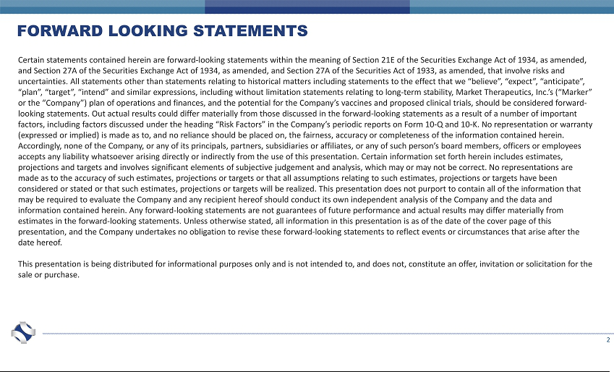

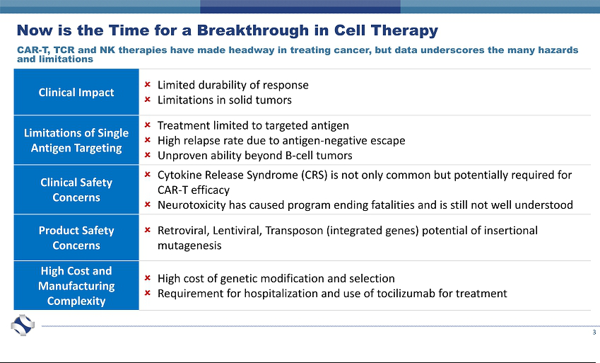

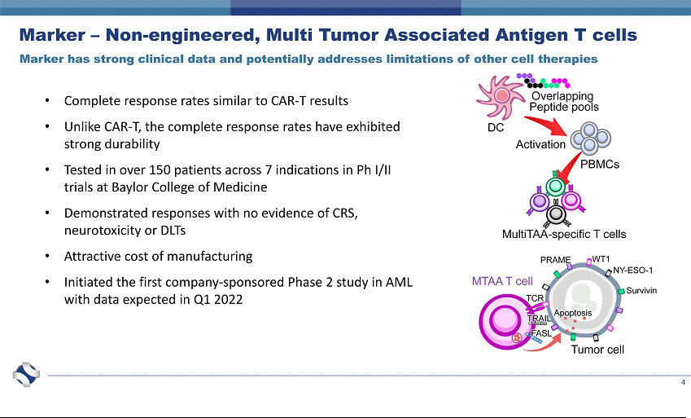

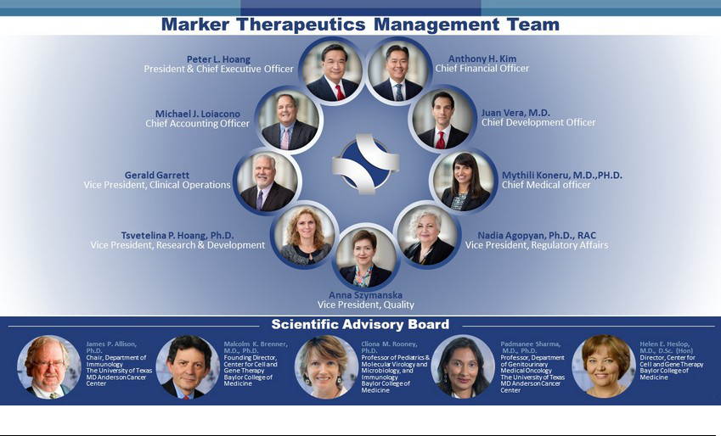



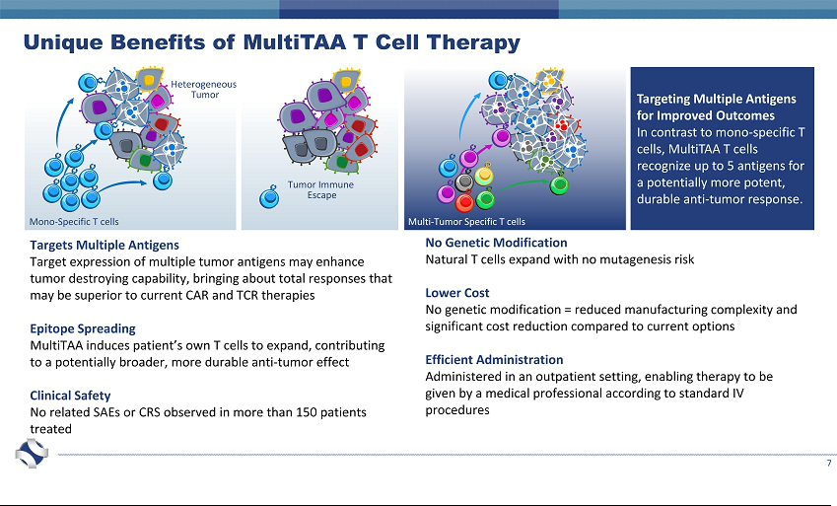

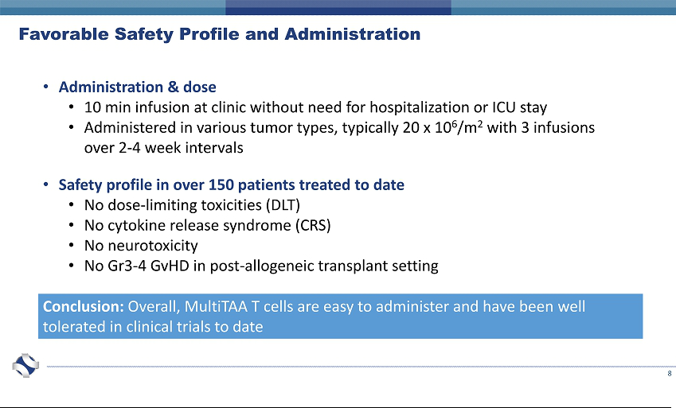

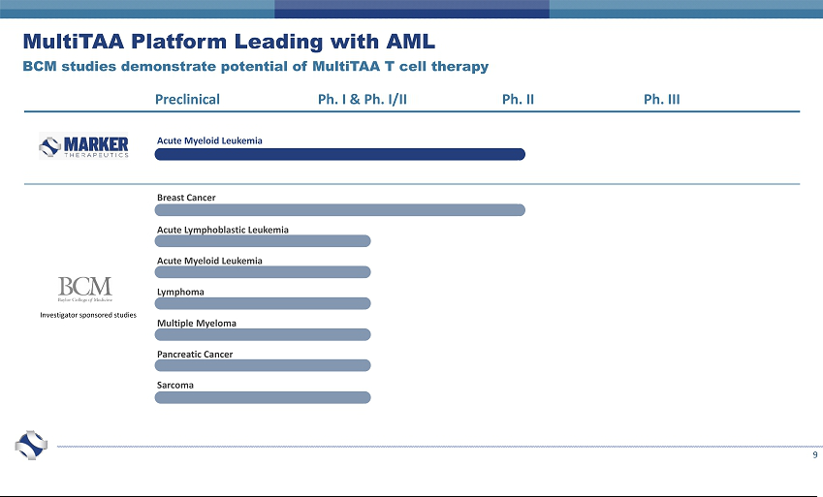

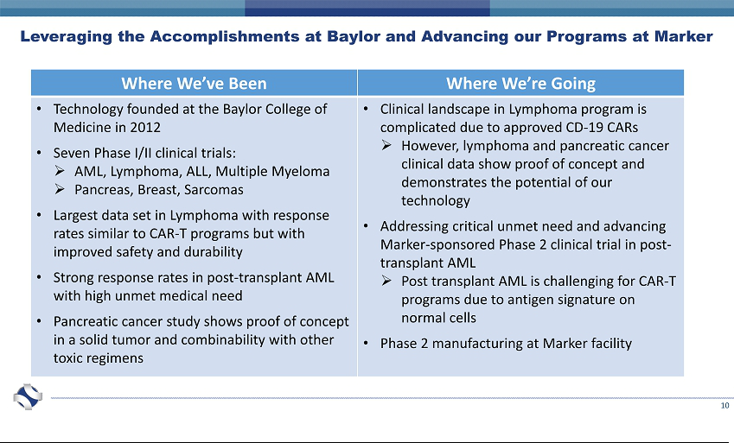



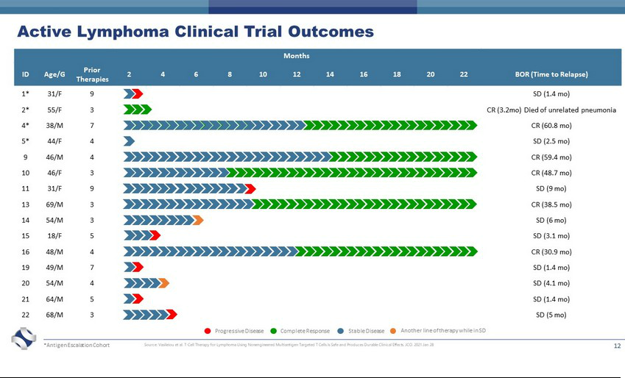

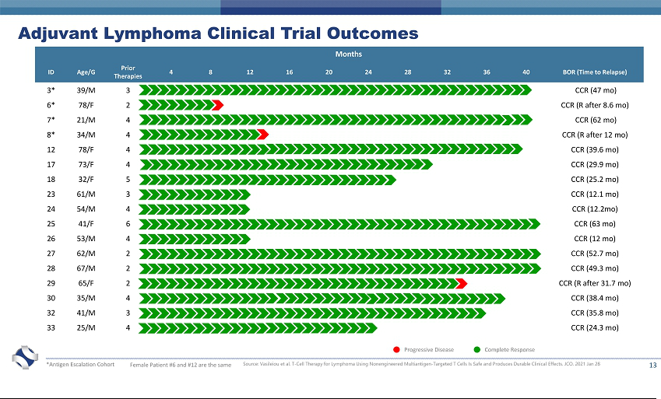

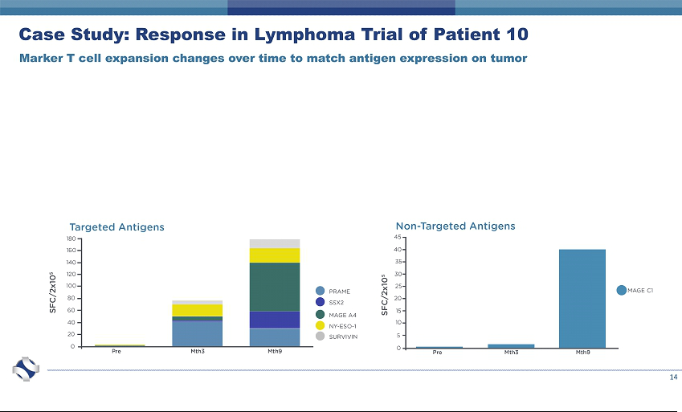

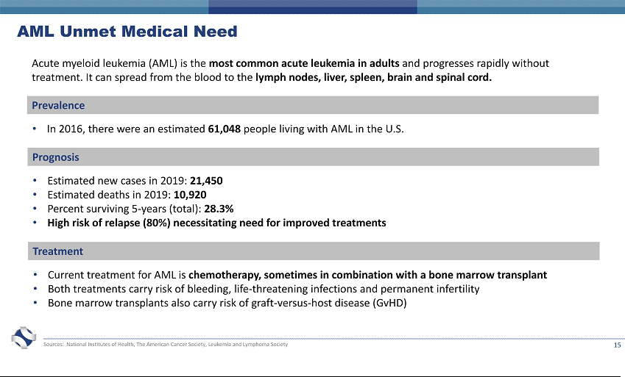

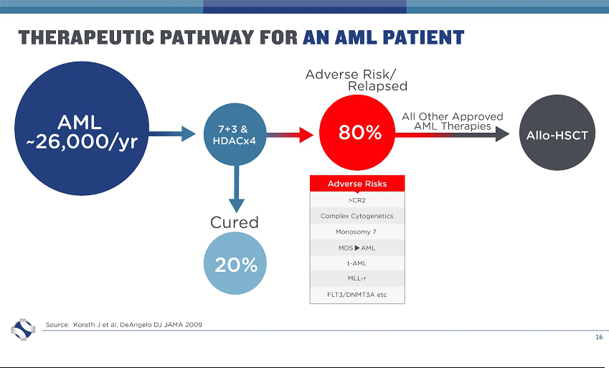

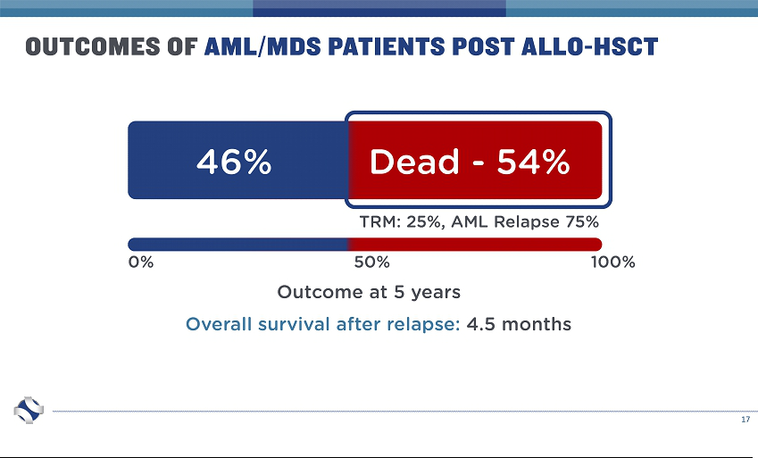

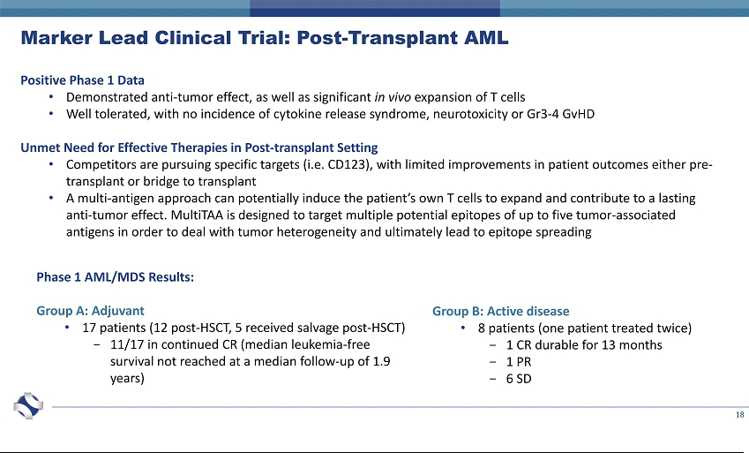

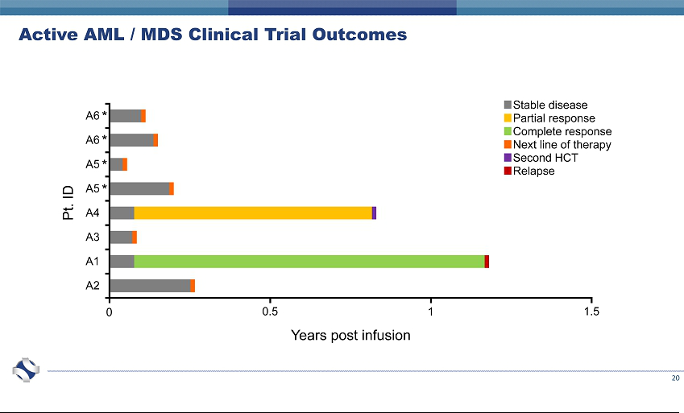

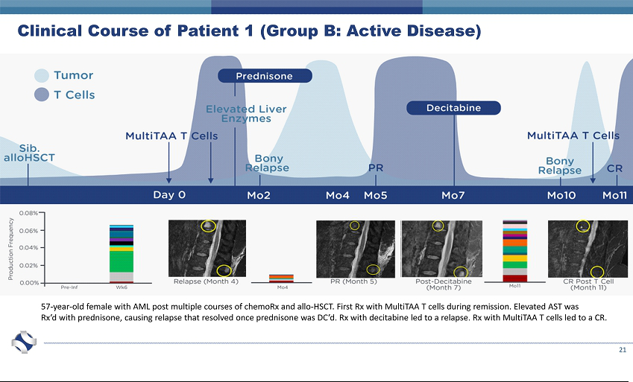

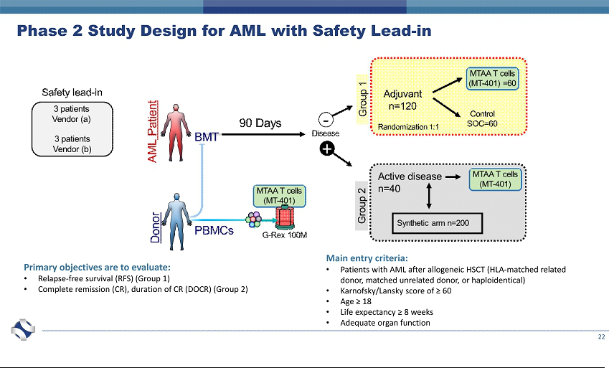



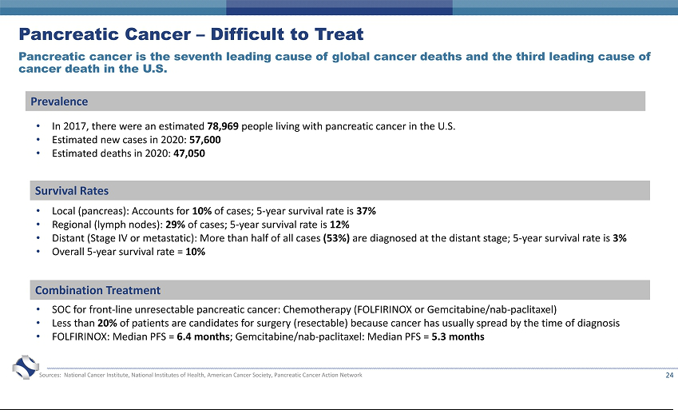

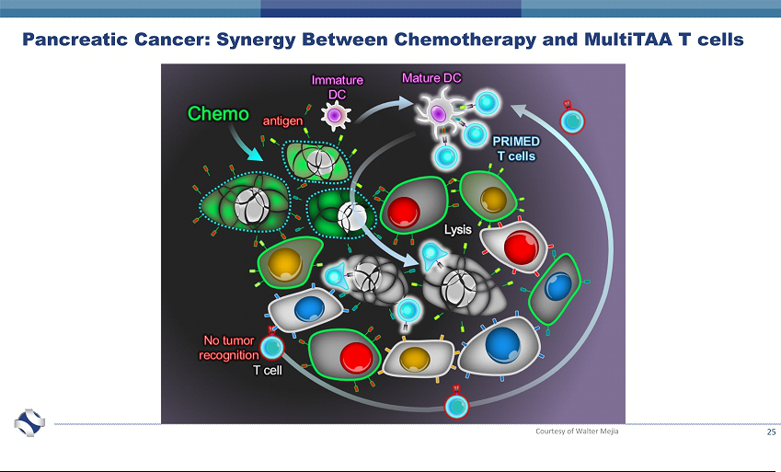

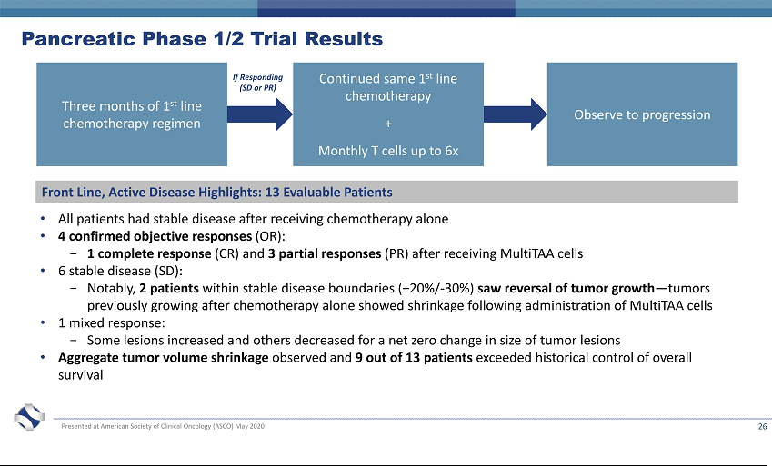

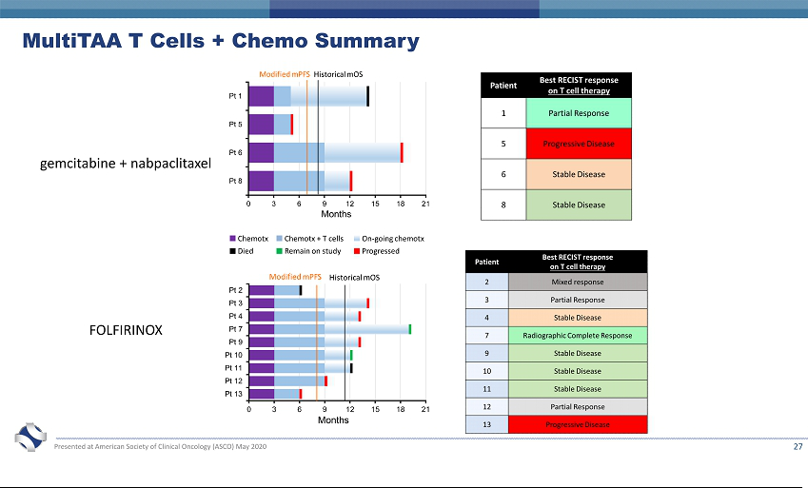

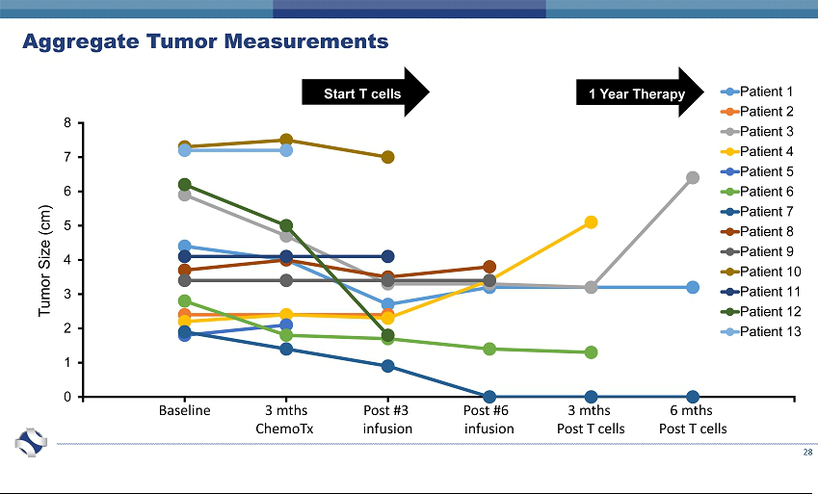



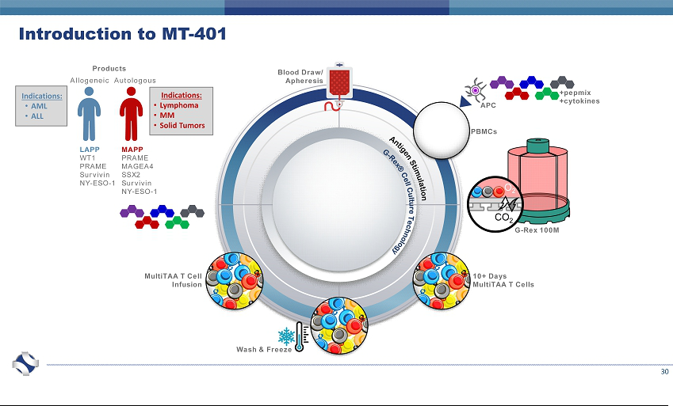

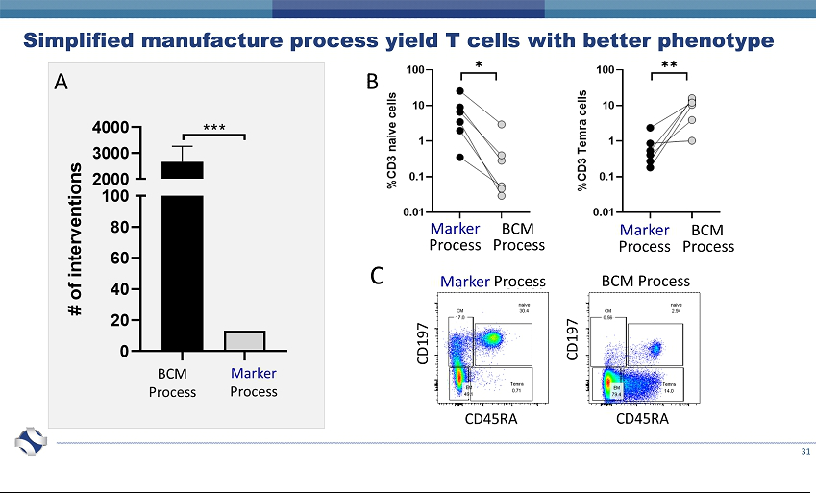

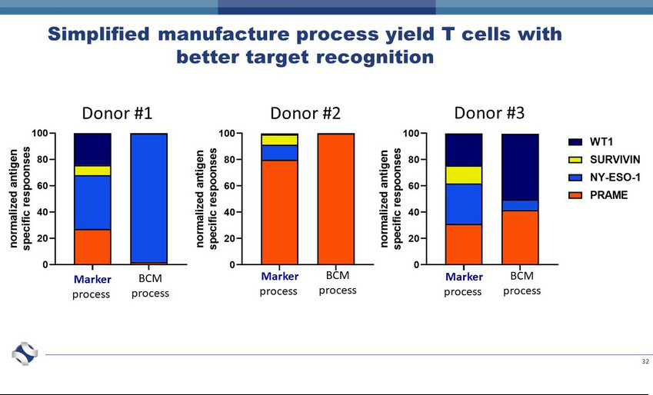

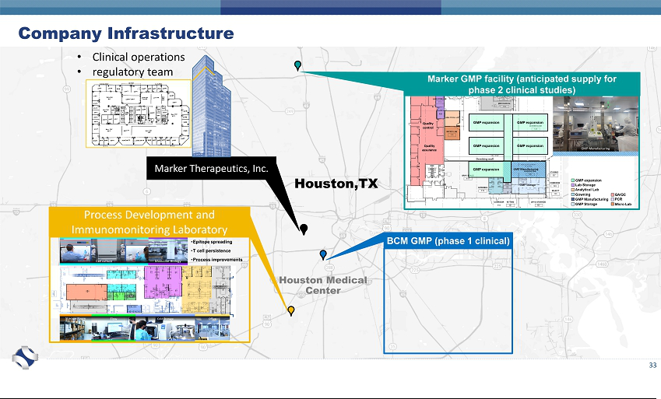

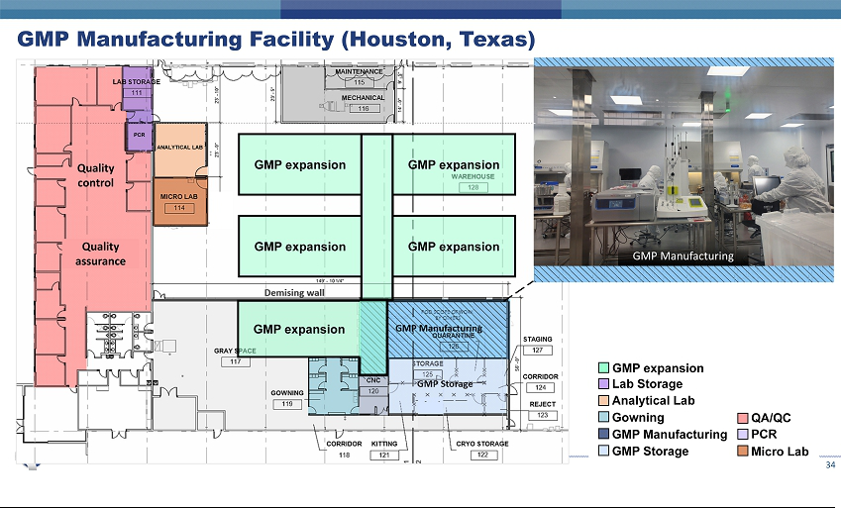

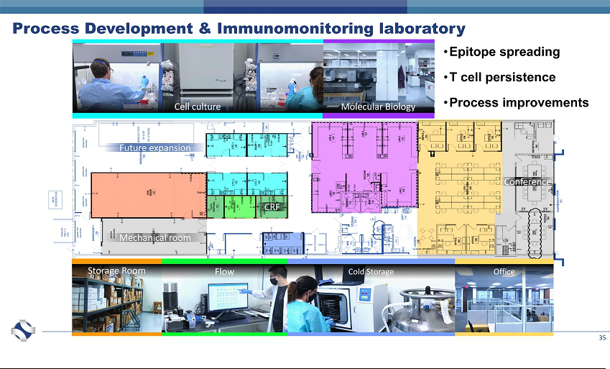

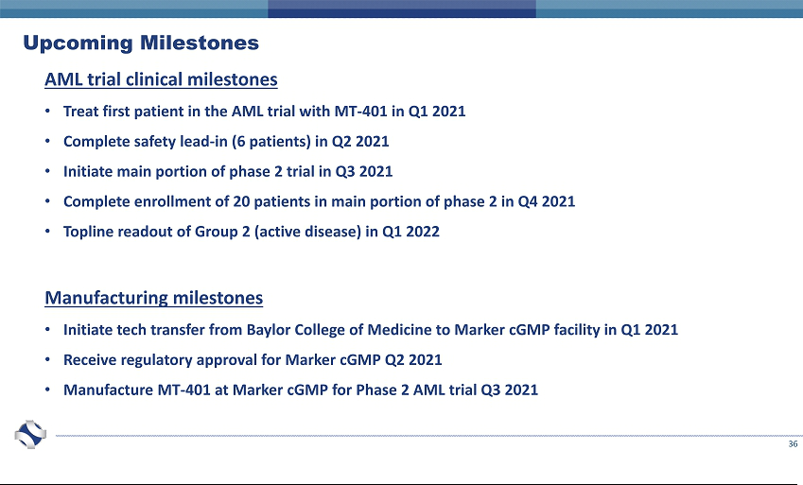

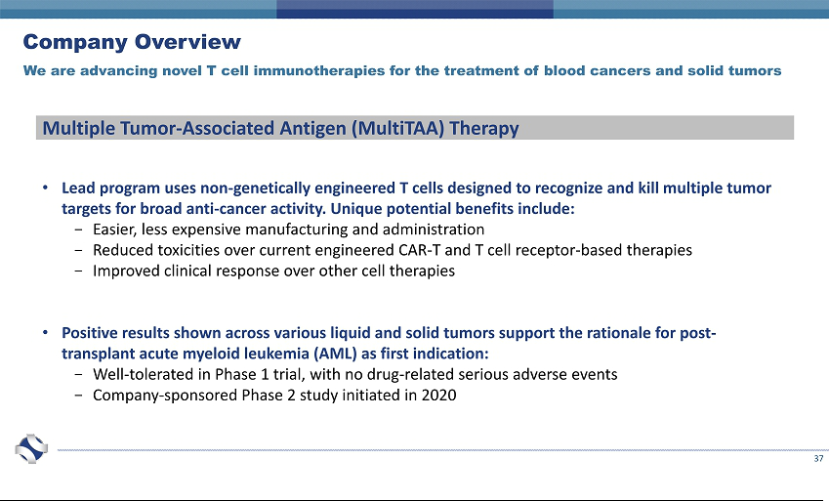



Exhibit 99.2

Marker Therapeutics, Inc. Announces Pricing of Public Offering of Common Stock

Houston, TX – March 12, 2021 – Marker Therapeutics, Inc. (Nasdaq: MRKR), a clinical-stage immuno-oncology company specializing in the development of next-generation T cell-based immunotherapies for the treatment of hematological malignancies and solid tumor indications, today announced the pricing of an underwritten public offering of 28,572,000 shares of its common stock at a public offering price of $1.75 per share. The gross proceeds to Marker from the offering, before deducting the underwriting discounts and commissions and other estimated offering expenses, are expected to be approximately $50.0 million. In addition, Marker has granted the underwriters a 30-day option to purchase up to an additional 4,285,800 shares of its common stock. All of the shares to be sold in the offering are to be sold by Marker. The offering is expected to close on or about March 16, 2021, subject to customary closing conditions.

Piper Sandler & Co. is acting as the sole active book-running manager for the offering. Cantor Fitzgerald & Co. is also acting as a book-running manager for the offering. Oppenheimer & Co. Inc. is acting as the lead manager and Roth Capital Partners is acting as the co-manager for the offering.

The offering is being made pursuant to a shelf registration statement, including a base prospectus, filed by Marker that was declared effective by the Securities and Exchange Commission (“SEC”) on June 25, 2019. The offering is being made only by means of a written prospectus and prospectus supplement that form a part of the registration statement. An electronic copy of the preliminary prospectus supplement and accompanying prospectus relating to the offering has been filed with the SEC and is available on the SEC’s website at www.sec.gov. Copies of the final prospectus supplement, when available, and the accompanying prospectus relating to the offering may be obtained by contacting Piper Sandler & Co., Attention: Prospectus Department, 800 Nicollet Mall, J12S03, Minneapolis, Minnesota 55402, by telephone at (800) 747-3924 or by email at prospectus@psc.com; or Cantor Fitzgerald & Co., Attention: Capital Markets Department, 499 Park Avenue, New York, NY 10022, or email: prospectus@cantor.com.

This press release shall not constitute an offer to sell or the solicitation of an offer to buy these securities, nor shall there be any sale of these securities in any state or other jurisdiction in which such offer, solicitation or sale would be unlawful prior to the registration or qualification under the securities laws of any such state or other jurisdiction.

Forward-Looking Statements

This release contains forward-looking statements for purposes of the safe harbor provisions of the Private Securities Litigation Reform Act of 1995. Statements in this news release concerning the Company’s expectations, plans, business outlook or future performance, and any other statements concerning assumptions made or expectations as to any future events, conditions, performance or other matters, are “forward-looking statements.” Forward-looking statements include statements regarding market risks and the satisfaction of customary closing conditions for an offering of securities. Forward-looking statements are by their nature subject to risks, uncertainties and other factors that could cause actual results to differ materially from those stated in such statements. Such risks, uncertainties and factors include, but are not limited to the risks set forth in the Company’s most recent Annual Report on Form 10-K and other SEC filings that are available through EDGAR at www.sec.gov. Such risks and uncertainties may be amplified by the COVID-19 pandemic and its impact on our business and the global economy. The Company assumes no obligation to update our forward-looking statements whether as a result of new information, future events or otherwise, after the date of this press release.

Contacts

Investor

Solebury Trout

Brian Korb

- 378-2923 bkorb@soleburytrout.com

Media

Solebury Trout

Amy Bonanno

- 450-0349 abonanno@soleburytrout.com

