UNITED STATES

SECURITIES AND EXCHANGE COMMISSION

Washington, D.C. 20549

FORM 8-K

CURRENT REPORT

Pursuant to Section 13 or 15(d) of the Securities Exchange Act of 1934

July 20, 2019

Date of Report (Date of earliest event reported)

MARKER THERAPEUTICS, INC.

(Exact name of registrant as specified in its charter)

 |  | Delaware |  |  | 001-37939 |  |  | 45-4497941
(State or other jurisdiction of incorporation) |  |  |  |  | (Commission File Number) |  |  | (IRS Employer Identification No.)
3200 Southwest Freeway
 | Suite 2240
 | Houston, Texas |  |  |  |  |  |  | 77027
(Address of principal executive offices) |  |  |  |  |  |  |  |  | (Zip Code)
 |  |  |  |  | (713) 400-6400
 |  |  |  |  | Registrant’s telephone number, including area code

N/A

(Former name or former address, if changed since last report)

Check the appropriate box below if the Form 8-K is intended to simultaneously satisfy the filing obligation of the registrant under any of the following provisions:

- Written communications pursuant to Rule 425 under the Securities Act (17 CFR 230.425)

- Soliciting material pursuant to Rule 14a-12 under the Exchange Act (17 CFR 240.14a-12)

- Pre-commencement communications pursuant to Rule 14d-2(b) under the Exchange Act (17 CFR 240.14d-2(b))

- Pre-commencement communications pursuant to Rule 13e-4(c) under the Exchange Act (17 CFR 240.13e-4(c))

Securities registered pursuant to Section 12(b) of the Act:
 | Trading
Title of each class | Symbol(s) | Name of each exchange on which registered
Common Stock, par value $0.001 per share | MRKR | The Nasdaq Stock Market LLC

Indicate by check mark whether the registrant is an emerging growth company as defined in Rule 405 of the Securities Act of 1933 (§230.405 of this chapter) or Rule 12b-2 of the Securities Exchange Act of 1934 (§240.12b-2 of this chapter).

Emerging growth company ☐

If an emerging growth company, indicate by check mark if the registrant has elected not to use the extended transition period for complying with any new or revised financial accounting standards provided pursuant to Section 13(a) of the Exchange Act. ☐

Item 7.01. Regulation FD Disclosure.

On July 22, 2019, Marker Therapeutics, Inc. (the “Company”) hosted a live webcast featuring Brandon G. Smaglo, M.D., FACP, lead investigator and Assistant Professor of Oncology at the Baylor College of Medicine, Houston, Texas, and the Company’s senior management to discuss interim results from an investigator-sponsored clinical trial led by Baylor College of Medicine evaluating the Company’s MultiTAA therapy for the treatment of patients with pancreatic adenocarcinoma (the “Clinical Trial”). A copy of the slides presented during the webcast is furnished herewith as Exhibit 99.1 and is incorporated herein by reference.

The information in this Item 7.01 of this Current Report on 8-K (including Exhibit 99.1) is furnished and shall not be deemed “filed” for purposes of Section 18 of the Securities Exchange Act of 1934, as amended, or subject to the liabilities of that section or Sections 11 and 12(a)(2) of the Securities Act of 1933, as amended. The information shall not be deemed incorporated by reference into any other filing with the Securities and Exchange Commission made by the Company, whether made before or after today’s date, regardless of any general incorporation language in such filing, except as shall be expressly set forth by specific references in such filing.

Item 8.01. Other Events.

On July 20, 2019, the Company issued a press release announcing interim results from the Clinical Trial. A copy of the press release is attached hereto as Exhibit 99.2 and is incorporated herein by reference.

Item 9.01. |  | Financial Statements and Exhibits.
(d) Exhibits.
Exhibit No. |  | Description
99.1 |  | Company Presentation, dated July 22, 2019.
99.2 |  | Press release issued on July 20, 2019.

SIGNATURES

In accordance with the requirements of the Exchange Act, the registrant caused this report to be signed on its behalf by the undersigned, thereunto duly authorized on this 22nd day of July, 2019.

MARKER THERAPEUTICS, INC.

(Registrant)

By: /s/ Anthony Kim

Anthony Kim

Chief Financial Officer

Exhibit 99.1
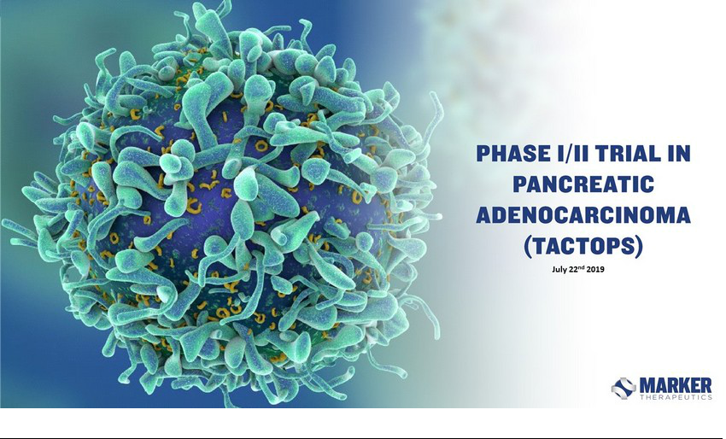

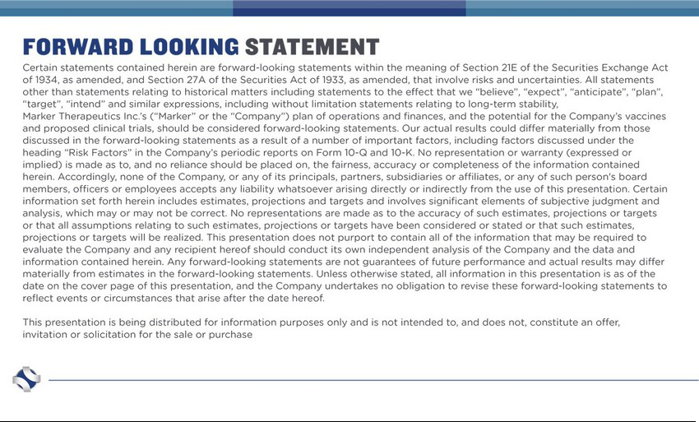



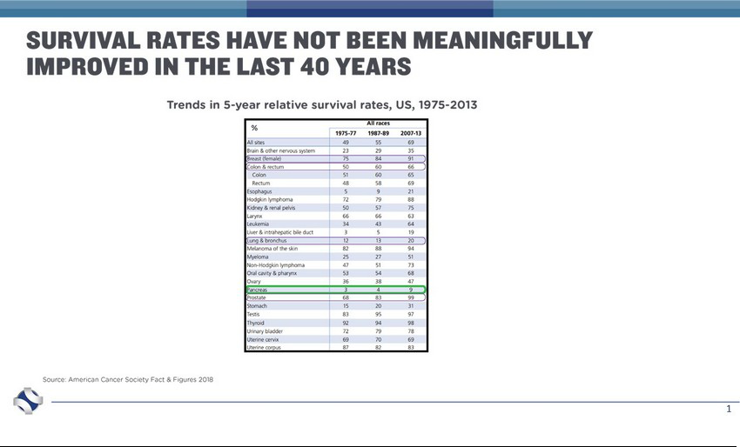

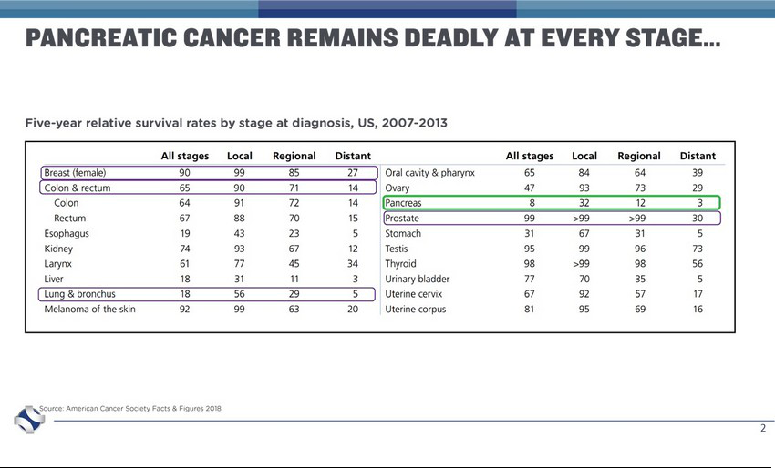

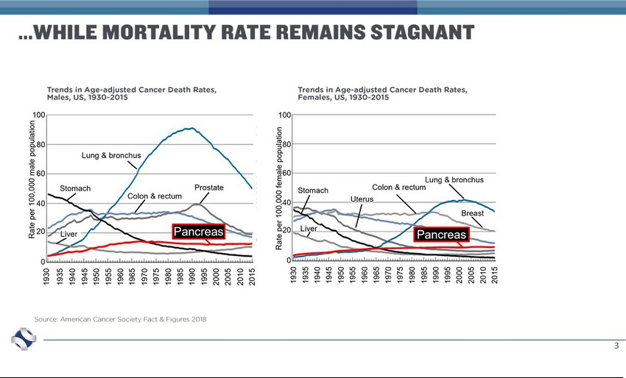



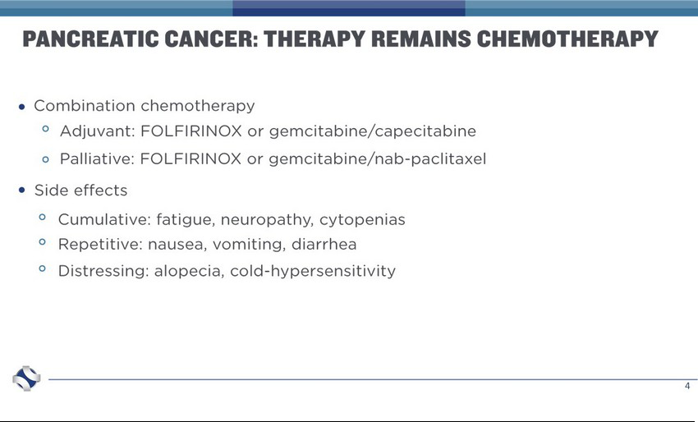

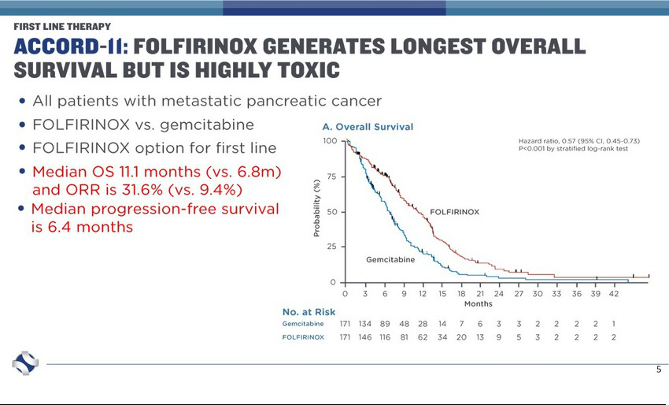

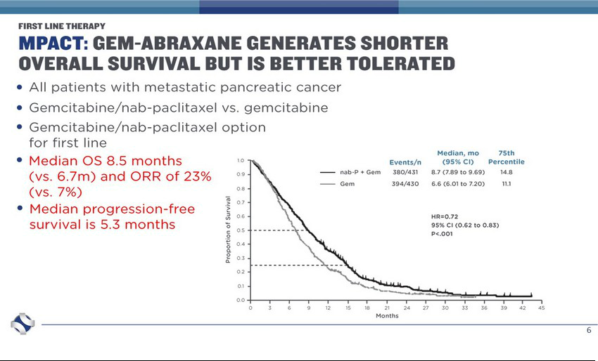

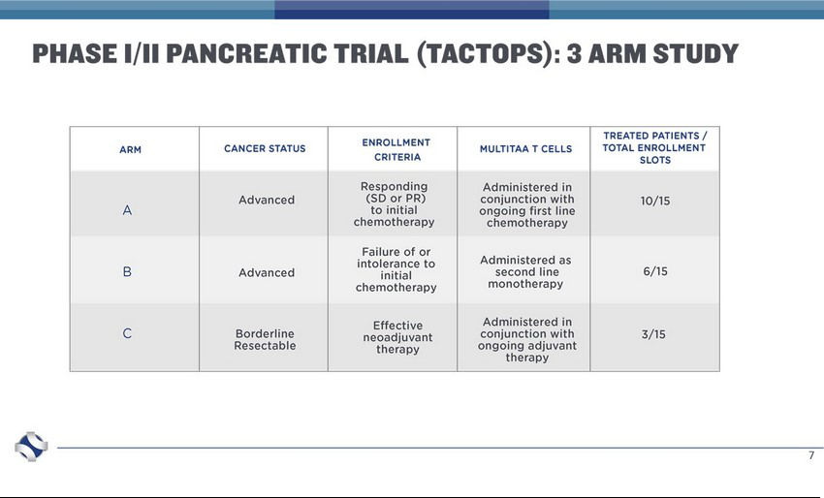

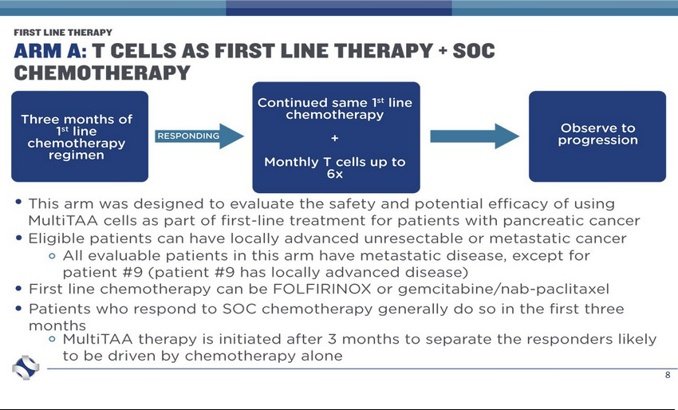

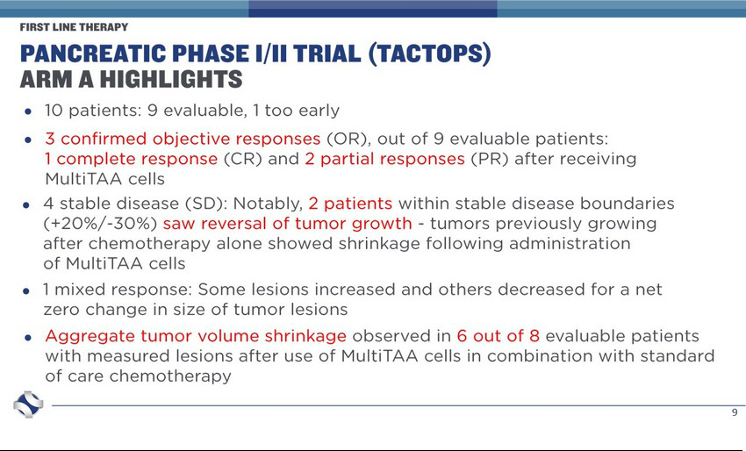

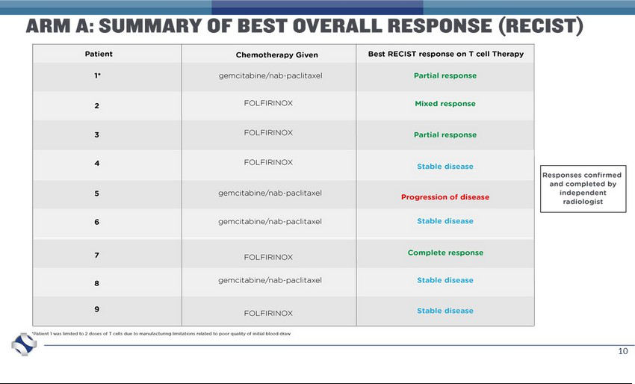

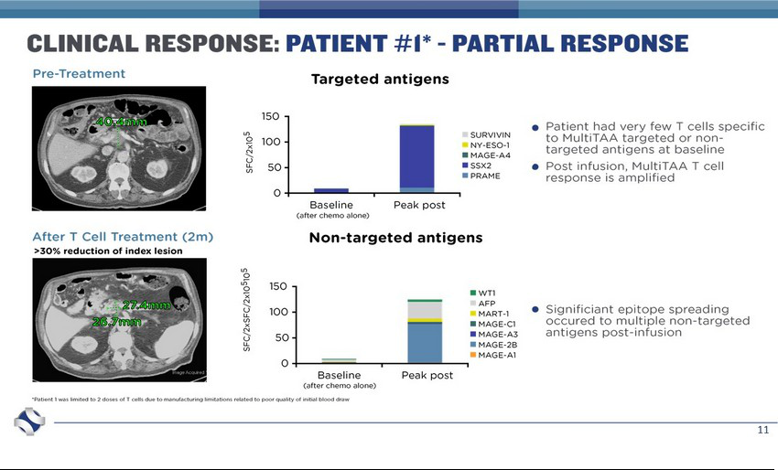

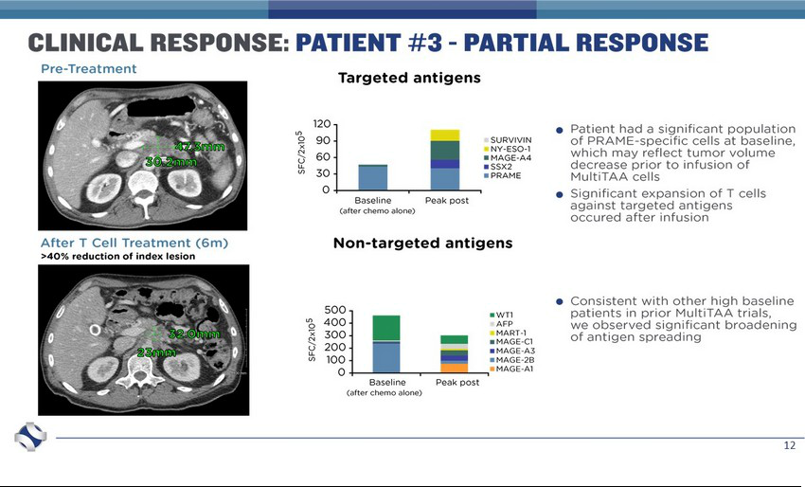

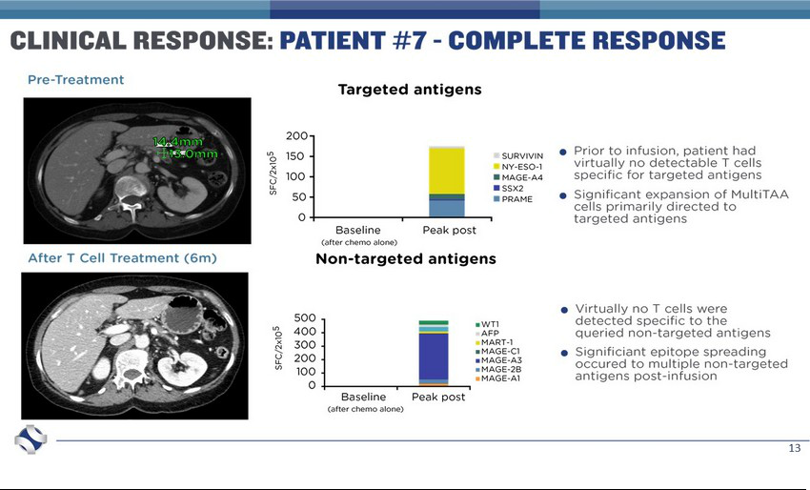

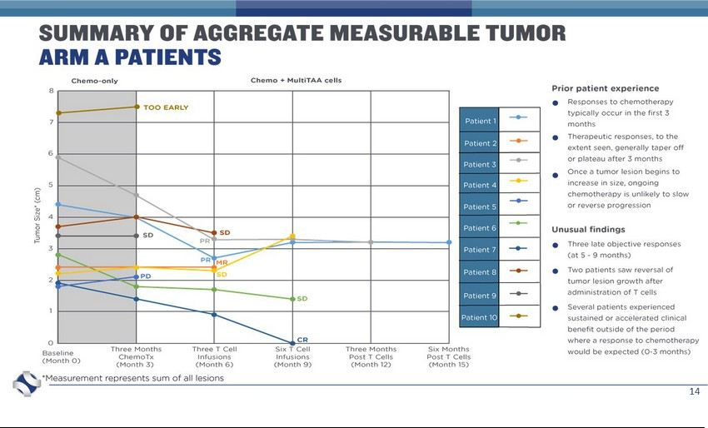

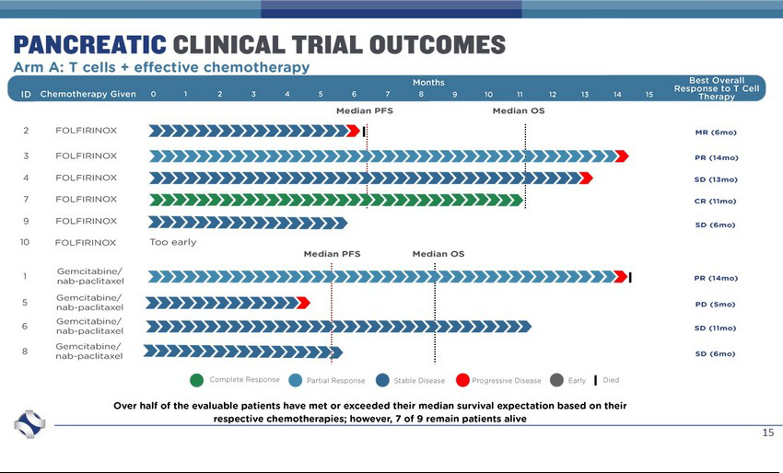

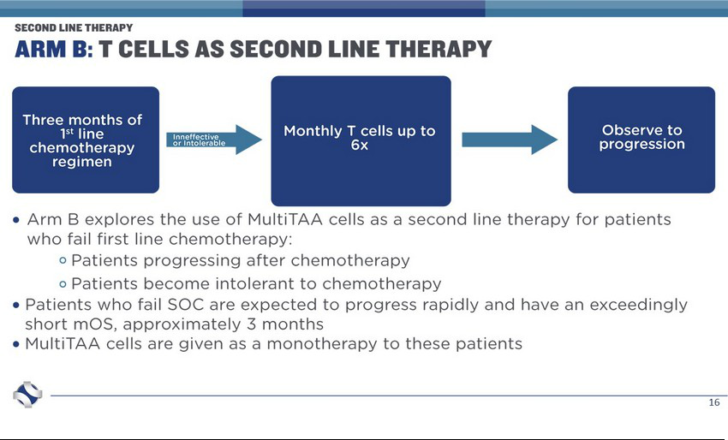

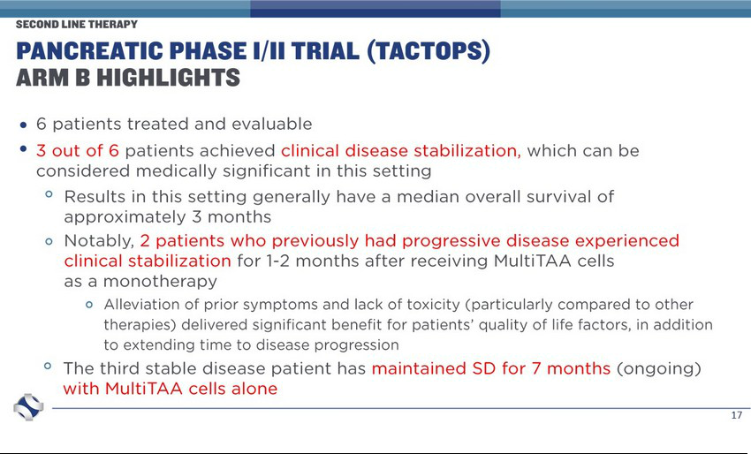

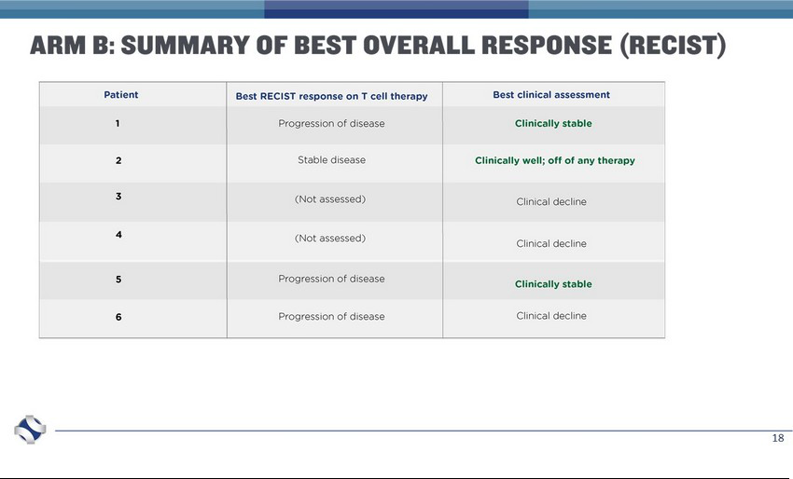

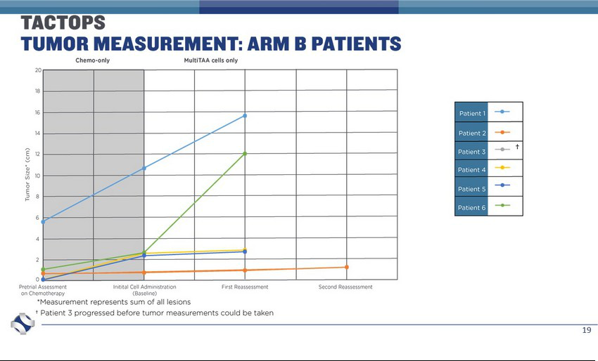

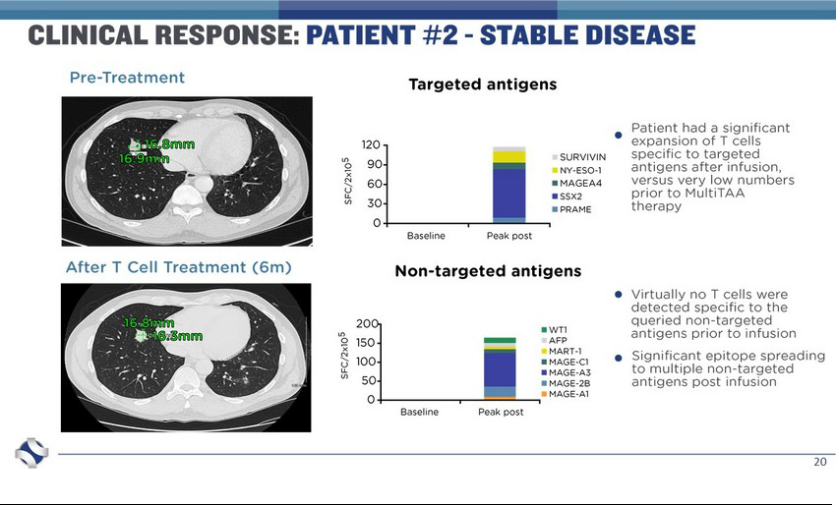

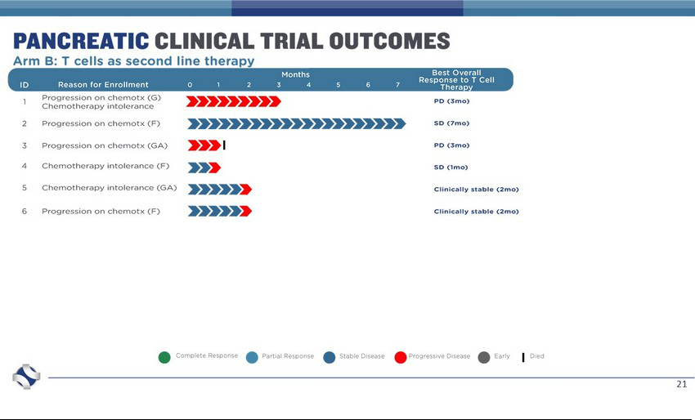

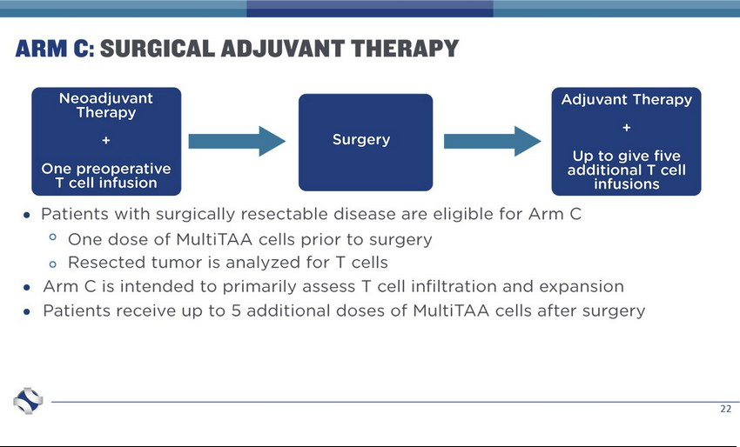

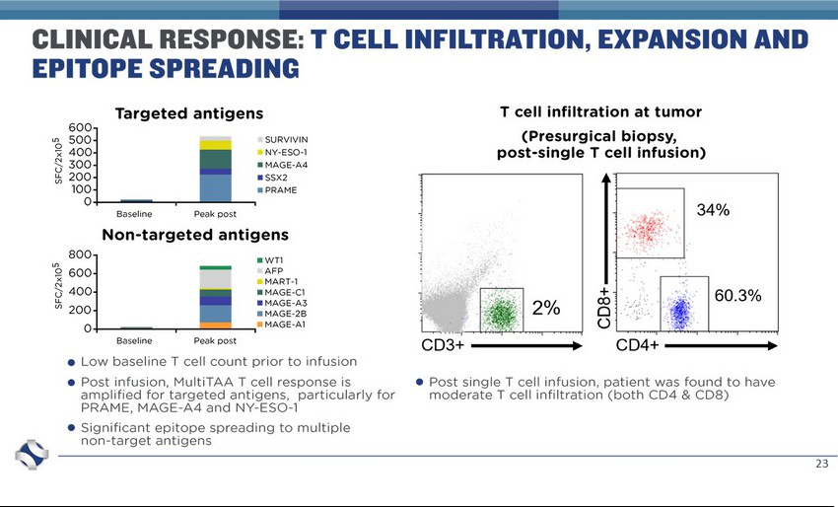

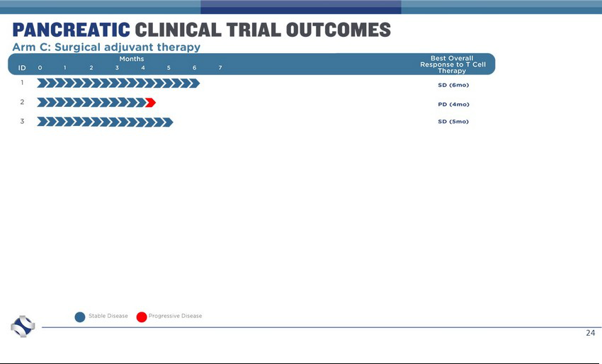





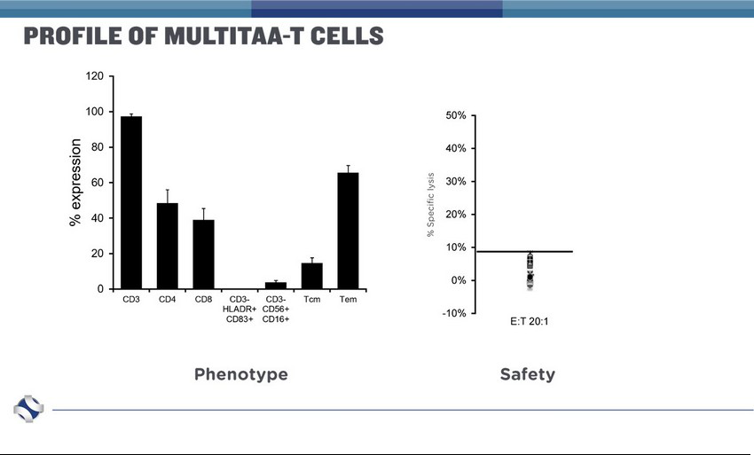

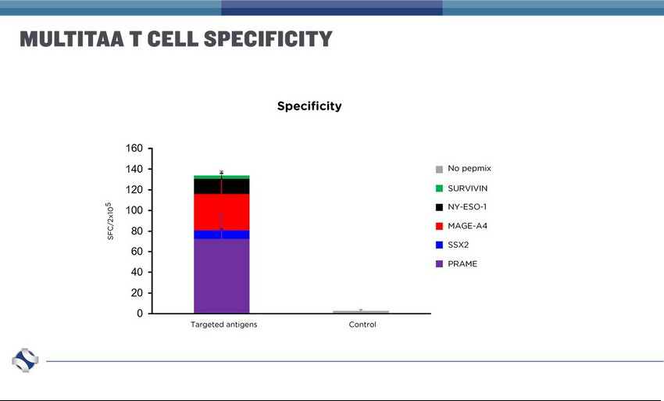

Exhibit 99.2


Marker Therapeutics Reports Interim Results of its MultiTAA T Cell Therapy in Patients with Pancreatic Adenocarcinoma at AACR

Results show potential of MultiTAA therapy in combination with chemotherapy as a first-line treatment for patients with pancreatic cancer; potential second-line treatment for chemo-refractory patients

T cell infiltration and expansion observed, supporting MultiTAA’s potential as a durable treatment in this patient population

Company to host conference call and webcast on Monday, July 22

San Francisco, CA—July 20, 2019—Marker Therapeutics, Inc. (Nasdaq:MRKR), a clinical-stage immuno-oncology company specializing in the development of next-generation T cell-based immunotherapies for the treatment of hematological malignancies and solid tumor indications, today announced interim data from an ongoing investigator-sponsored clinical trial led by Baylor College of Medicine, evaluating the Company’s MultiTAA T cell therapy in patients with pancreatic adenocarcinoma. The data were reviewed today in an oral presentation during a plenary session, as well as a poster presentation, at the American Association for Cancer Research’s (AACR) Immune Cell Therapies for Cancer: Successes and Challenges of CAR T Cells and Other Forms of Adoptive Therapy conference held in San Francisco, California from July 19-22, 2019.

“Pancreatic cancer continues to be one of the most challenging solid tumor malignancies to treat and survival rates have not seen a meaningful improvement in more than 40 years,” said Brandon G. Smaglo, M.D., FACP, lead investigator and Assistant Professor of Oncology at Baylor College of Medicine. “We are encouraged by these interim data which suggest that MultiTAA therapy may contribute to more durable responses without added toxicity when used in combination with standard-of-care chemotherapy, or as a second-line therapy for patients who are chemo-refractory. Additionally, despite the particularly dense desmoplastic stroma surrounding pancreatic tumors—which has been long considered a major obstacle for T cell effectiveness—our study of patients with borderline surgically resectable disease suggests that MultiTAA cells are capable of meaningfully infiltrating the tumor.”

Trial Overview

Title: Targeting pancreatic cancer using non-engineered, multi-antigen specific T cells (TACTOPS)

The trial plans to enroll a total of 45 patients with advanced or borderline resectable pancreatic adenocarcinoma in a three-arm trial. Arm A is for patients with unresectable/metastatic disease who are responding to standard first-line chemotherapy. Arm B is for patients with progressive disease or therapy intolerance. Arm C is an exploratory arm for patients with surgically resectable disease. To date, a total of 19 patients have been administered infusions of MultiTAA T cell therapy (ten patients in Arm A, six patients in Arm B and three patients in Arm C).

1

Interim Results

Arm A: This arm was designed to evaluate the safety and potential efficacy of using MultiTAA cells as part of first-line treatment for patients with pancreatic cancer. These patients in the chemo-responsive arm have completed or will complete at least three months of standard-of-care chemotherapy (gemcitabine/nab-paclitaxel or FOLFIRINOX) – the period during which a response to chemotherapy would typically occur – before receiving up to six administrations of MultiTAA T cells in conjunction with chemotherapy.

- Out of the 9 evaluable patients (one patient was too early to be evaluated):

  - 3 patients experienced objective responses after administration of MultiTAA cells

    - 1 patient experienced a complete response

    - 2 patients experienced partial responses

  - 4 patients experienced stable disease; 2 patients within stable disease boundaries (+20%/-30%) saw reversal of tumor growth – tumors previously growing after chemotherapy alone showed shrinkage after administration of MultiTAA cells
  - 1 patient experienced a mixed response (some lesions increased in size and others decreased for a net zero change in size of tumor lesions)

  - 1 patient experienced disease progression

- Overall tumor volume shrinkage was observed in six out of the eight patients with a measurable tumor after administration of MultiTAA cells. One evaluable patient did not have tumor measurements for analysis.
- Of the 9 evaluable patients, over half have survived to or beyond the historical median overall survival associated with their respective chemotherapy regimens, and 7 of the 9 patients remain alive.
- In patients responding to therapy, significant expansion of the infused MultiTAA cells was observed, along with broad-based epitope spreading, with significant expansion of endogenous T cells specific for other tumor specific antigens.

Arm B: This arm was designed to evaluate the use of MultiTAA cells as a second-line therapy for patients who have failed first-line chemotherapy. The patients in this chemo-refractory arm are either ineligible for chemotherapy or have progressed on chemotherapy and have received or are receiving up to six doses of MultiTAA T cells as a monotherapy.

- Of the 6 patients treated and evaluable:

  - 3 patients experienced stable disease or clinical disease stabilization

    - 2 patients who previously had progressive disease experienced clinical disease stabilization for up to two months

    - 1 has maintained stable disease for 7 months (ongoing)

  - 3 experienced clinical decline

- Among the patients who saw clinical disease stabilization, significant expansion of the infused MultiTAA cells was observed, along with broad-based epitope spreading, with significant expansion of endogenous T cells specific for other tumor specific antigens.

Arm C: This arm was designed to assess T cell infiltration and expansion. These patients with borderline surgically resectable disease received or will receive a dose of T cells following chemotherapy, radiotherapy or combination prior to surgical resection and up to five additional doses of T cells after surgery.

2

- In these patients, MultiTAA T cells were measurable in meaningful numbers as detected by correlative analysis of resected tumor, and significant expansion of the infused MultiTAA cells was observed, along with broad-based epitope spreading, with significant expansion of endogenous T cells specific for other tumor specific antigens.

Overall, investigators observed a clinical benefit correlated with the detection of tumor-reactive T cells in patient peripheral blood (Arms A, B and C) and within tumor biopsy samples (Arm C) post-infusion. T cells exhibited activity against both targeted antigens as well as non-targeted TAAs including WT-1, AFP, MART-1 and numerous antigens of the MAGE family, indicating induction of antigen/epitope spreading.

No infusion-related systemic- or neurotoxicity was observed, and patients continue to be evaluated and enrolled in the trial.

Peter L. Hoang, President & CEO of Marker Therapeutics commented: “We are encouraged by the early clinical results we have seen in this clinical trial for patients who otherwise have few therapeutic options and a dire prognostic outcome, and we are optimistic about the prospect of potentially validating the use of MultiTAA therapy in the context of first-line and second-line care for patients with pancreatic adenocarcinoma. Moreover, we are very pleased with the data we see of MultiTAA T cell infiltration and subsequent epitope spreading observed in this trial, suggesting that MultiTAA therapy may initiate and contribute to a potent and durable treatment effect. We plan to continue following these patients and enroll new patients to further evaluate durability.”

Conference Call and Webcast

For those unable to attend the presentations at AACR, Marker will host a conference call and webcast on Monday, July 22nd at 5:30am PDT/8:30am EDT featuring Dr. Brandon Smaglo, as well as Marker senior management. A live webcast of the investor presentation will be available in the investors section of the Company’s website at https://www.markertherapeutics.com/ and will be available for replay following the event.

About MultiTAA

Marker’s Multi-Antigen Targeted (MultiTAA) platform is a novel, non-genetically modified cell therapy approach that selectively expands tumor-specific T cells from a patient’s blood capable of recognizing a broad range of tumor antigens. In early clinical trials, the multi-antigen approach has been well tolerated and shown to enhance tumor destroying capability and is one of the first therapies to consistently demonstrate epitope spreading – inducing the patient’s own T cells to expand, potentially contributing to a lasting anti-tumor effect. Unlike other cell therapies which require pre-conditioning regimens and hospitalization, MultiTAA is designed to be administered in an outpatient setting.

About Marker Therapeutics, Inc.

Marker Therapeutics, Inc. is a clinical-stage immuno-oncology company specializing in the development of next-generation T cell-based immunotherapies for the treatment of hematological malignancies and solid tumor indications. Marker’s cell therapy technology is based on the selective expansion of non-engineered, tumor-specific T cells that recognize tumor associated antigens (i.e. tumor targets) and kill tumor cells expressing those targets. This population of T cells is designed to attack multiple tumor targets following infusion into patients and to activate the patient’s immune system to produce broad spectrum anti-tumor activity. Because Marker does not genetically engineer its T cells therapies, we believe that our product candidates will be easier and less expensive to manufacture, with reduced toxicities, compared to current engineered CAR-T and TCR-based approaches, and may provide patients with meaningful clinical benefit. As a result, Marker believes its portfolio of T cell therapies has a compelling product profile, as compared to current gene-modified CAR-T and TCR-based therapies.

3

Marker is also advancing a number of innovative peptide- and gene-based immuno-therapeutics for the treatment of metastatic solid tumors, including the Folate Receptor Alpha program (TPIV200) for breast and ovarian cancers and the HER2/neu program (TPIV100/110) for breast cancer, currently in Phase 2 clinical trials.

To receive future press releases via email, please visit: https://markertherapeutics.com/email-alerts/

Forward-Looking Statement Disclaimer

This release contains forward-looking statements for purposes of the safe harbor provisions of the Private Securities Litigation Reform Act of 1995. Statements in this news release concerning the Company’s expectations, plans, business outlook or future performance, and any other statements concerning assumptions made or expectations as to any future events, conditions, performance or other matters, are “forward-looking statements.” Forward-looking statements include statements regarding our intentions, beliefs, projections, outlook, analyses or current expectations concerning, among other things: the final trial results for MultiTAA T cell therapy in patients with pancreatic adenocarcinoma; our research and development activities relating to our non-engineered multi-tumor antigen specific T cell therapies; our TPIV200 and TPIV100/110 programs; the effectiveness of these programs or the possible range of application and potential curative effects and safety in the treatment of diseases; and, the timing and success of our clinical trials, as well as clinical trials conducted by our collaborators. Forward-looking statements are by their nature subject to risks, uncertainties and other factors which could cause actual results to differ materially from those stated in such statements. Such risks, uncertainties and factors include, but are not limited to the risks set forth in the Company’s most recent Form 10-K, 10-Q and other SEC filings which are available through EDGAR at www.sec.gov. The Company assumes no obligation to update our forward-looking statements whether as a result of new information, future events or otherwise, after the date of this press release.

Contacts

Investor

Solebury Trout

Chiara Russo

- 221-9197 crusso@soleburytrout.com

Media

Solebury Trout

Brad Miles

- 513-3125 bmiles@soleburytrout.com

– or –

Amy Bonanno

- 450-0349 abonanno@soleburytrout.com

4

