SECURITIES AND EXCHANGE COMMISSION

Washington, D.C. 20549

FORM 8-K

CURRENT REPORT

Pursuant to Section 13 or 15(d) of the Securities Exchange Act of 1934

February 25, 2019

Date of Report

MARKER THERAPEUTICS, INC.

(Exact name of registrant as specified in its charter)

 | Delaware |  | 001-37939 |  |  |  |  | 45-4497941
(State or other jurisdiction of |  |  | (Commission File Number) |  |  |  |  | (IRS Employer
incorporation) |  |  |  |  |  |  |  | Identification No.)
3200 Southwest Freeway
Suite 2240
Houston, Texas |  |  |  |  |  |  |  | 77027
(Address of principal executive offices) |  |  |  |  |  |  |  |  | (Zip Code)
 |  |  | (713) 400-6400
 |  |  | Registrant’s telephone number, including area code
 |  |  |  |  | N/A
 |  |  | (Former name or former address, if changed since last report)

Check the appropriate box below if the Form 8-K is intended to simultaneously satisfy the filing obligation of the registrant under any of the following provisions:

- Written communications pursuant to Rule 425 under the Securities Act (17 CFR 230.425)

- Soliciting material pursuant to Rule 14a-12 under the Exchange Act (17 CFR 240.14a-12)

- Pre-commencement communications pursuant to Rule 14d-2(b) under the Exchange Act (17 CFR 240.14d-2(b))

- Pre-commencement communications pursuant to Rule 13e-4(c) under the Exchange Act (17 CFR 240.13e-4(c))

Indicate by check mark whether the registrant is an emerging growth company as defined in Rule 405 of the Securities Act of 1933 (§230.405 of this chapter) or Rule 12b-2 of the Securities Exchange Act of 1934 (§240.12b-2 of this chapter). Emerging growth company ☐

If an emerging growth company, indicate by check mark if the registrant has elected not to use the extended transition period for complying with any new or revised financial accounting standards provided pursuant to Section 13(a) of the Exchange Act. ☐

Item 8.01 Other Events.

On February 25, 2019, Marker Therapeutics, Inc. (“Marker” or the “Company”) issued a press release announcing a clinical update from four clinical trials using the Company’s multi-antigen targeted T cell (MultiTAA) therapies. The data was reviewed in oral and poster presentations at the Transplantation & Cellular Therapy (“TCT”) Meetings of the American Society for Blood and Marrow Transplantation and the Center for International Blood and Marrow Transplant Research (“ASBMT” and “CIBMTR”) The meetings took place in Houston, Texas from February 20-24, 2019.

A copy of the press release is attached hereto as Exhibit 99.1 and is incorporated herein by reference.

As previously announced by the Company on January 15, 2019, the Center for Cell and Gene Therapy at Baylor College of Medicine presented data from four abstracts at ASBMT and CIBMTR meetings between February 20-February 23, 2019. The presentations include: (i) an oral presentation regarding Targeting Lymphomas Using Non-Engineered, Multi-Antigen-Specific T Cells; (ii) an oral presentation regarding Administering Leukemia-Directed Donor Lymphocytes to Patients with AML or MDS to Prevent or Treat Post-Allogeneic HSCT Relapse; (iii) an oral presentation regarding Adoptive T-Cell Therapy for Acute Lymphoblastic Leukemia Targeting Multiple Tumor-Associated Antigens; and (iv) a poster presentation regarding Safety and Efficacy of Multiantigen-Targeted T Cells for Multiple Myeloma. The studies describe results achieved using multi-tumor antigen specific T cells that were developed at the Baylor College of Medicine in the laboratories of Dr. Ann Leen and Dr. Juan Vera, and exclusively licensed to Marker Therapeutics, Inc. Copies of the presentation and posters are attached hereto as Exhibits 99.2, 99.3, 99.4, and 99.5, respectively. The presentations are available on Marker Therapeutics website at www.markertherapeutics.com under the caption “Recognition.”

The information furnished pursuant to Item 8.01 on this Form 8-K, including Exhibit 99.2, 99.3 and 99.4 and 99.5 attached hereto, shall not be deemed “filed” for purposes of Section 18 of the Securities Exchange Act of 1934, as amended (the “Exchange Act”), or otherwise subject to the liabilities of that section, nor shall it be deemed incorporated by reference into any other filing under the Securities Act or the Exchange Act, except as expressly set forth by specific reference in such a filing.

Item 9.01. Financial Statements and Exhibits.

(d) Exhibits.
Exhibit No. |  |  |  |  | Description
99.1 |  |  | Press release issued on February 25, 2019.
99.2 |  |  | 2019 | TCT Meeting Presentation- Targeting Lymphomas Using Non-Engineered, Multi-Antigen-Specific T Cells.*
99.3 |  |  | 2019 | TCT Meeting Presentation- Administering Leukemia-Directed Donor Lymphocytes to Patients with AML or MDS to Prevent or Treat Post-Allogeneic HSCT Relapse. *
99.4 |  |  | 2019 | TCT Meeting Presentation- Adoptive T-Cell Therapy for Acute Lymphoblastic Leukemia Targeting Multiple Tumor-Associated Antigens.*
99.5 |  |  | 2019 | TCT Meeting Poster Presentation- Safety and Efficacy of Multiantigen-Targeted T Cells for Multiple Myeloma.*
*Furnished herewith.

SIGNATURES

In accordance with the requirements of the Exchange Act, the registrant caused this report to be signed on its behalf by the undersigned, thereunto duly authorized on this 25th day of February, 2019.

MARKER THERAPEUTICS, INC.

(Registrant)

BY: | /s/ Michael Loiacono
 | Michael Loiacono
 | Chief Accounting Officer

Exhibit 99.1


Marker Therapeutics Announces Clinical Update at the Transplantation & Cellular Therapy Meetings of ASBMT and CIBMTR 2019

Houston, TX – February 25, 2019 – Marker Therapeutics, Inc. (NASDAQ:MRKR), a clinical-stage immuno-oncology company specializing in the development of next-generation T cell-based immunotherapies for the treatment of hematological malignancies and solid tumor indications, today announced updated data from four clinical trials using the Company’s multi-antigen targeted T cell (MultiTAA) therapies. The data was reviewed in oral and poster presentations at the Transplantation & Cellular Therapy Meetings of ASBMT and CIBMTR 2019 which took place in Houston, TX from February 20-24. Among the highlights, were results from an ongoing study including patients with acute myeloid leukemia (AML), which were reviewed in an oral presentation by Dr. Premal Lulla, M.B.B.S., Assistant Professor of Medicine, Baylor College of Medicine.

“We continue to be highly encouraged by the clinical results we’ve seen to date with our MultiTAA therapies. In AML, we believe we are seeing increasing evidence of meaningful therapeutic benefit for patients with limited treatment alternatives. Our MultiTAA therapy appears to be safe and well-tolerated with the potential to mediate a meaningful anti-tumor effect, in addition to demonstrating a compelling correlation between therapeutic responses, with superior in vivo expansion of our T cells,” said Peter L. Hoang, President & CEO of Marker Therapeutics. “Similarly, the studies ongoing in acute lymphoblastic leukemia, or ALL, lymphoma and multiple myeloma continue to demonstrate positive results, and are supportive of the data we presented at ASH in December, importantly with no additional disease relapses. Overall, this data update and our update at ASH 2018 in December collectively have increased our total reported number of patients to 78 as compared to the 57 patients we had reported as of November.”

AML Study Results

In Arm A of the AML study, 13 patients at Baylor College of Medicine were dosed with MultiTAA T cells as a maintenance therapy after receiving allogeneic stem cell transplant. Results demonstrated:

- 11 out of 13 patients remain alive, ranging from 6 weeks to 2.5 years post-infusion. Nine of these patients have never relapsed after MultiTAA therapy and continue to remain in complete remission (CR), durable between 6 weeks to 2.5 years;
- Two patients saw local relapse in the central nervous system, but in both cases these patients were successfully treated with local therapy alone;

- One patient saw extramedullary relapse and was subsequently treated in the active disease arm (Arm B) of the trial, generating a CR that was durable for 13 months; and

- One patient relapsed 8 months after receiving MultiTAA T cells but following a second allogeneic stem cell transplant this patient remains alive in relapse 1.5 years following his initial T cell infusion.

In Arm B of the AML study, 6 patients suffering from active disease with relapsed/refractory (r/r) AML have been treated, with 1 patient having been treated twice for active disease with MultiTAA T cells;

- 2 patients were non-responsive to MultiTAA therapy and progressed with r/r disease;

- 1 patient developed a complete response (CR), which was durable for 13 months; and

- 1 patient developed a partial response (PR) that enabled that patient to receive a second allogeneic stem cell transplant;

  - The patient who developed a partial response saw significant tumor debulking, with circulating blasts reduced from over 50% to 15%.

- 2 additional patients who did not meet partial response criteria experienced disease stabilization enabling a 2-month delay to next-line therapy

  - Of these patients with disease stability, one patient was sufficiently stabilized to enable that patient to receive a second allogeneic stem cell transplant. The second transplant eliminated the patient’s MultiTAA T cells. This patient was given a second dose of MultiTAA T cells after initial disease relapse after the second transplant, but progressed to another line of therapy prior to any evaluable response assessment to the subsequent dose of MultiTAA T cells;
  - The other patient who had disease stability saw significant reduction in tumor burden, with a reduction in circulating blasts from 70% prior to infusion of MultiTAA T cells, to approximately 45% circulating blasts after MultiTAA therapy.
- For patients in Arm B, overall survival ranged from 4 to 21 months after T cell infusions.

ALL Results

In addition to data from ongoing lymphoma and multiple myeloma trials, also presented in an oral presentation at the meeting were updated results from an ongoing study in ALL. Updates from this trial included:

- Patients are now up to 28 months in CCR (Continued Complete Remission);

- The only patient who has experienced relapse was a patient who displayed mixed donor/recipient chimerism after transplant, but remained in CCR for 6 months prior to relapse;

- Patients that remain in CCR have been durable for between 4 to 28 months, with a median duration of 16 months.

“We are very excited about the results we are seeing in our early clinical trials. For patients with r/r AML, we believe that MultiTAA therapies may produce meaningful improvements in overall survival of patients who historically have had a dire prognostic outlook,” stated Mythili Koneru, Senior Vice President of Clinical Development at Marker Therapeutics. “In adjuvant settings for patients currently in remission, I believe our early clinical results suggest that we may be providing significant additional protection against relapse and disease recurrence.”

About Marker Therapeutics, Inc.

Marker Therapeutics, Inc. is a clinical-stage immuno-oncology company specializing in the development of next-generation T cell-based immunotherapies for the treatment of hematological malignancies and solid tumor indications. Marker’s cell therapy technology is based on the selective expansion of non-engineered, tumor-specific T cells that recognize tumor associated antigens (i.e. tumor targets) and kill tumor cells expressing those targets. Once infused into patients, this population of T cells attacks multiple tumor targets and acts to activate the patient’s immune system to produce broad spectrum anti-tumor activity. Because Marker does not genetically engineer its T cells, when compared to current engineered CAR-T and TCR-based approaches, its products (i) are significantly less expensive and easier to manufacture, (ii) appear to be markedly less toxic, and (iii) are associated with meaningful clinical benefit. As a result, Marker believes its portfolio of T cell therapies has a compelling therapeutic product profile, as compared to current gene-modified CAR-T and TCR-based therapies.

Marker is also advancing a number of innovative peptide- and gene-based immuno-therapeutics for the treatment of metastatic solid tumors, including the Folate Receptor Alpha program (TPIV200) for breast and ovarian cancers and the HER2/neu program (TPIV100/110) for breast cancer, currently in Phase II clinical trials. In parallel, we are developing a proprietary DNA expression technology named PolyStart™ that can enhance the ability of the immune system to recognize and destroy diseased cells.

For additional information, please call toll free at (904) 862-6490 or visit: markertherapeutics.com

To receive future press releases via email, please visit: https://markertherapeutics.com/email-alerts/

Follow us on Twitter @MRKRTherapeutic, or follow us on Facebook.

Forward-Looking Statement Disclaimer

This release contains forward-looking statements for purposes of the safe harbor provisions of the Private Securities Litigation Reform Act of 1995. Statements in this news release concerning the Company’s expectations, plans, business outlook or future performance, and any other statements concerning assumptions made or expectations as to any future events, conditions, performance or other matters, are “forward-looking statements”. Forward-looking statements include statements regarding our intentions, beliefs, projections, outlook, analyses or current expectations concerning, among other things: our research and development activities relating to our non-engineered multi-tumor antigen specific T cell therapies; our TPIV200 and TPIV100/110 programs and our PolyStart™ program; the effectiveness of these programs or the possible range of application and potential curative effects and safety in the treatment of diseases; and, the timing and success of our clinical trials, as well as multi-tumor antigen specific T cell clinical trials conducted by our collaborators. Forward-looking statements are by their nature subject to risks, uncertainties and other factors which could cause actual results to differ materially from those stated in such statements. Such risks, uncertainties and factors include, but are not limited to the risks set forth in the Company’s most recent Form 10-K, 10-Q and other SEC filings which are available through EDGAR at www.sec.gov. The Company assumes no obligation to update our forward-looking statements whether as a result of new information, future events or otherwise, after the date of this press release.

Contacts

Marker Therapeutics, Inc.

Aaron Santos

- 862-6490 investor.relations@markertherapeutics.com

Solebury Trout

Brad Miles

- 513-3125 bmiles@soleburytrout.com

- or -

Amy Bonanno

- 450-0349 abonanno@soleburytrout.com

Exhibit 99.2
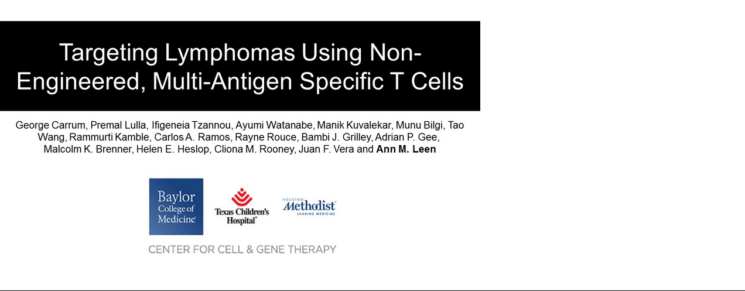

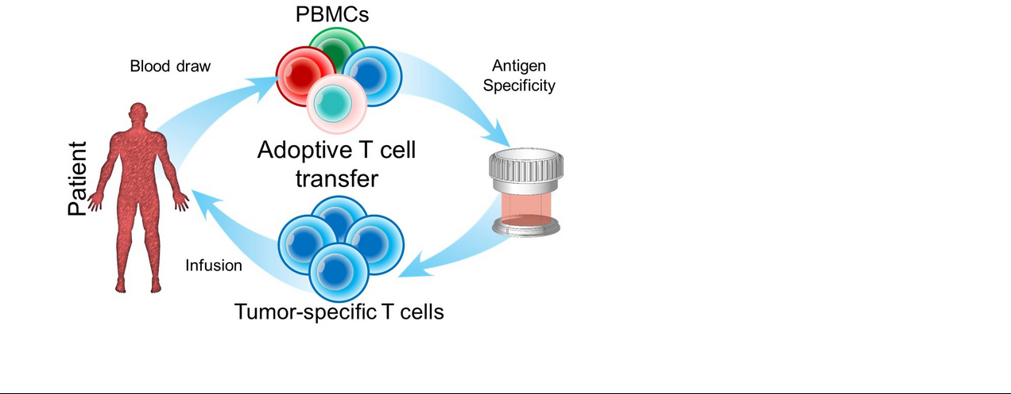

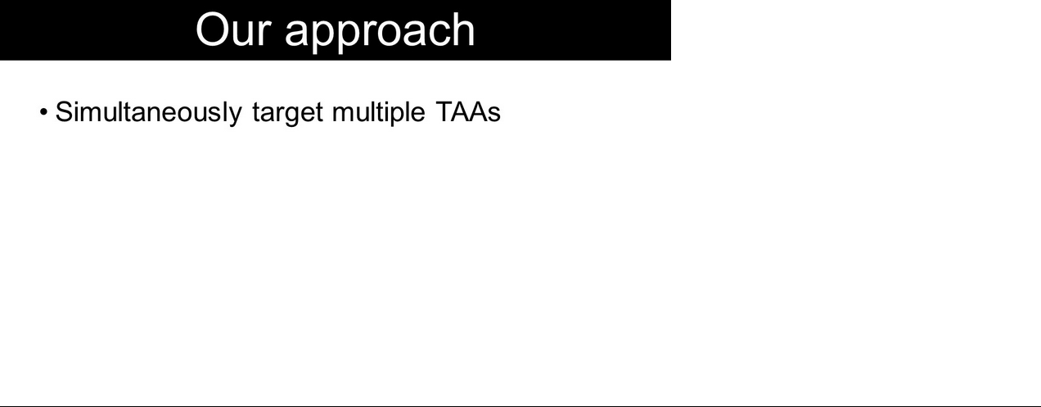

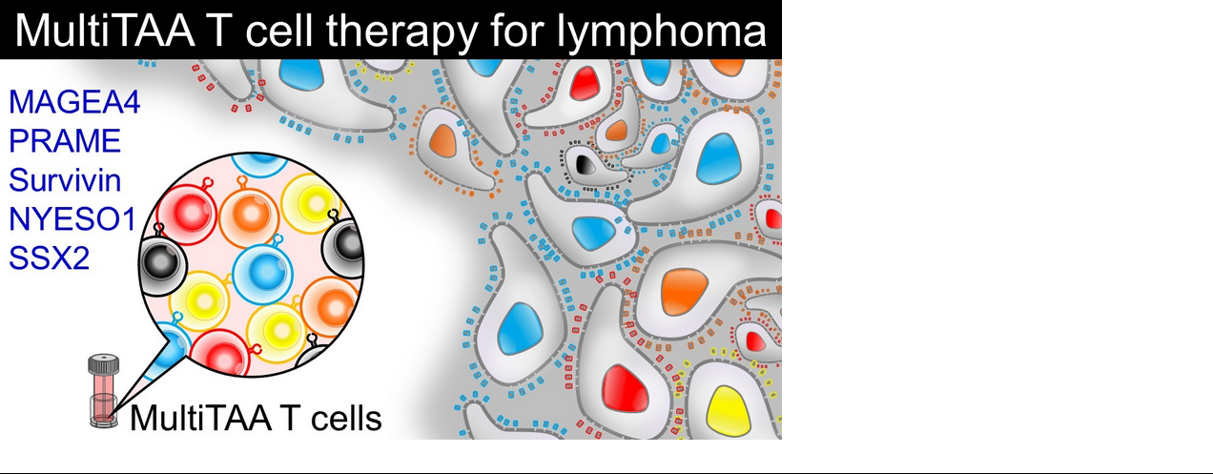

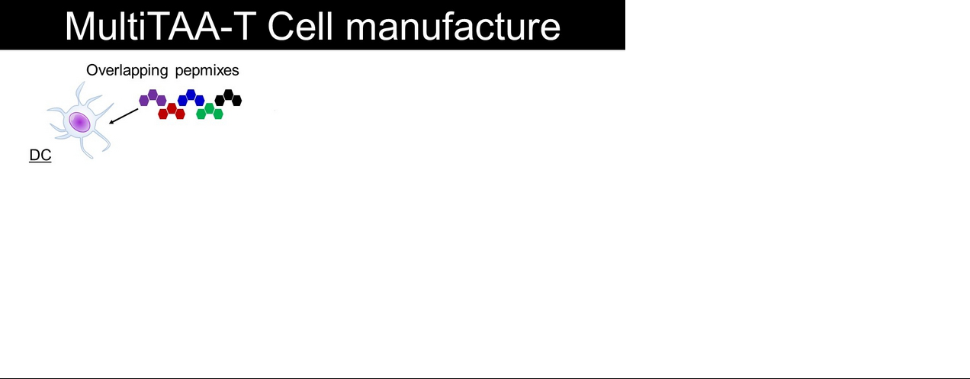

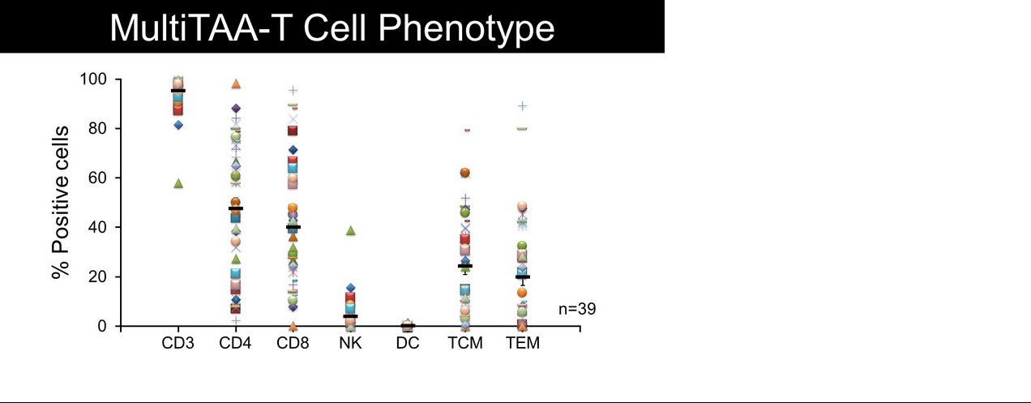

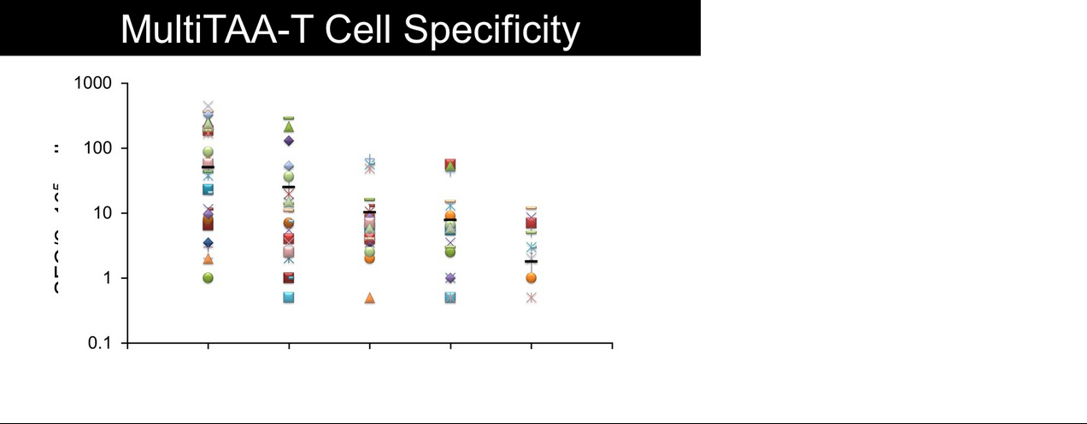

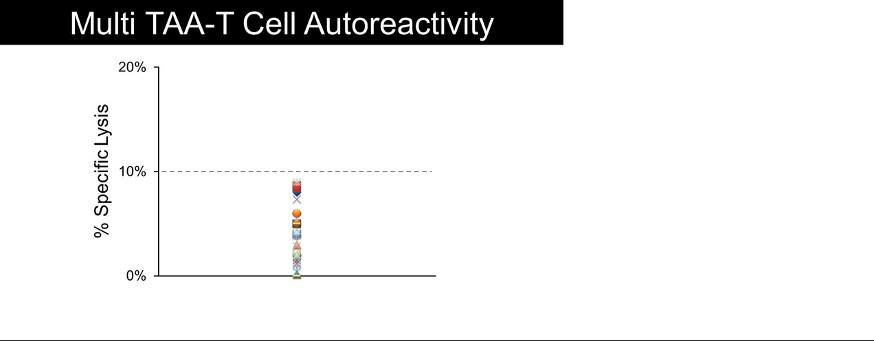

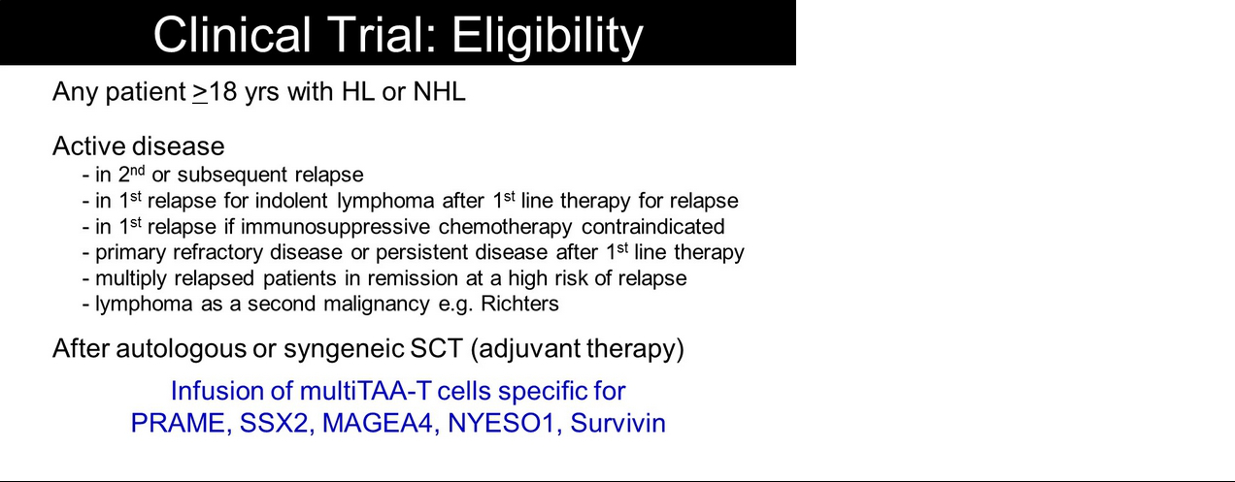

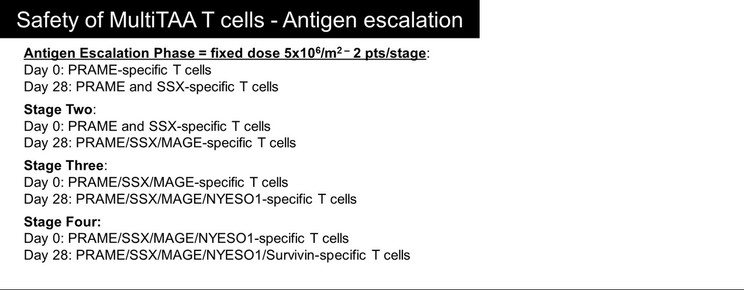

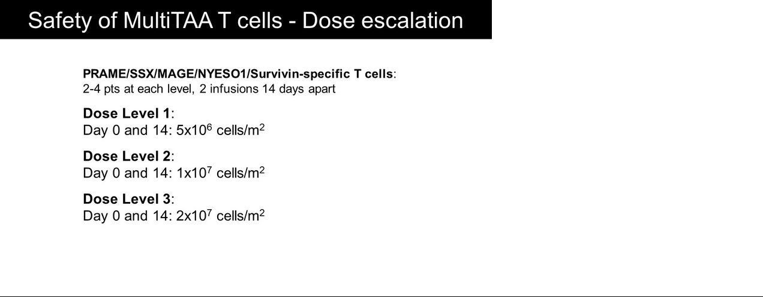

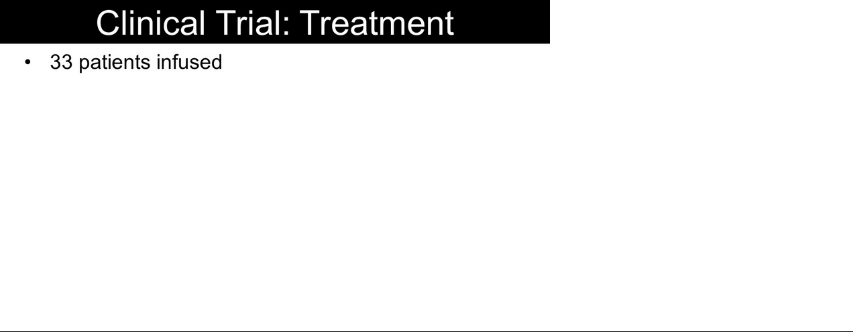

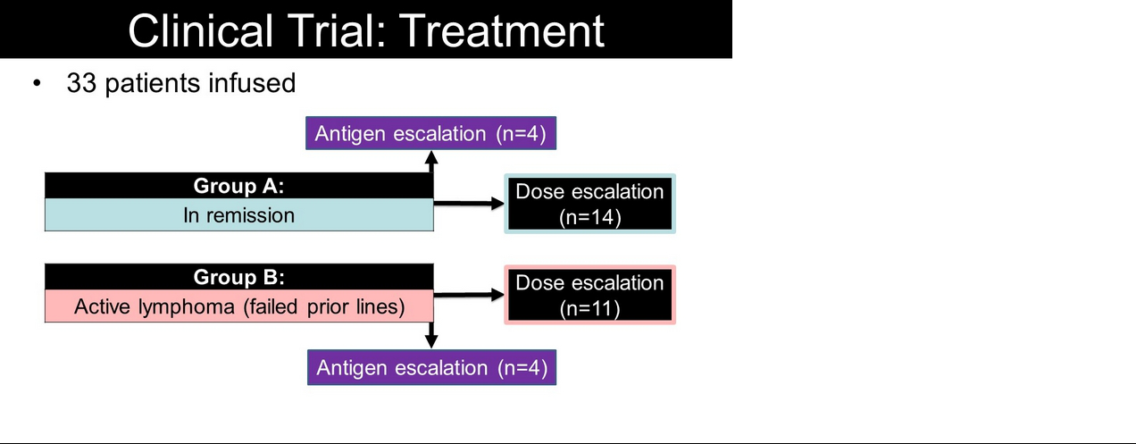

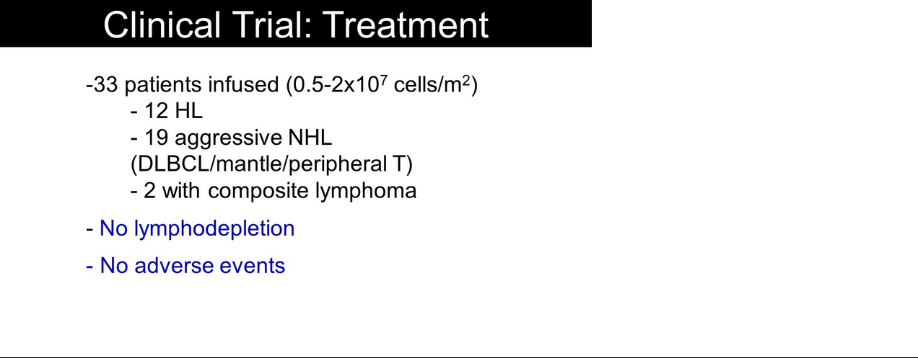

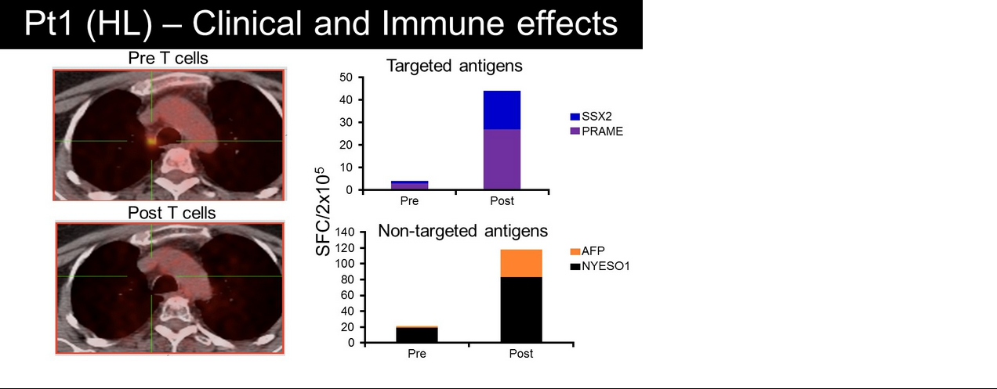

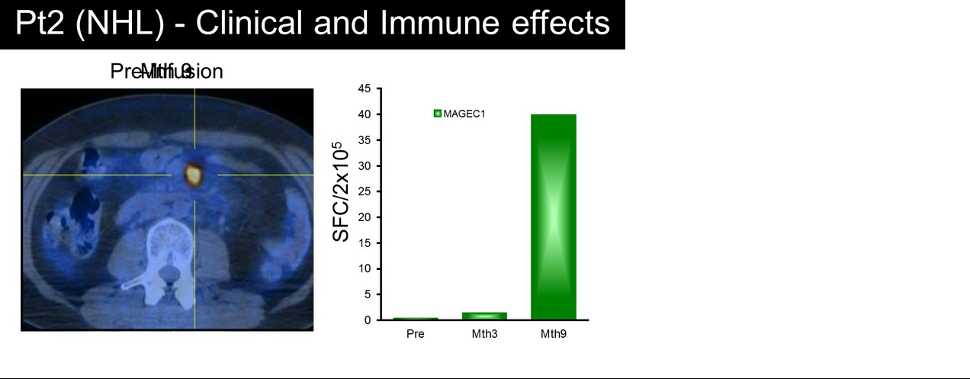

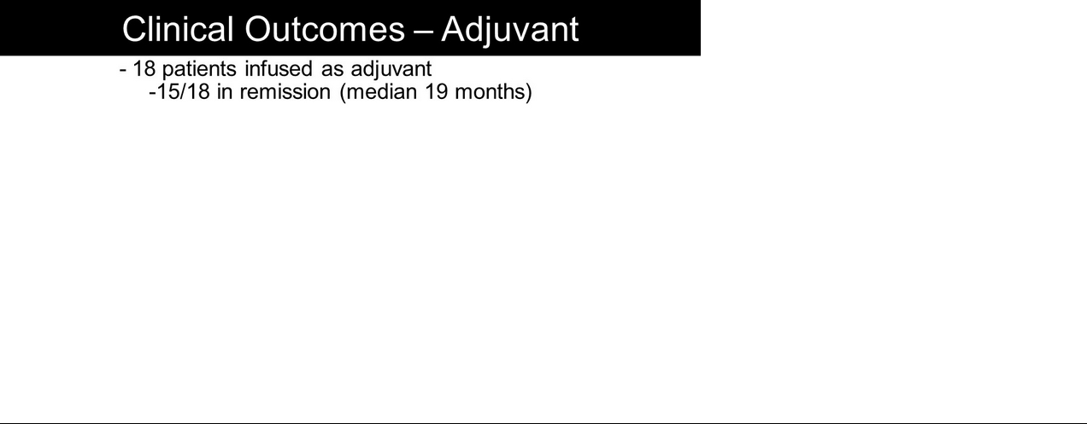

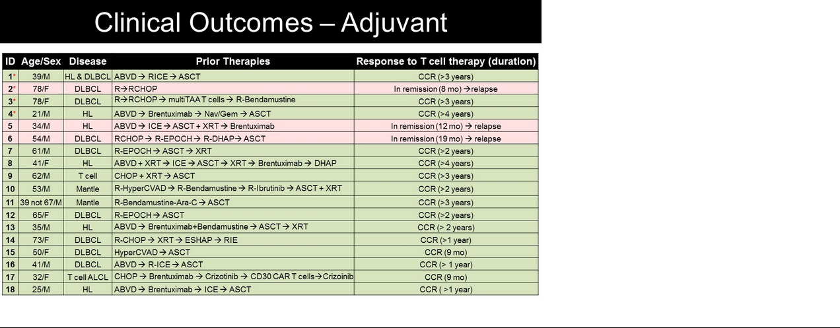

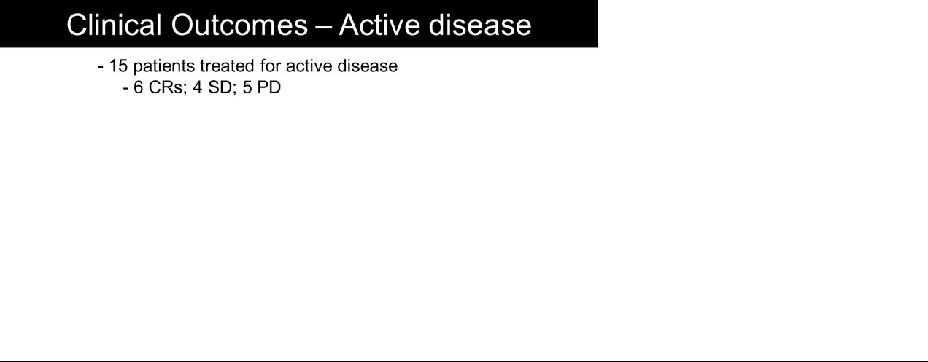

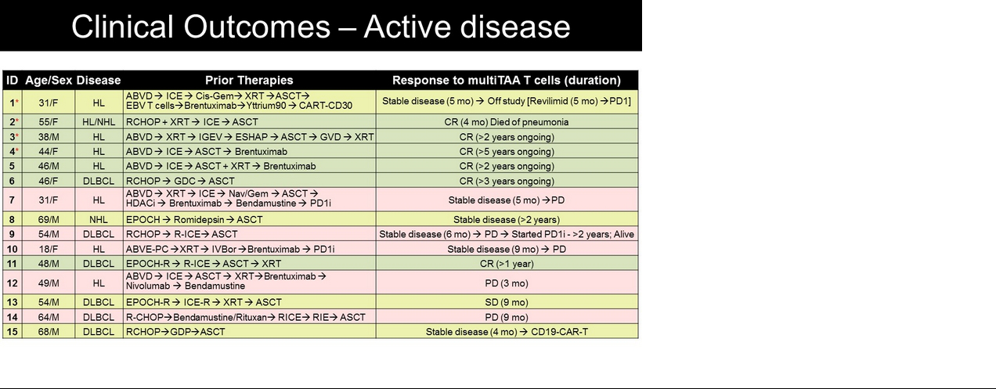

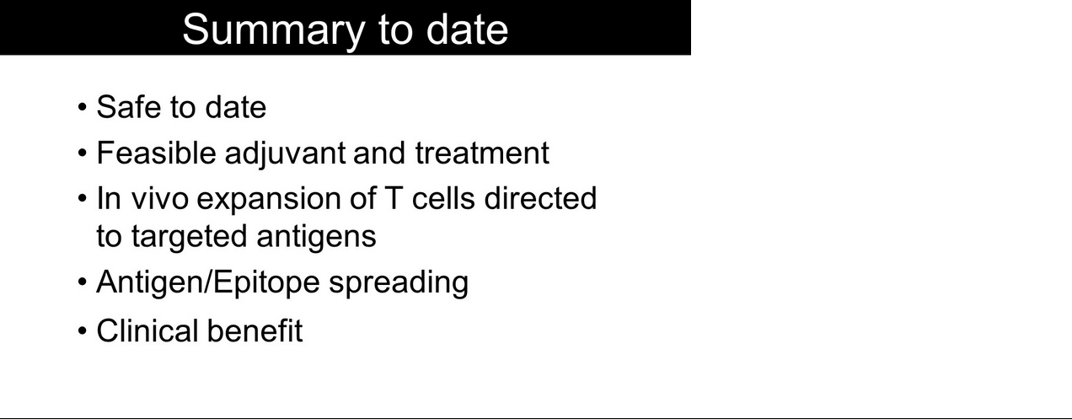

Exhibit 99.3
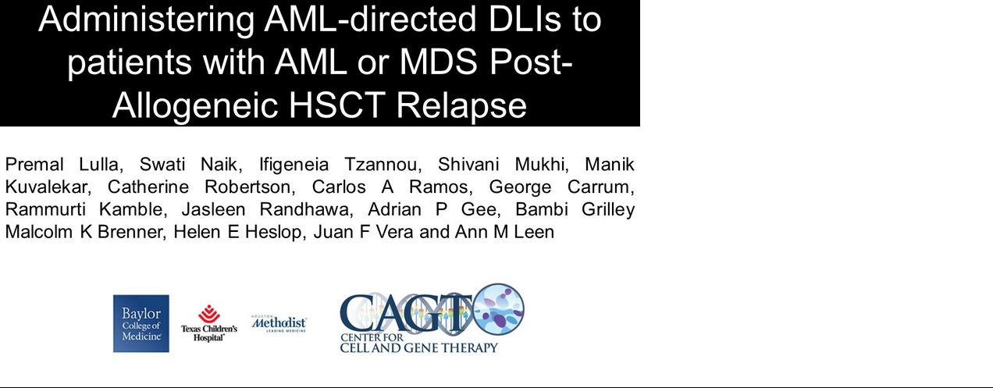

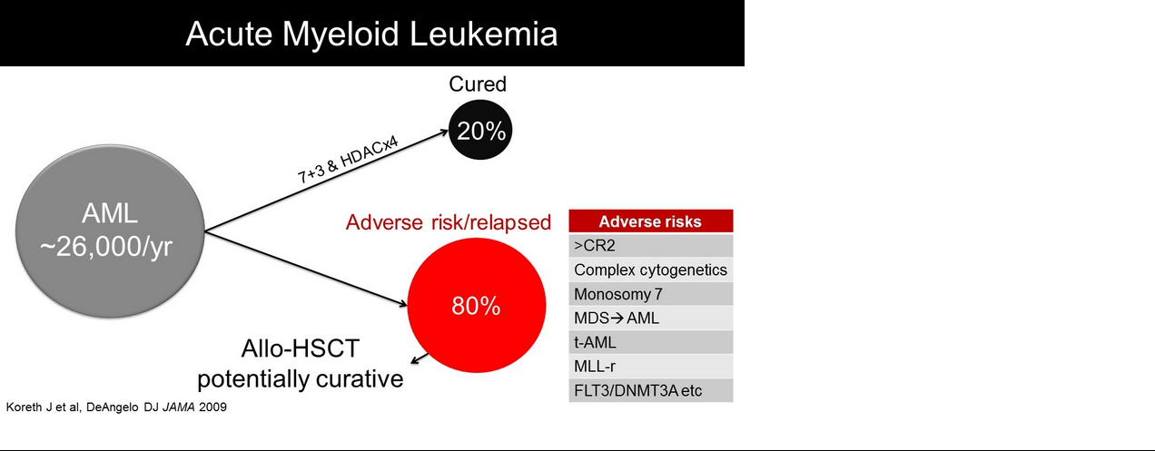

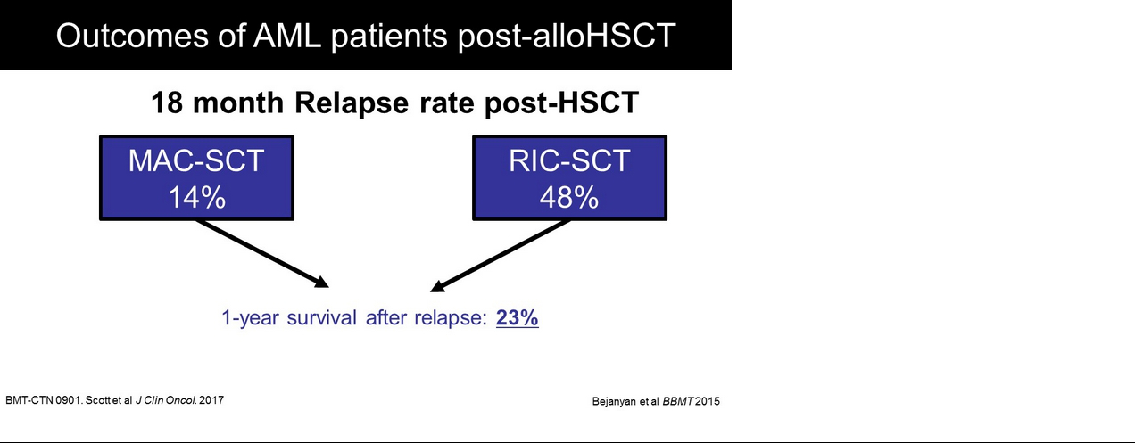

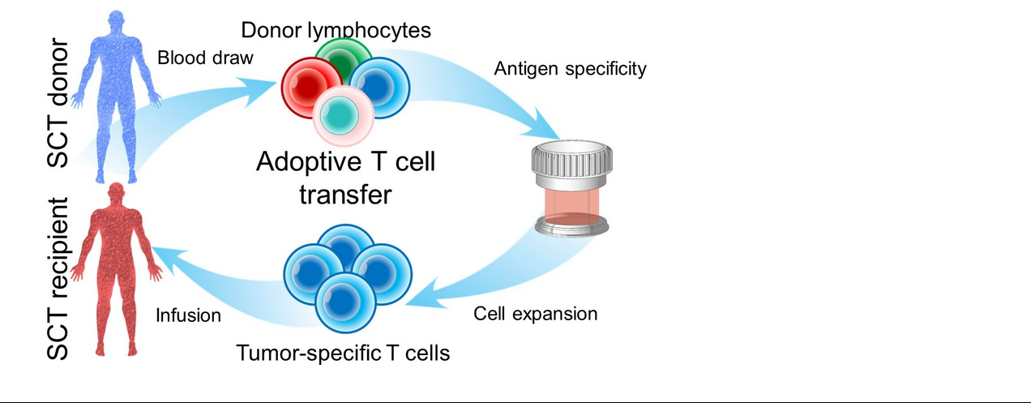

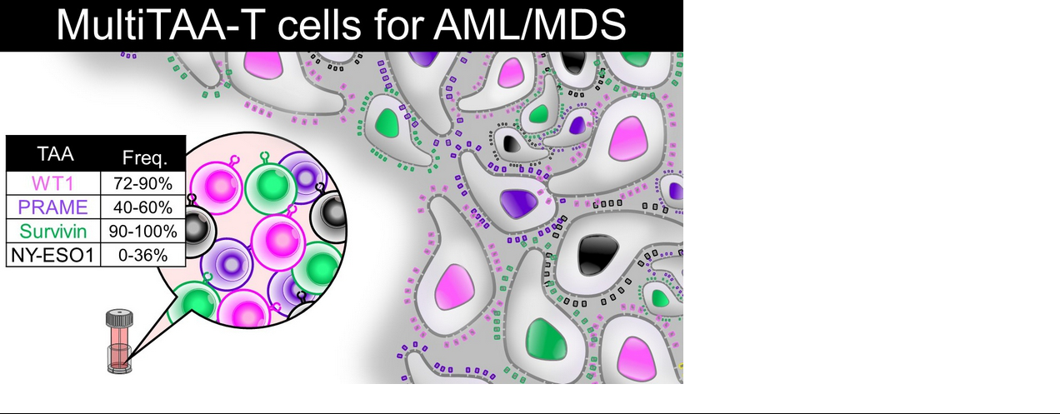

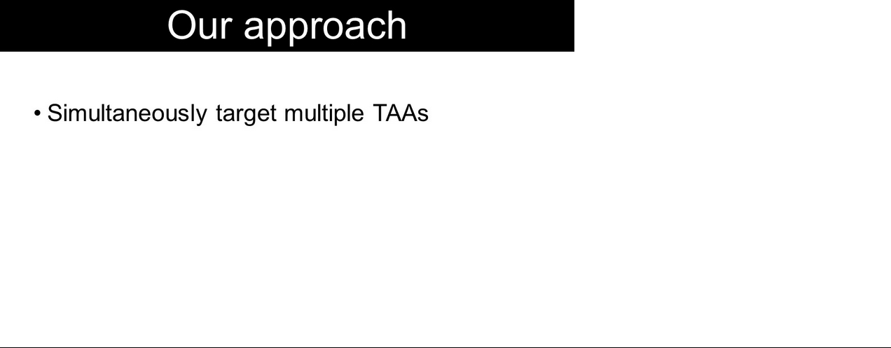

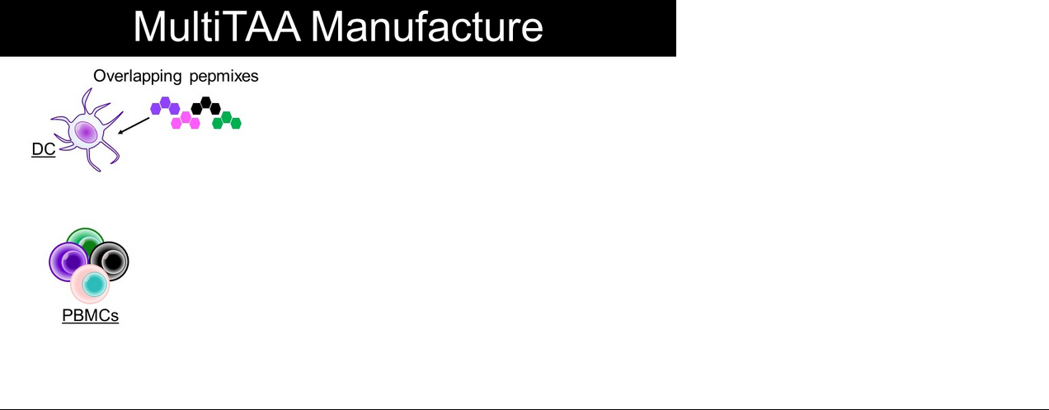

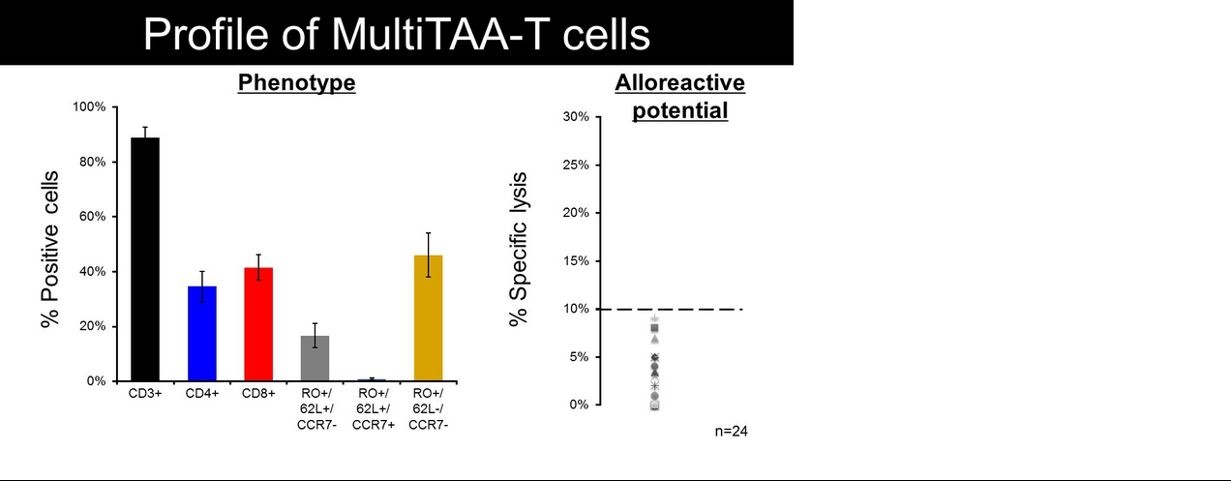

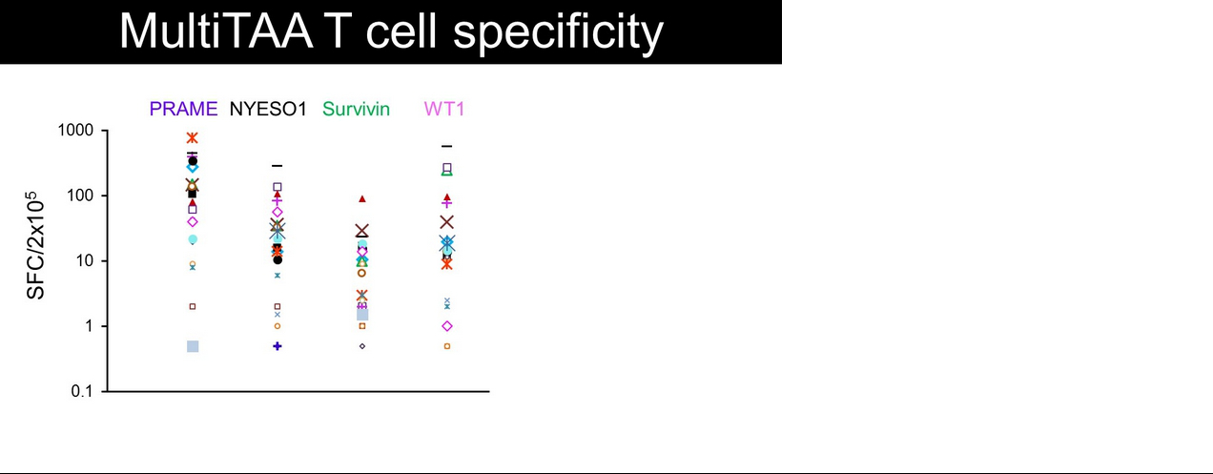

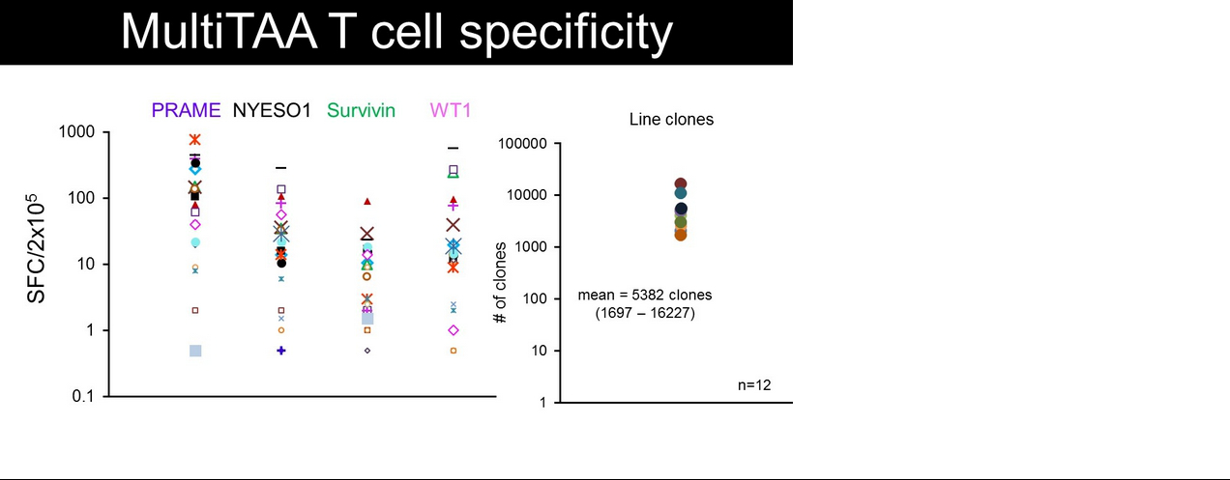

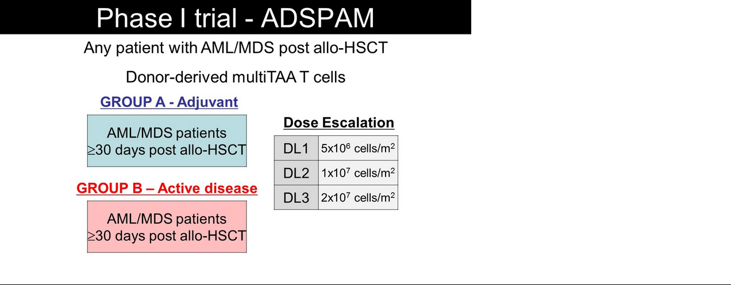

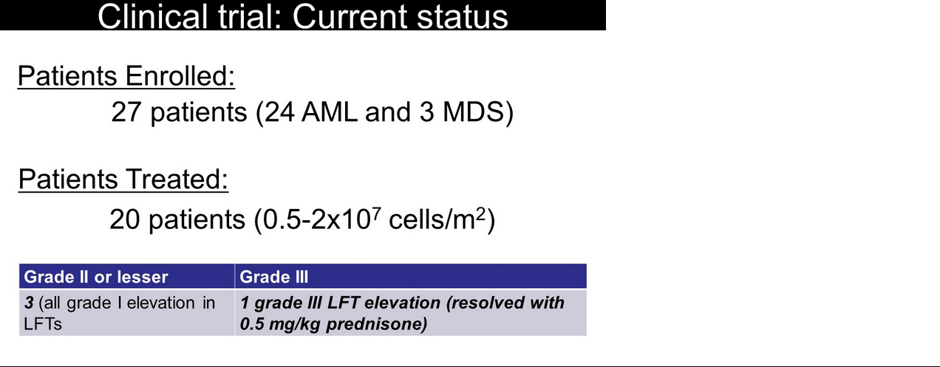

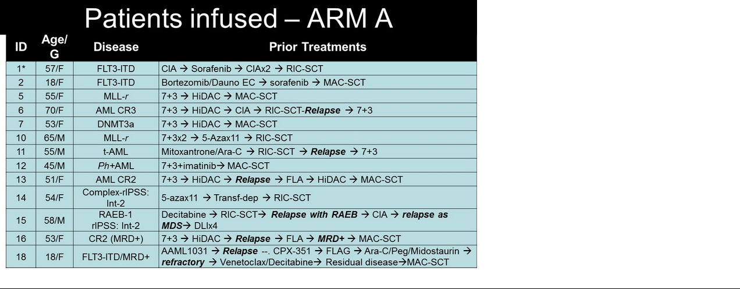

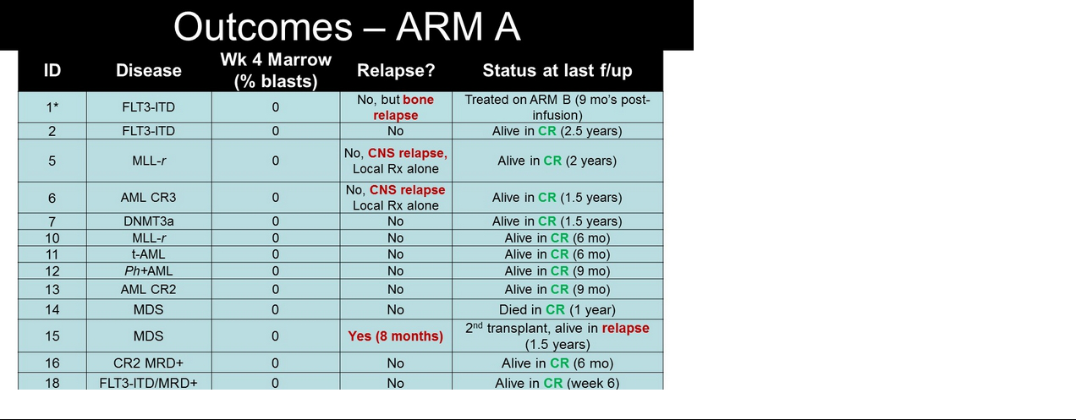

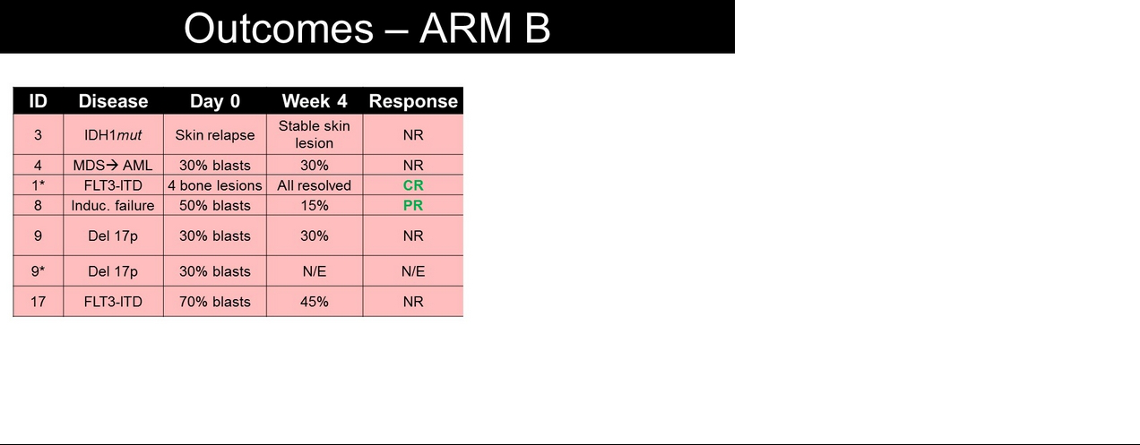

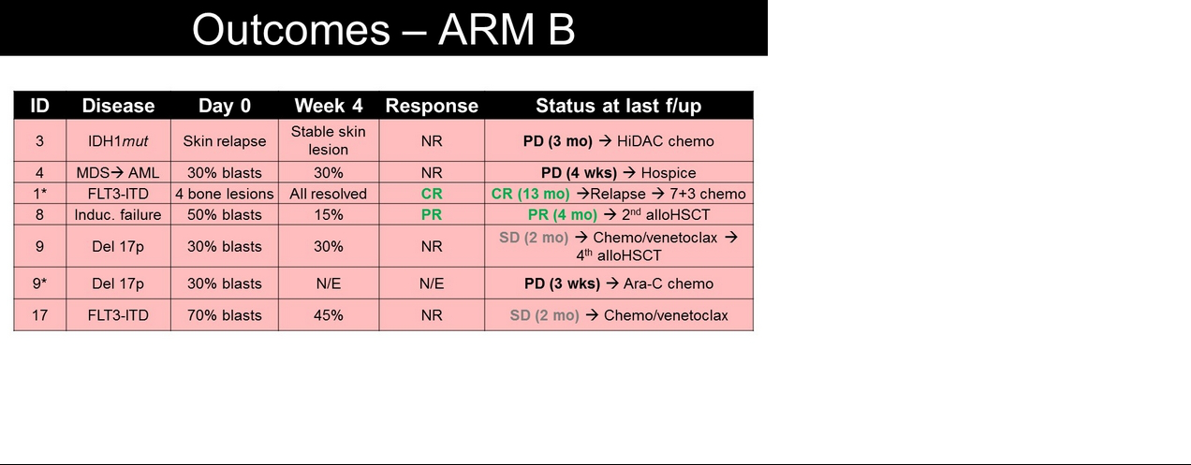

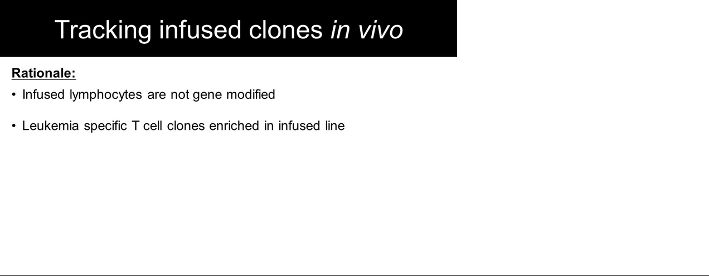

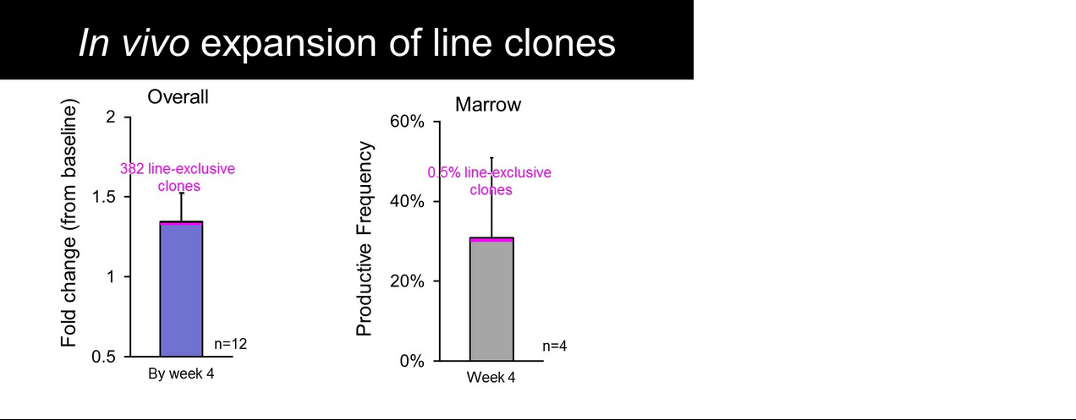

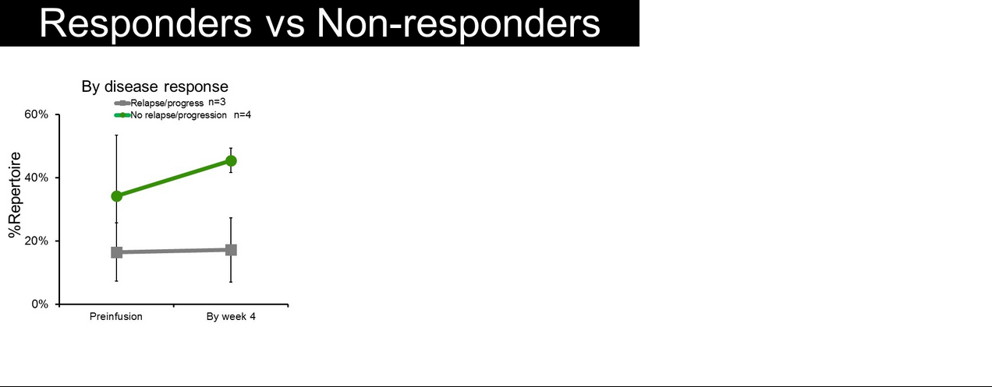

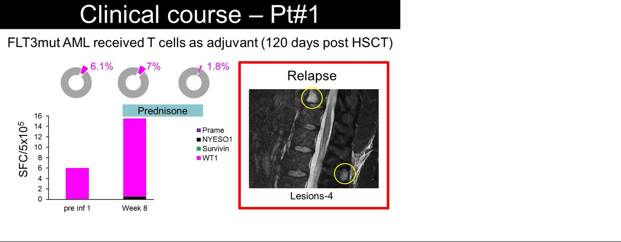

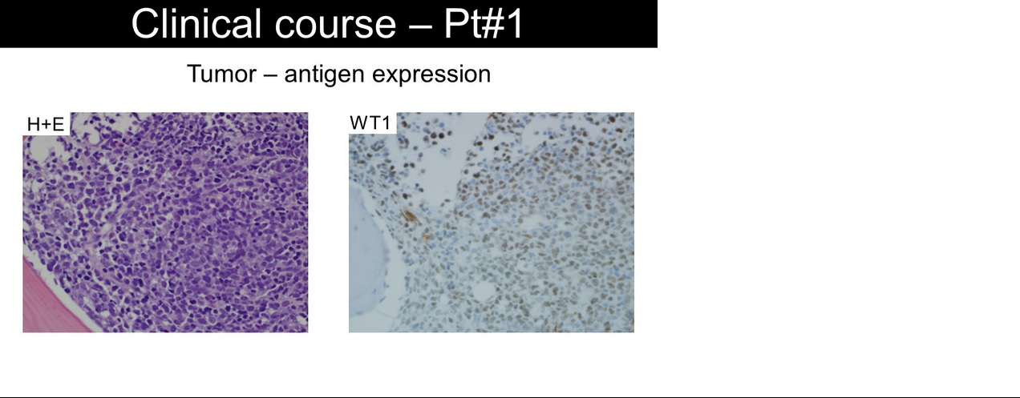

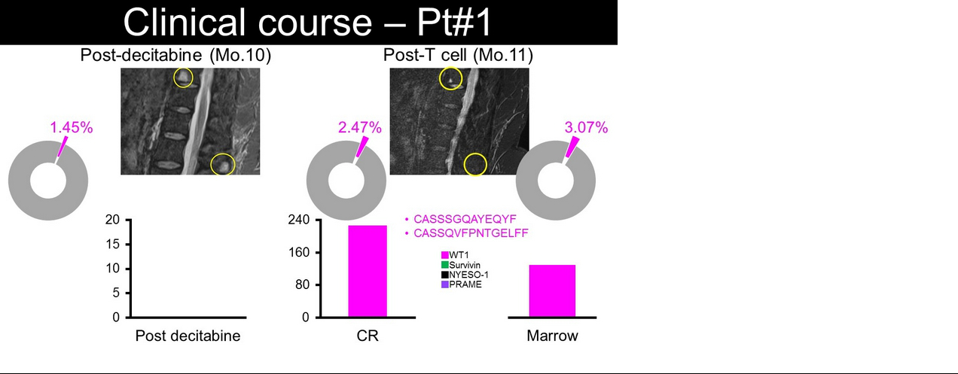

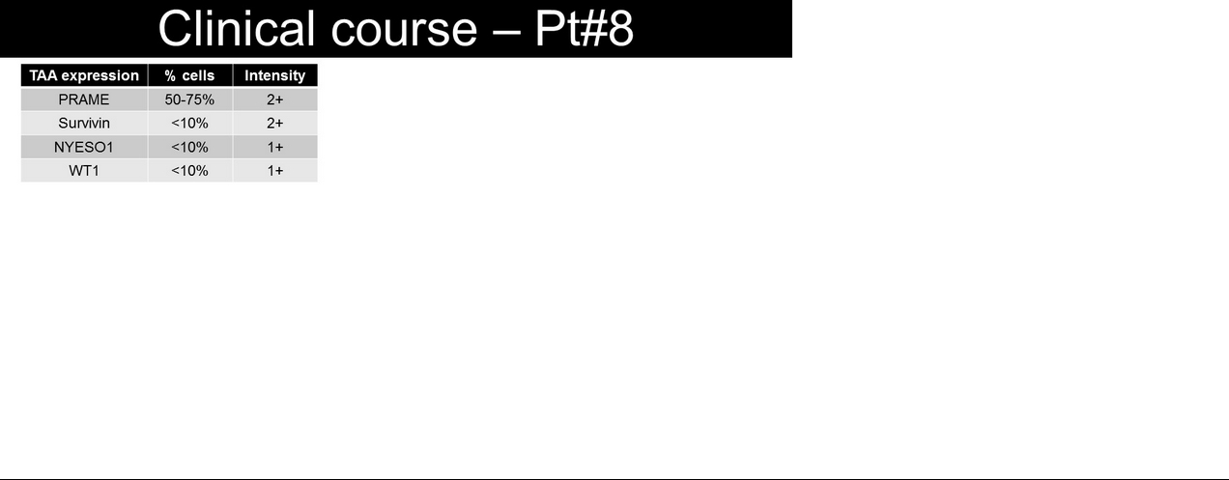

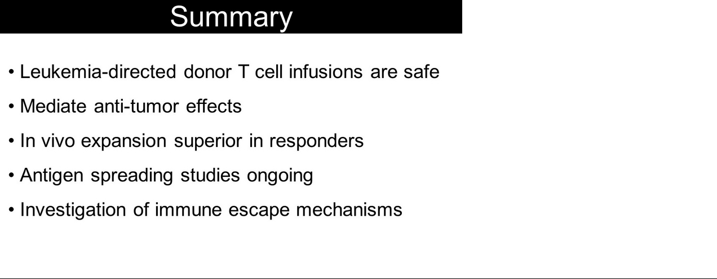

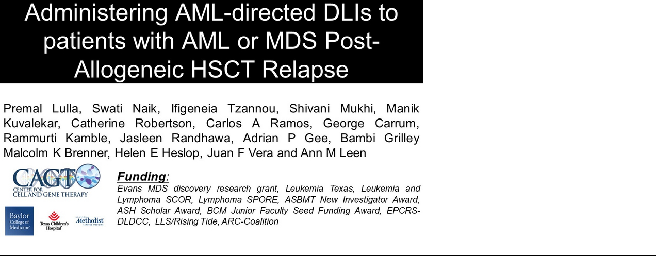

Exhibit 99.4
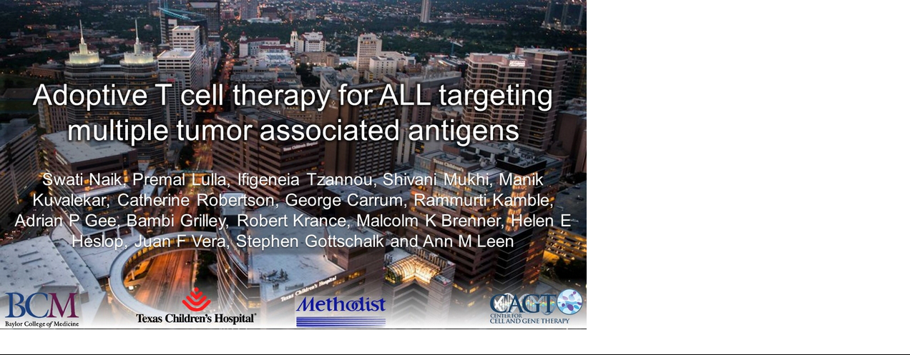

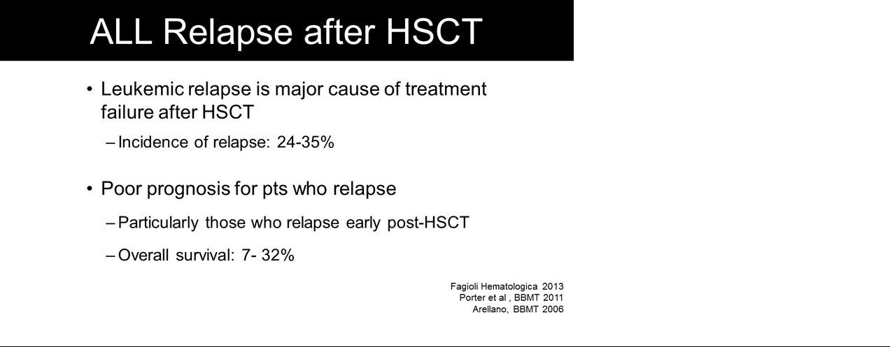

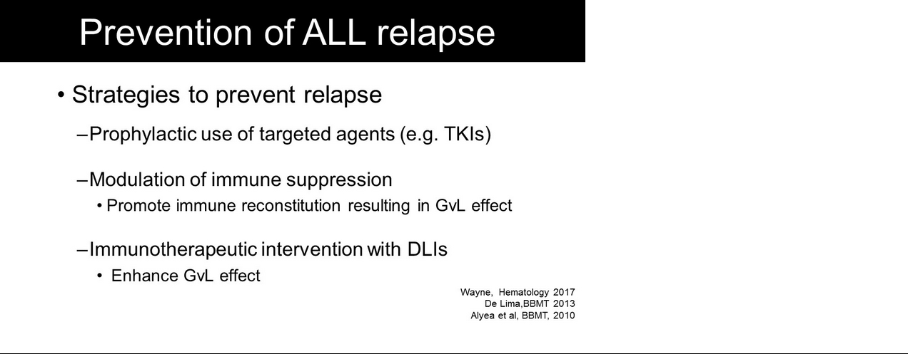

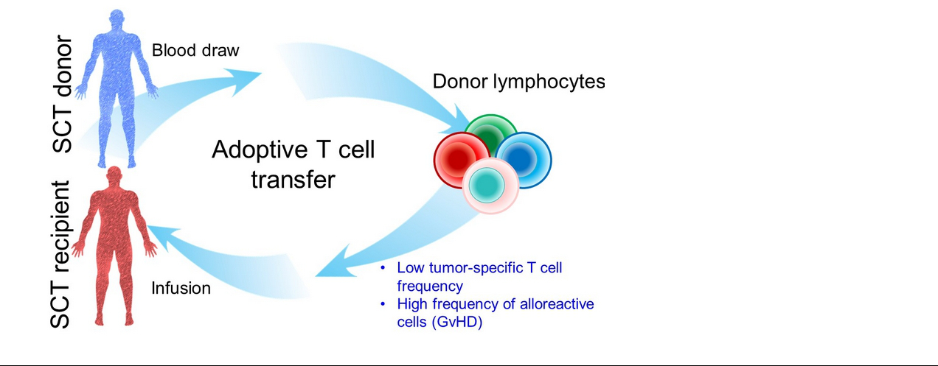

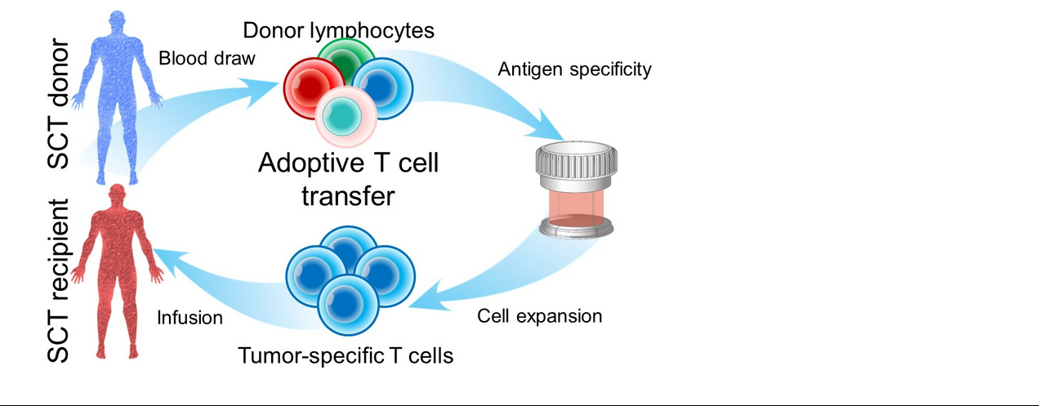

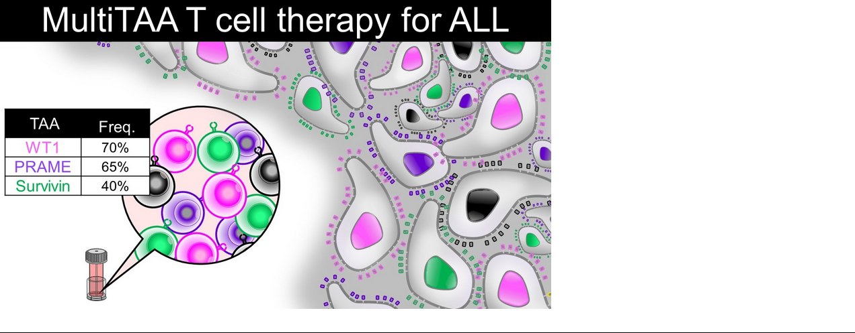

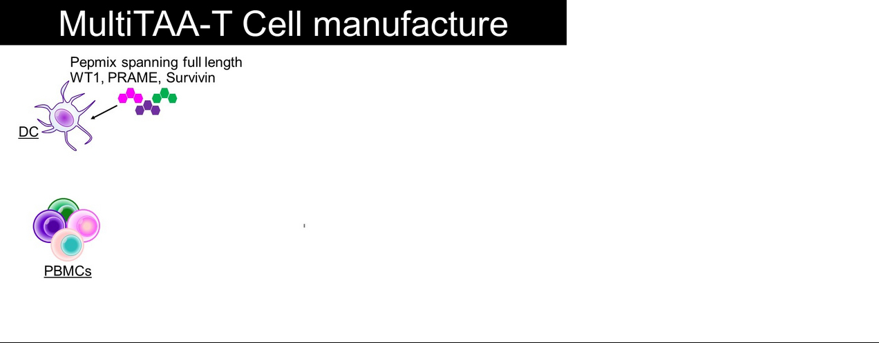

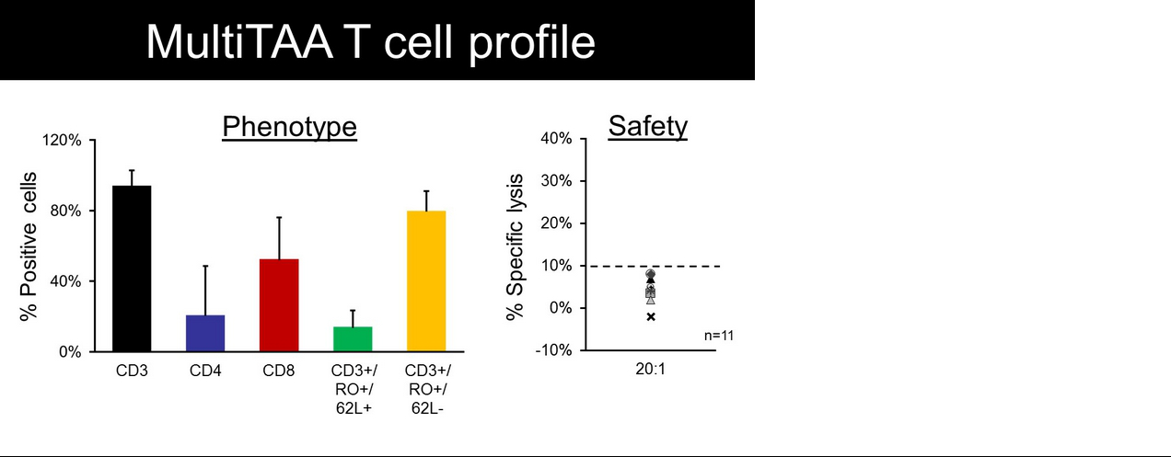

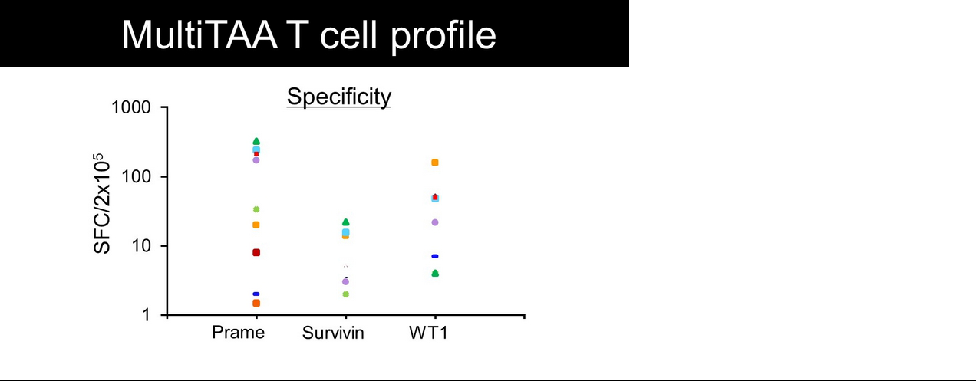

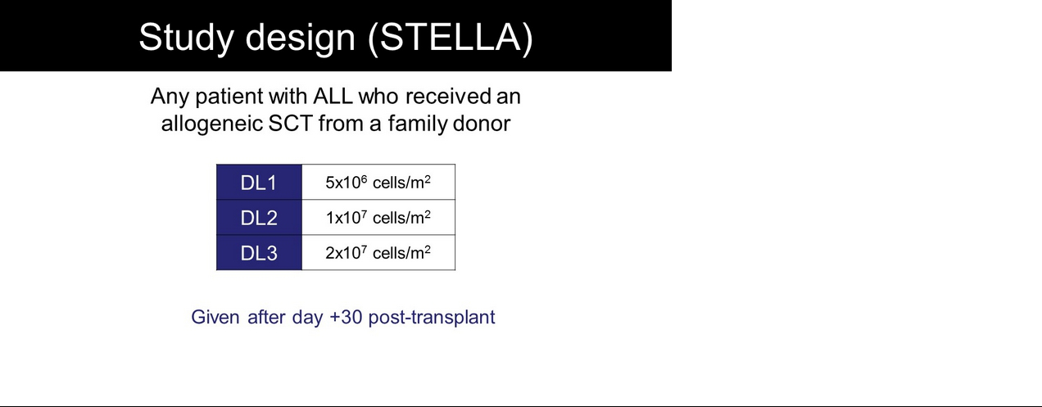

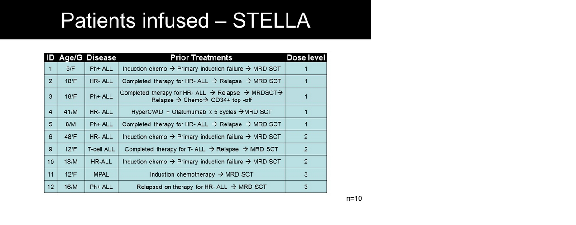

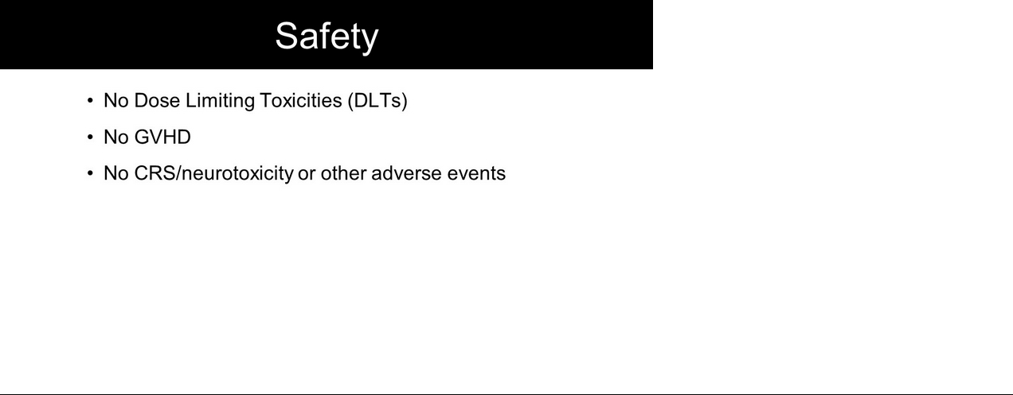

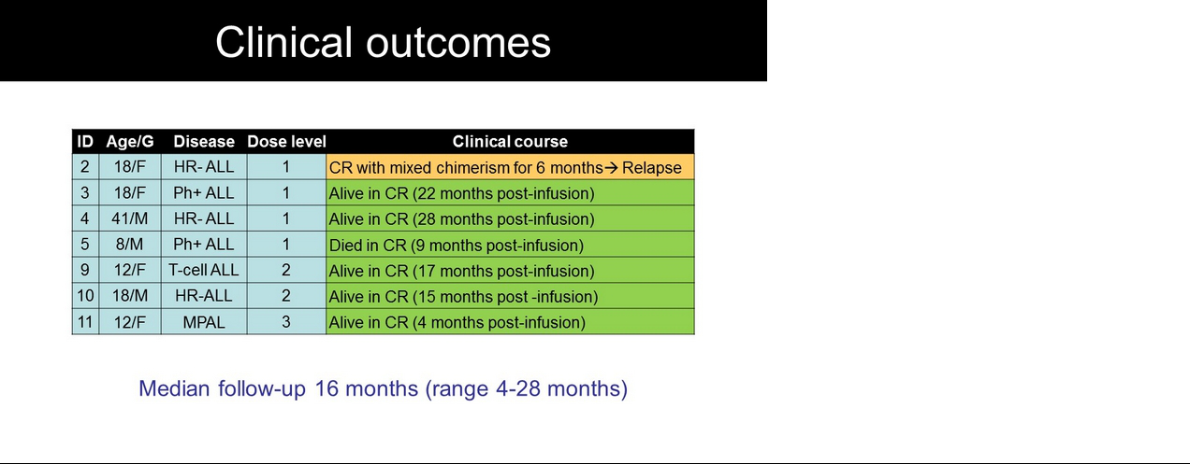

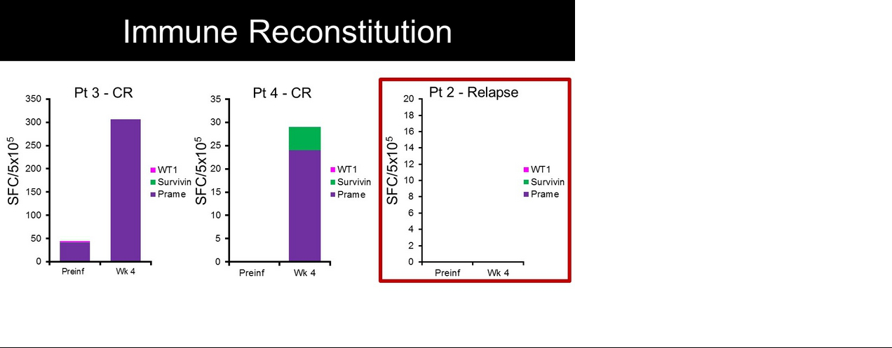

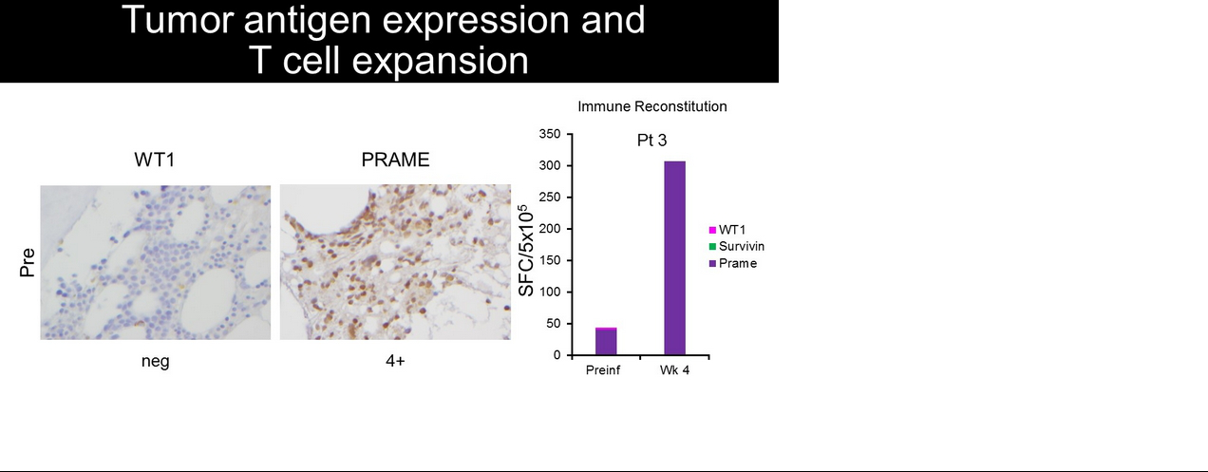

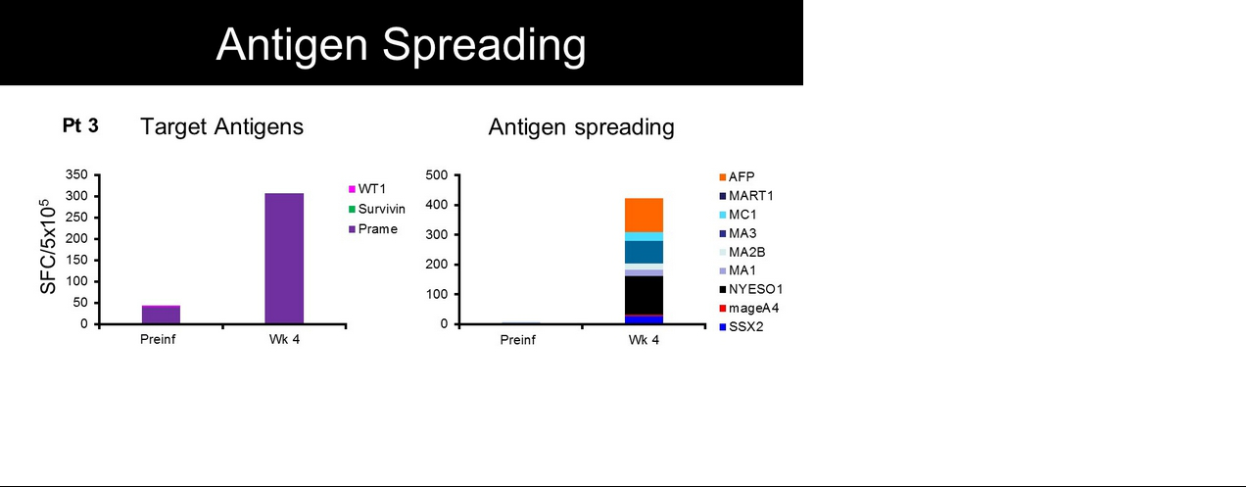

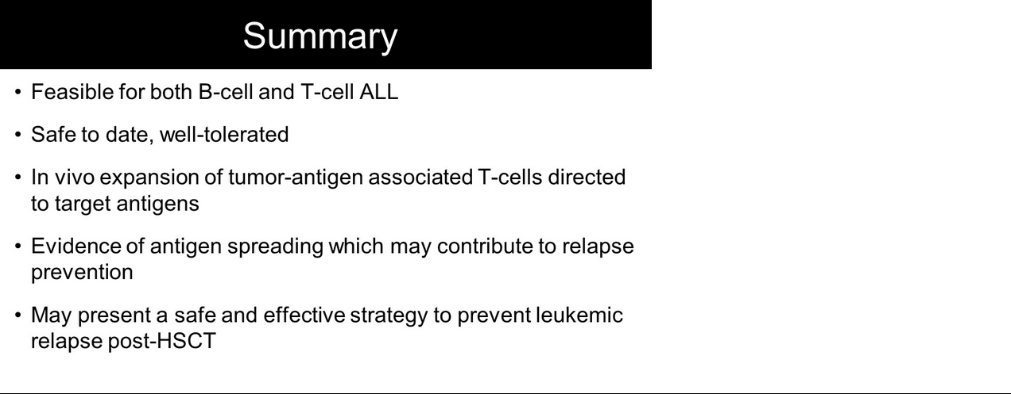

Exhibit 99.5


