SECURITIES AND EXCHANGE COMMISSION
Washington, D.C. 20549

FORM 8-K

CURRENT REPORT
Pursuant to Section 13 or 15(d) of the Securities Exchange Act of 1934

December 1, 2018
Date of Report

MARKER THERAPEUTICS, INC.
(Exact name of registrant as specified in its charter)

Delaware | 001-37939 | 45-4497941
(State or other jurisdiction of incorporation) | (Commission File Number) | (IRS Employer Identification No.)

5 West Forsyth Street  Suite 200  Jacksonville, FL |  | 32202
(Address of principal executive offices) |  | (Zip Code)

(904) 516-5436
Registrant’s telephone number, including area code

N/A
(Former name or former address, if changed since last report)

Check the appropriate box below if the Form 8-K is intended to simultaneously satisfy the filing obligation of the registrant under any of the following provisions:

☐ | Written communications pursuant to Rule 425 under the Securities Act (17 CFR 230.425)
☐ | Soliciting material pursuant to Rule 14a-12 under the Exchange Act (17 CFR 240.14a-12)
☐ | Pre-commencement communications pursuant to Rule 14d-2(b) under the Exchange Act (17 CFR 240.14d-2(b))
☐ | Pre-commencement communications pursuant to Rule 13e-4(c) under the Exchange Act (17 CFR 240.13e-4(c))

Indicate by check mark whether the registrant is an emerging growth company as defined in Rule 405 of the Securities Act of 1933 (§230.405 of this chapter) or Rule 12b-2 of the Securities Exchange Act of 1934 (§240.12b-2 of this chapter). Emerging growth company ☐

If an emerging growth company, indicate by check mark if the registrant has elected not to use the extended transition period for complying with any new or revised financial accounting standards provided pursuant to Section 13(a) of the Exchange Act. ☐

Item 8.01 | Other Events.

As previously announced by the Company, the Center for Cell and Gene Therapy at Baylor College of Medicine presented data from three abstracts at the 60th American Society of Hematology Annual Meeting between December 1-4, 2018. The Company previously issued a press release on the presentation of such dates on November 27, 2018 and the press release was filed as an exhibit to a Form 8-K on the same date. The presentations include: (i) an oral presentation regarding Safety and Efficacy of Multiantigen-Targeted T Cells for Multiple Myeloma by Premal Lulla, M.B.B.S., Assistant Professor of Medicine at the Center for Cell and Gene Therapy, Hematology-Oncology, at the Baylor College of Medicine.; (ii) a poster presentation regarding Targeting Lymphomas Using Non-Engineered, Multi-Antigen Specific T Cells; and (iii) a poster presentation regarding Adoptive T-Cell Therapy for Acute Leukemia Targeting Multiple Tumor Associated Antigens The studies describe results achieved using multi-tumor antigen specific T cells that were developed at the Baylor College of Medicine in the laboratories of Dr. Ann Leen and Dr. Juan Vera, and exclusively licensed to Marker Therapeutics, Inc. Copies of the presentation and posters are attached hereto as Exhibits 99.1, 99.2 and 99.3, respectively. The presentations are available on Marker Therapeutics website at www.markertherapeutics.com under the caption “Recognition.”

The information furnished pursuant to Item 8.01 on this Form 8-K, including Exhibit 99.1, 99.2 and 99.3 attached hereto, shall not be deemed “filed” for purposes of Section 18 of the Securities Exchange Act of 1934, as amended (the “Exchange Act”), or otherwise subject to the liabilities of that section, nor shall it be deemed incorporated by reference into any other filing under the Securities Act or the Exchange Act, except as expressly set forth by specific reference in such a filing.

 | Item 9.01 | Financial Statements and Exhibits.

(d) Exhibits.

Exhibit No. | Description
99.1 | 2018 ASH Conference Presentation- Safety and Efficacy of Multiantigen-Targeted T Cells for Multiple Myeloma.*
99.2 | 2018 ASH Conference Poster Presentation-Targeting Lymphomas Using Non-Engineered, Multi-Antigen Specific T Cells.*
99.3 | 2018 ASH Conference Poster Presentation-Adoptive T-Cell Therapy for Acute Leukemia Targeting Multiple Tumor Associated Antigens.*

*Furnished herewith.

SIGNATURES

In accordance with the requirements of the Exchange Act, the registrant caused this report to be signed on its behalf by the undersigned, thereunto duly authorized on this 3rd day of December, 2018.

MARKER THERAPEUTICS, INC.
(Registrant)
 | BY: | /s/ Michael Loiacono
Michael Loiacono
Chief Accounting Officer

Exhibit 99.1
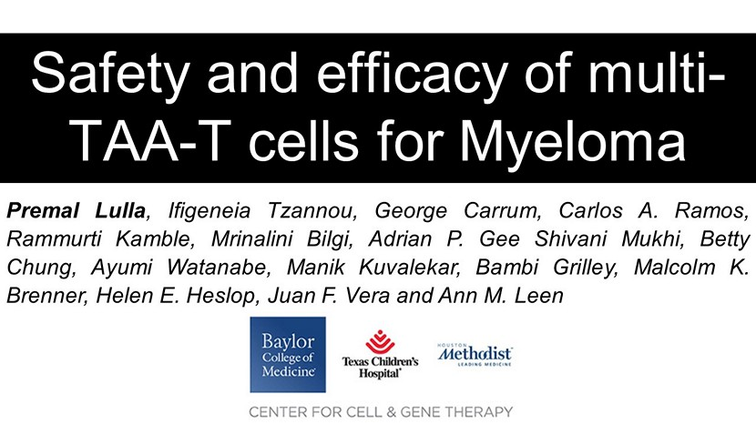
Safety and efficacy of multi - TAA - T cells for Myeloma Premal Lulla , Ifigeneia Tzannou , George Carrum , Carlos A . Ramos, Rammurti Kamble , Mrinalini Bilgi , Adrian P . Gee Shivani Mukhi , Betty Chung, Ayumi Watanabe, Manik Kuvalekar , Bambi Grilley , Malcolm K . Brenner, Helen E . Heslop , Juan F . Vera and Ann M . Leen

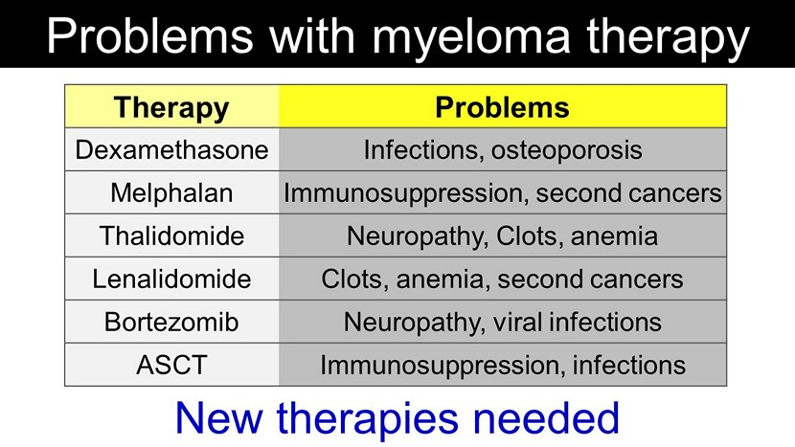
Therapy Problems Dexamethasone Infections, osteoporosis Melphalan Immunosuppression, second cancers Thalidomide Neuropathy , Clots, anemia Lenalidomide Clots, anemia, second cancers Bortezomib Neuropathy, viral infections ASCT Immunosuppression, infections Problems with myeloma therapy New therapies needed

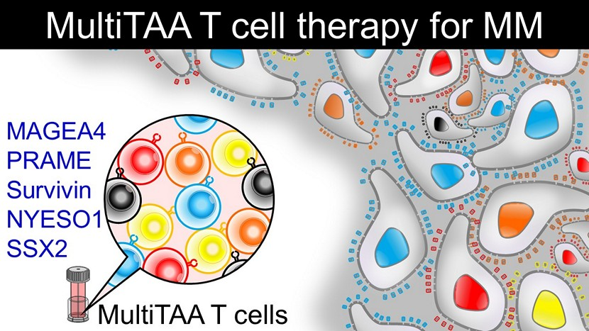
MultiTAA T cells MultiTAA T cell therapy for MM MAGEA4 PRAME Survivin NYESO1 SSX2

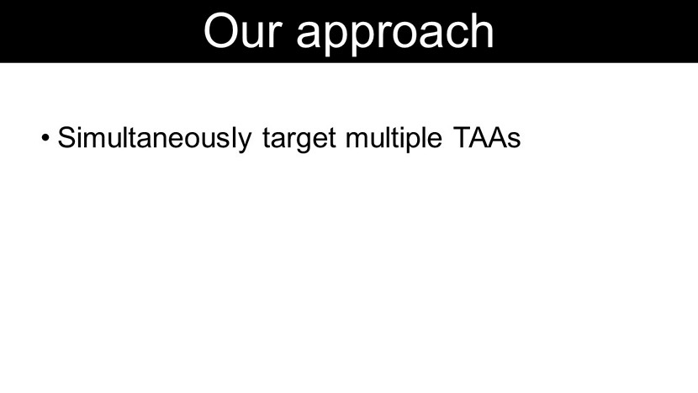
• Simultaneously target multiple TAAs • Target multiple epitopes (CD4 and CD8) within each antigen • T cells with native T cell receptor specificity (non - engineered) Our approach

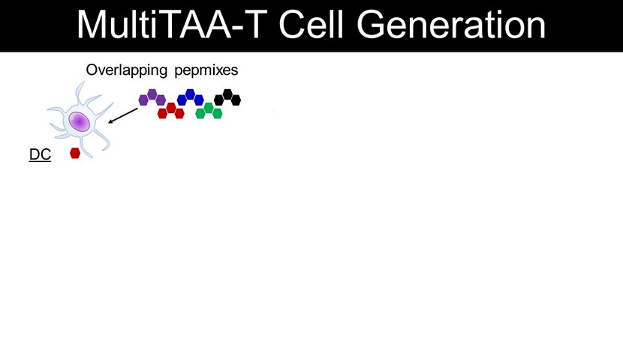
MultiTAA - T Cell Generation Activation DC Overlapping pepmixes PBMCs MultiTAA T cells Expansion

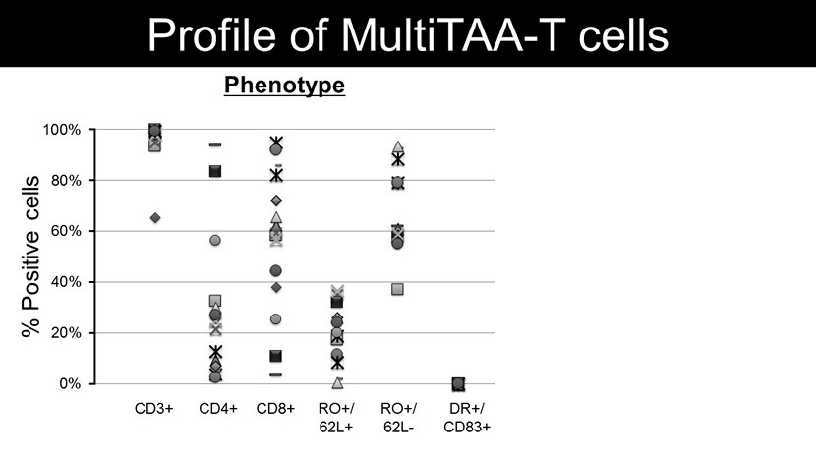
n=20 0% 20% 40% 60% 80% 100% CD3+ CD4+ CD8+ DR+/ CD83+ Profile of MultiTAA - T cells RO+/ 62L+ RO+/ 62L - -10% 0% 10% 20% 30% 40% 50% % Positive cells Phenotype Safety % Specific lysis

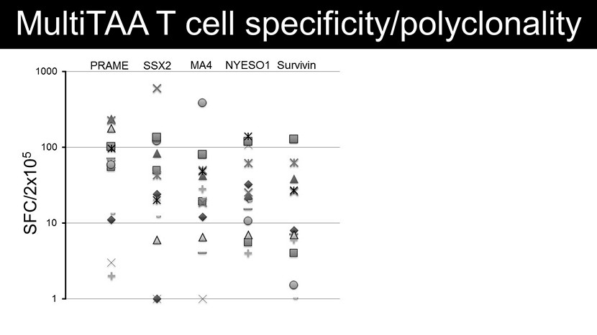
1 10 100 1000 MultiTAA T cell specificity/ polyclonality SFC/2x10 5 PRAME NYESO1 SSX2 MA4 Survivin 1 10 100 1000 10000 100000 # of clones mean = 4,597 clones n=10 Clonal diversity (v  deep sequencing)

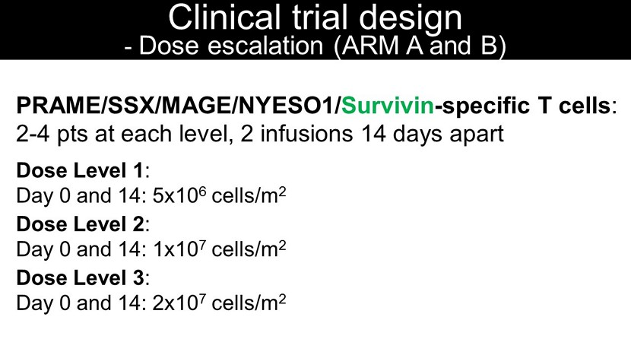
Clinical trial design - Dose escalation (ARM A and B) PRAME/SSX/MAGE/NYESO1/ Survivin - specific T cells : 2 - 4 pts at each level, 2 infusions 14 days apart Dose Level 1 : Day 0 and 14: 5x10 6 cells/m 2 Dose Level 2 : Day 0 and 14: 1x10 7 cells/m 2 Dose Level 3 : Day 0 and 14: 2x10 7 cells/m 2

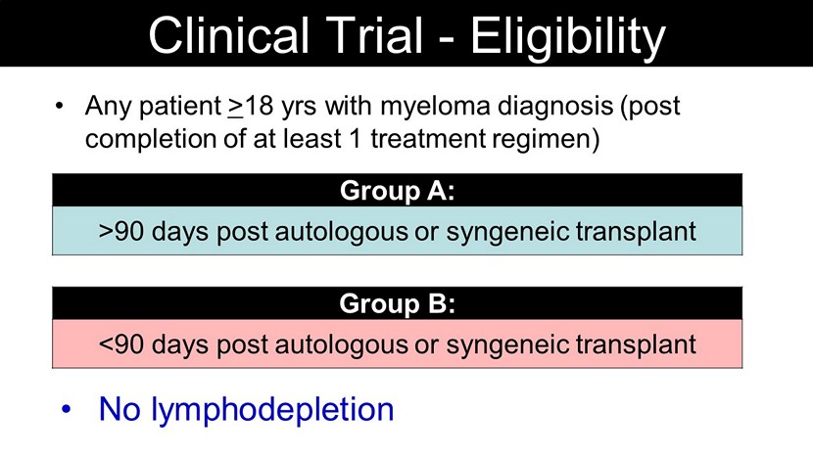
• Any patient > 18 yrs with myeloma diagnosis (post completion of at least 1 treatment regimen) Group A: >90 days post autologous or syngeneic transplant Group B: <90 days post autologous or syngeneic transplant Clinical Trial - Eligibility • No lymphodepletion Group B: <90 days post autologous or syngeneic transplant Group A: >90 days post autologous or syngeneic transplant

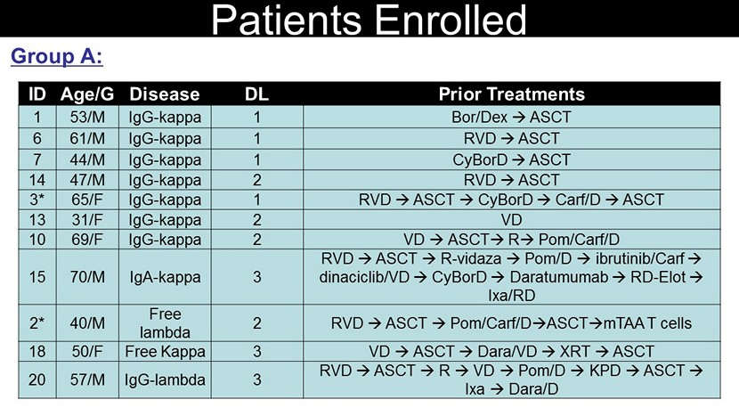
ID Age/G Disease DL Prior Treatments 1 53/M IgG - kappa 1 Bor / Dex → ASCT 6 61/M IgG - kappa 1 RVD → ASCT 7 44/M IgG - kappa 1 CyBorD → ASCT 14 47/M IgG - kappa 2 RVD → ASCT 3* 65/F IgG - kappa 1 RVD → ASCT → CyBorD → Carf /D → ASCT 13 31/F IgG - kappa 2 VD 10 69/F IgG - kappa 2 VD → ASCT → R → Pom / Carf /D 15 70/M IgA - kappa 3 RVD → ASCT → R - vidaza → Pom /D → ibrutinib / Carf → dinaciclib /VD → CyBorD → Daratumumab → RD - Elot → Ixa /RD 2* 40/M Free lambda 2 RVD → ASCT → Pom / Carf / D → ASCT → mTAA T cells 18 50/F Free Kappa 3 VD → ASCT → Dara/VD → XRT → ASCT 20 57/M IgG - lambda 3 RVD → ASCT → R → VD → Pom /D → KPD → ASCT → Ixa → Dara/D Group A: Patients Enrolled

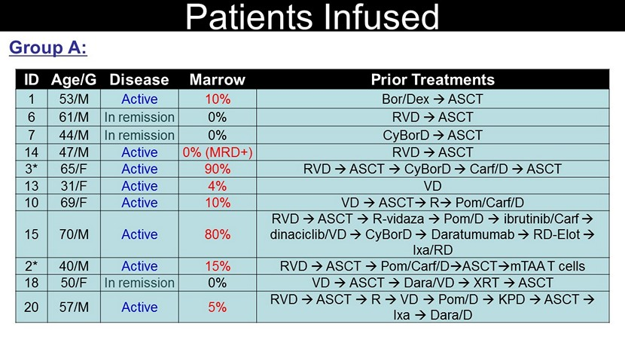
ID Age/G Disease Marrow Prior Treatments 1 53/M Active 10% Bor / Dex → ASCT 6 61/M In remission 0% RVD → ASCT 7 44/M In remission 0% CyBorD → ASCT 14 47/M Active 0% (MRD+) RVD → ASCT 3* 65/F Active 90% RVD → ASCT → CyBorD → Carf /D → ASCT 13 31/F Active 4% VD 10 69/F Active 10% VD → ASCT → R → Pom / Carf /D 15 70/M Active 80% RVD → ASCT → R - vidaza → Pom /D → ibrutinib / Carf → dinaciclib /VD → CyBorD → Daratumumab → RD - Elot → Ixa /RD 2* 40/M Active 15% RVD → ASCT → Pom / Carf / D → ASCT → mTAA T cells 18 50/F In remission 0% VD → ASCT → Dara/VD → XRT → ASCT 20 57/M Active 5% RVD → ASCT → R → VD → Pom /D → KPD → ASCT → Ixa → Dara/D Group A: Patients Infused

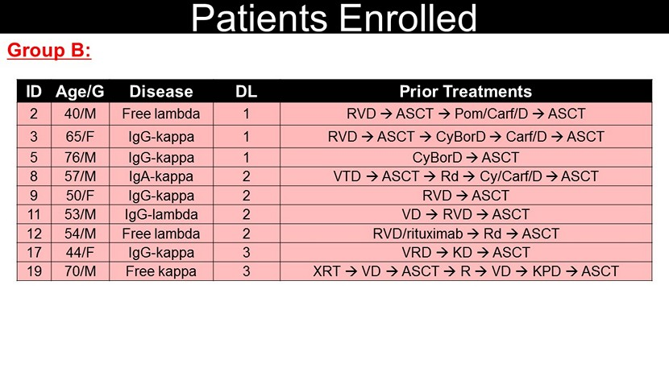
ID Age/G Disease DL Prior Treatments 2 40/M Free lambda 1 RVD → ASCT → Pom / Carf /D → ASCT 3 65/F IgG - kappa 1 RVD → ASCT → CyBorD → Carf /D → ASCT 5 76/M IgG - kappa 1 CyBorD → ASCT 8 57/M IgA - kappa 2 VTD → ASCT → Rd → Cy/ Carf /D → ASCT 9 50/F IgG - kappa 2 RVD → ASCT 11 53/M IgG - lambda 2 VD → RVD → ASCT 12 54/M Free lambda 2 RVD/rituximab → Rd → ASCT 17 44/F IgG - kappa 3 VRD → KD → ASCT 19 70/M Free kappa 3 XRT → VD → ASCT → R → VD → KPD → ASCT Group B: Patients Enrolled

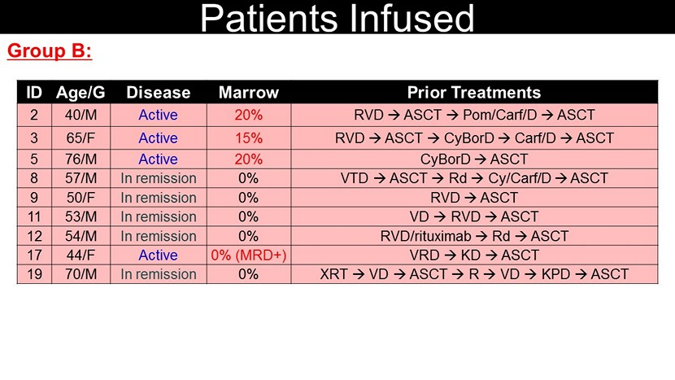
ID Age/G Disease Marrow Prior Treatments 2 40/M Active 20% RVD → ASCT → Pom / Carf /D → ASCT 3 65/F Active 15% RVD → ASCT → CyBorD → Carf /D → ASCT 5 76/M Active 20% CyBorD → ASCT 8 57/M In remission 0% VTD → ASCT → Rd → Cy/ Carf /D → ASCT 9 50/F In remission 0% RVD → ASCT 11 53/M In remission 0% VD → RVD → ASCT 12 54/M In remission 0% RVD/rituximab → Rd → ASCT 17 44/F Active 0% (MRD+) VRD → KD → ASCT 19 70/M In remission 0% XRT → VD → ASCT → R → VD → KPD → ASCT Group B: Patients Infused

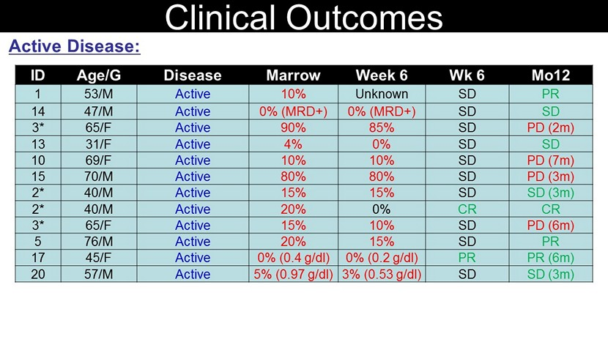
Active Disease: Clinical Outcomes ID Age/G Disease Marrow Week 6 Wk 6 Mo12 1 53/M Active 10% Unknown SD PR 14 47/M Active 0% (MRD+) 0% (MRD+) SD SD 3* 65/F Active 90% 85% SD PD (2m) 13 31/F Active 4% 0% SD SD 10 69/F Active 10% 10% SD PD (7m) 15 70/M Active 80% 80% SD PD (3m) 2* 40/M Active 15% 15% SD SD (3m) 2* 40/M Active 20% 0% CR CR 3* 65/F Active 15% 10% SD PD (6m) 5 76/M Active 20% 15% SD PR 17 45/F Active 0% (0.4 g/dl) 0% (0.2 g/dl) PR PR (6m) 20 57/M Active 5% (0.97 g/dl) 3% (0.53 g/dl) SD SD (3m)

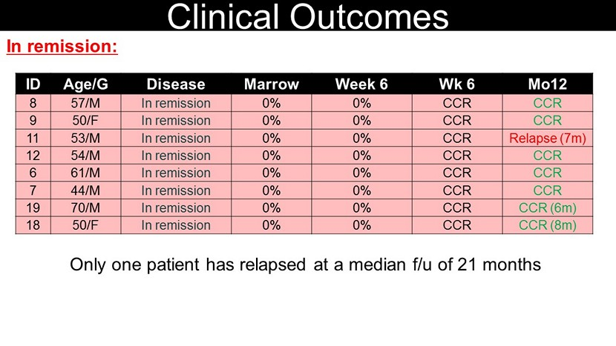
In remission: Clinical Outcomes Only one patient has relapsed at a median f/u of 21 months ID Age/G Disease Marrow Week 6 Wk 6 Mo12 8 57/M In remission 0% 0% CCR CCR 9 50/F In remission 0% 0% CCR CCR 11 53/M In remission 0% 0% CCR Relapse (7m) 12 54/M In remission 0% 0% CCR CCR 6 61/M In remission 0% 0% CCR CCR 7 44/M In remission 0% 0% CCR CCR 19 70/M In remission 0% 0% CCR CCR (6m) 18 50/F In remission 0% 0% CCR CCR (8m)

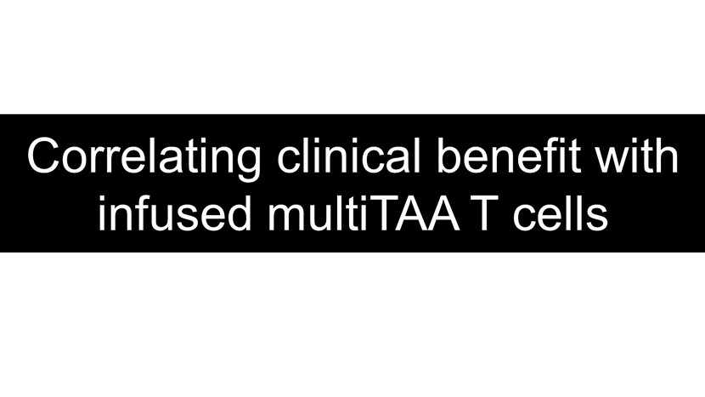
Correlating clinical benefit with infused multiTAA T cells

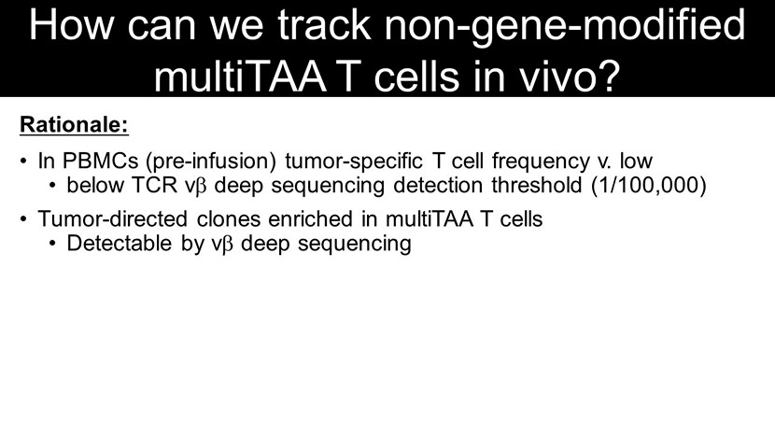
How can we track non - gene - modified multiTAA T cells in vivo? Rationale: • In PBMCs (pre - infusion) tumor - specific T cell frequency v. low • below TCR v  deep sequencing detection threshold (1/100,000) • Tumor - directed clones enriched in multiTAA T cells • Detectable by v  deep sequencing Approach: • Deep sequencing of pre - infusion PBMCs and multiTAA T cells • Identify v  sequences unique to the line infused • Enable in vivo tracking

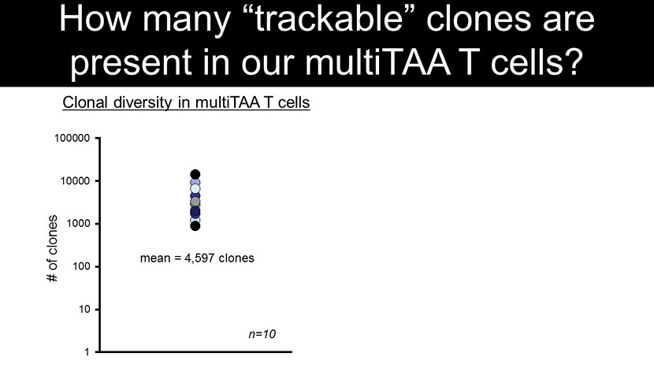
How many “trackable” clones are present in our multiTAA T cells? 0 20 40 60 80 100 % unique clones 1 10 100 1000 10000 100000 # of clones mean = 4,597 clones n=10 Clonal diversity in multiTAA T cells Unique clones 59% 95% Avg = 80% Pt#2

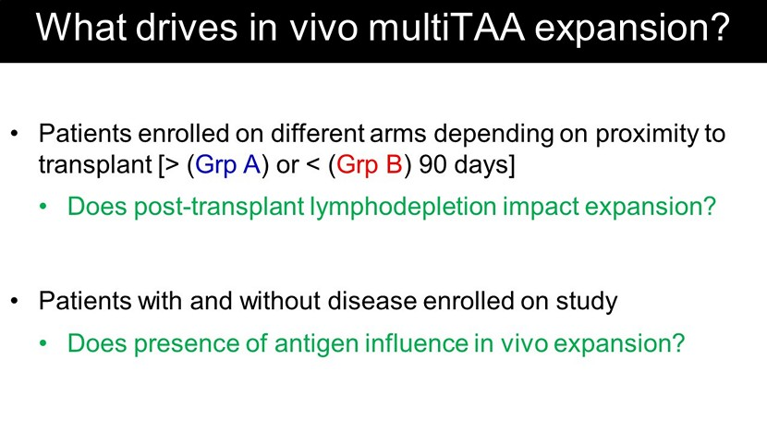
• Patients enrolled on different arms depending on proximity to transplant [> ( Grp A ) or < ( Grp B ) 90 days] • Does post - transplant lymphodepletion impact expansion? What drives in vivo multiTAA expansion? • Patients with and without disease enrolled on study • Does presence of antigen influence in vivo expansion?

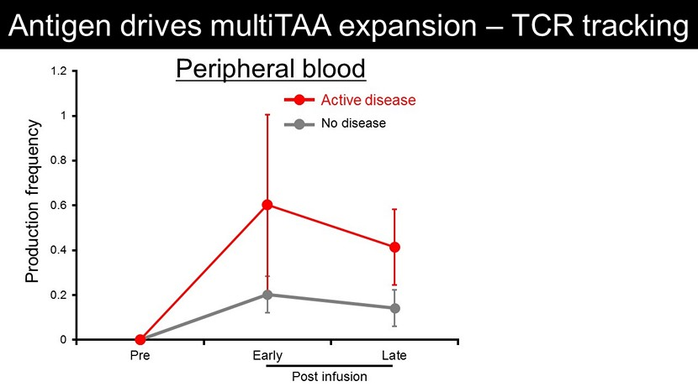
0 0.2 0.4 0.6 0.8 1 1.2 Pre Early Late Antigen drives multiTAA expansion – TCR tracking 0 0.2 0.4 0.6 0.8 1 1.2 1 Production frequency Peripheral blood Marrow Post infusion Production frequency Post infusion Active disease No disease

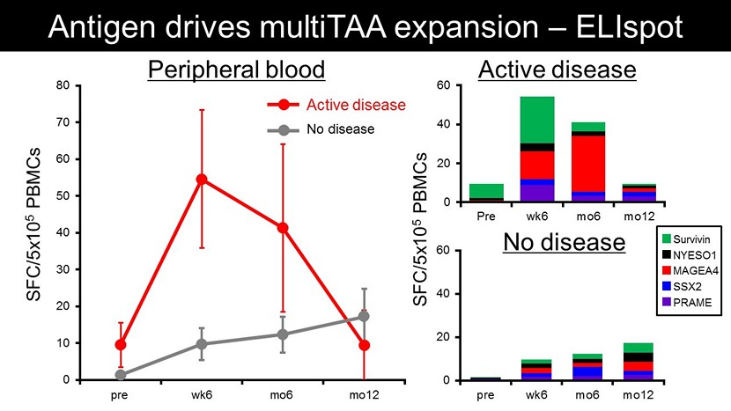
0 10 20 30 40 50 60 70 80 Preinf Week 6 Mo 6 Mo 12 Antigen drives multiTAA expansion – ELIspot Active disease No disease SFC/5x10 5 PBMCs Peripheral blood pre wk6 mo6 mo12 0 20 40 60 Pre wk6 mo6 mo12 0 20 40 60 pre wk6 mo6 mo12 Active disease No disease Survivin NYESO1 MAGEA4 SSX2 PRAME SFC/5x10 5 PBMCs

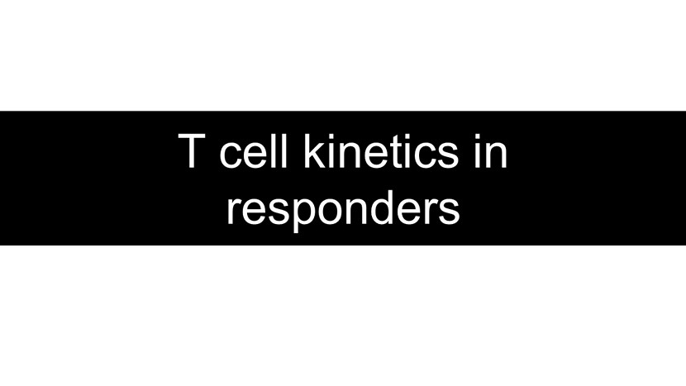
T cell kinetics in responders

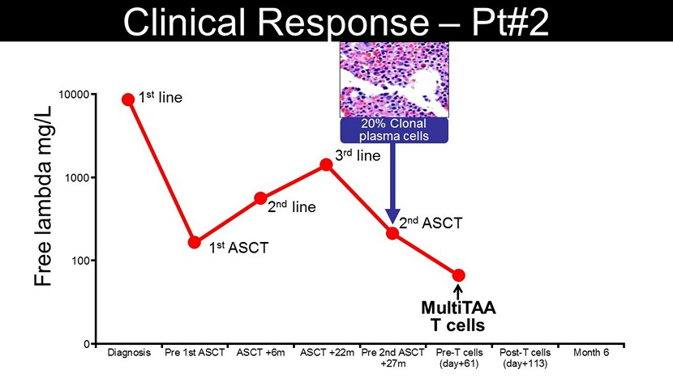
Clinical Response – Pt#2 20% Clonal plasma cells Diagnosis Pre 1st ASCT ASCT +6m ASCT +22m Pre 2nd ASCT +27m Pre-T cells (day+61) Post-T cells (day+113) Month 6 2 nd line 2 nd ASCT 1 st line 1 st ASCT 3 rd line 100 1000 10000 0 MultiTAA T cells Free lambda mg/L

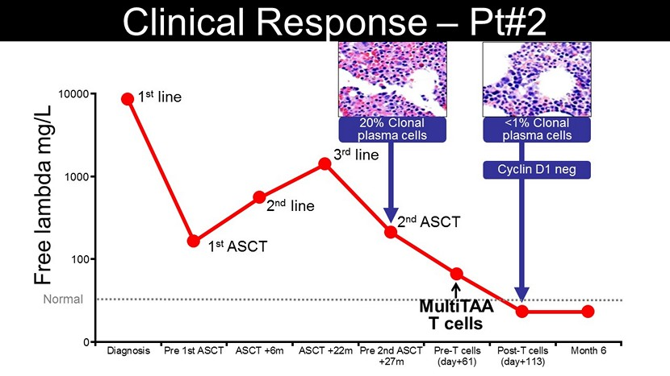
Clinical Response – Pt#2 <1% Clonal plasma cells Cyclin D1 neg 20% Clonal plasma cells Diagnosis Pre 1st ASCT ASCT +6m ASCT +22m Pre 2nd ASCT +27m Pre-T cells (day+61) Post-T cells (day+113) Month 6 2 nd line 2 nd ASCT 1 st line 1 st ASCT 3 rd line 100 1000 10000 0 Normal MultiTAA T cells Free lambda mg/L

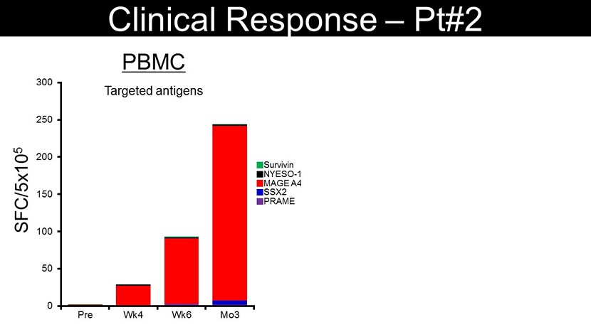
0 50 100 150 200 250 300 Pre Wk4 Wk6 Mo3 SFC/5x10 5 60 120 180 0 6 Wk Post SFC/5x10 5 MAGE A4 SSX2 Survivin NYESO - 1 PRAME Targeted antigens PBMC Marrow Clinical Response – Pt#2 MAGE A4 SSX2 Survivin NYESO - 1 PRAME

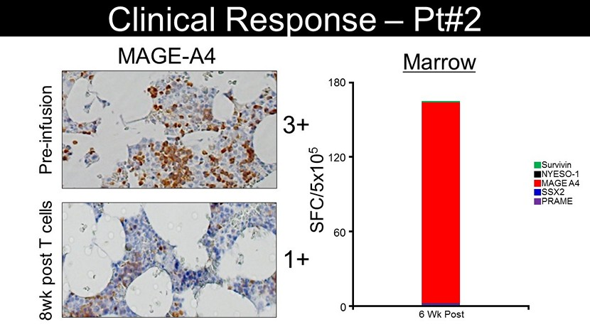
60 120 180 0 6 Wk Post SFC/5x10 5 MAGE A4 SSX2 Survivin NYESO - 1 PRAME Marrow Clinical Response – Pt#2 MAGE - A4 3+ Pre - infusion 1+ 8wk post T cells

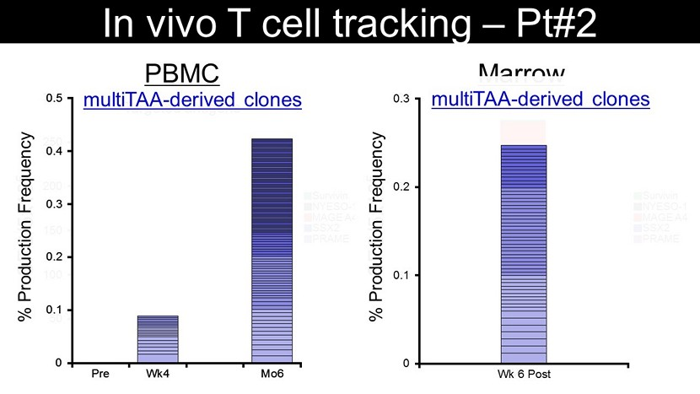
Targeted antigens SFC/5x10 5 0 50 100 150 200 250 300 Pre Wk4 Wk6 Mo3 60 120 180 0 6 Wk Post MAGE A4 SSX2 Survivin NYESO - 1 PRAME MAGE A4 SSX2 Survivin NYESO - 1 PRAME SFC/5x10 5 PBMC Marrow In vivo T cell tracking – Pt#2 0 0.1 0.2 0.3 0.4 0.5 Pre Wk4 Mo6 % Production Frequency 0 0.1 0.2 0.3 Wk 6 Post % Production Frequency 0 0.1 0.2 0.3 0.4 0.5 Pre Wk4 Mo6 multiTAA - derived clones multiTAA - derived clones

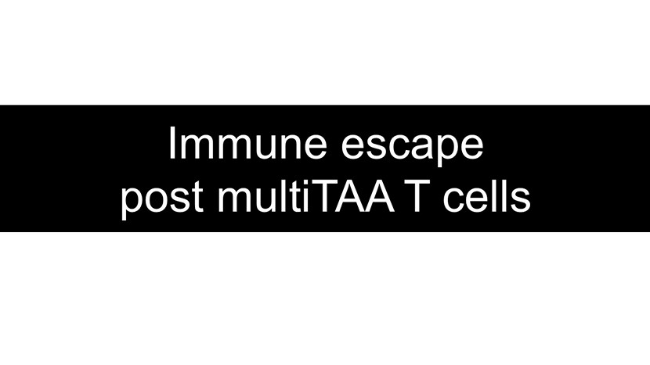
Immune escape post multiTAA T cells

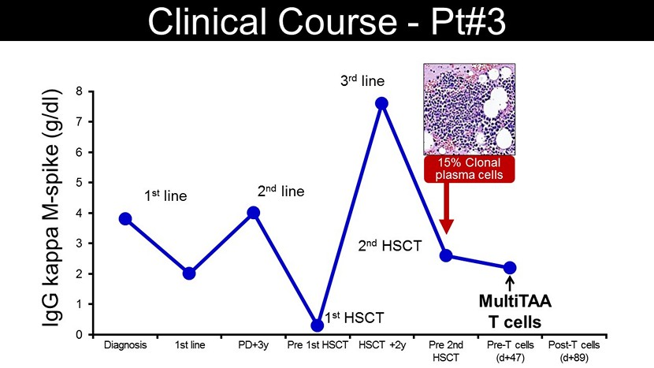
0 1 2 3 4 5 6 7 8 Diagnosis 1st line PD+3y Pre 1st HSCT HSCT +2y Pre 2nd HSCT Pre - T cells (d+47) Post - T cells (d+89) IgG kappa M - spike (g/dl) Clinical Course - Pt#3 2 nd line 3 rd line 1 st HSCT 2 nd HSCT 1 st line MultiTAA T cells 15% Clonal plasma cells

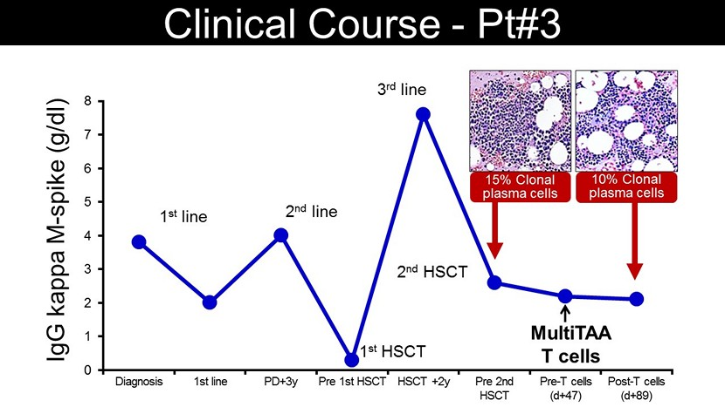
0 1 2 3 4 5 6 7 8 Diagnosis 1st line PD+3y Pre 1st HSCT HSCT +2y Pre 2nd HSCT Pre - T cells (d+47) Post - T cells (d+89) IgG kappa M - spike (g/dl) Clinical Course - Pt#3 2 nd line 3 rd line 1 st HSCT 2 nd HSCT 1 st line 15% Clonal plasma cells 10% Clonal plasma cells MultiTAA T cells

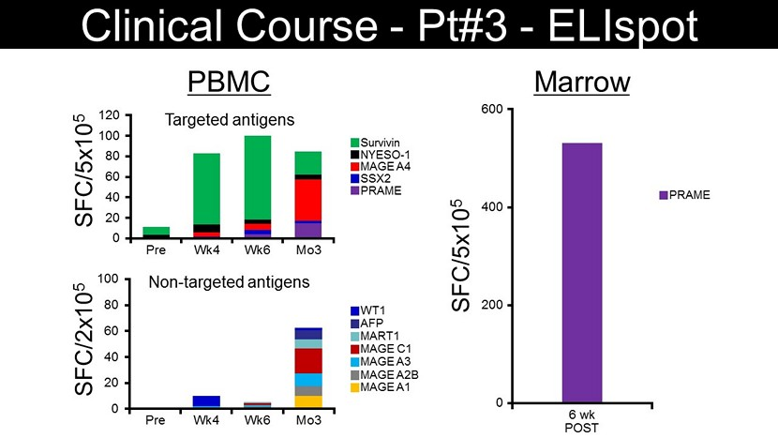
0 20 40 60 80 100 Pre Wk4 Wk6 Mo3 SFC/2x10 5 MART1 MAGE C1 WT1 AFP MAGE A3 MAGE A2B MAGE A1 Non - targeted antigens 0 20 40 60 80 100 120 Pre Wk4 Wk6 Mo3 SFC/5x10 5 MAGE A4 SSX2 Survivin NYESO - 1 PRAME Targeted antigens PBMC SFC/5x10 5 PRAME Marrow 0 200 400 600 6 wk POST Clinical Course - Pt#3 - ELIspot

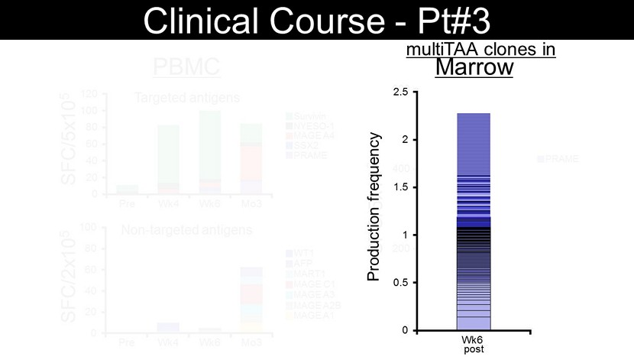
0 20 40 60 80 100 Pre Wk4 Wk6 Mo3 SFC/2x10 5 MART1 MAGE C1 WT1 AFP MAGE A3 MAGE A2B MAGE A1 Non - targeted antigens 0 20 40 60 80 100 120 Pre Wk4 Wk6 Mo3 SFC/5x10 5 MAGE A4 SSX2 Survivin NYESO - 1 PRAME Targeted antigens PBMC SFC/5x10 5 PRAME Marrow 0 200 400 600 6 wk POST Clinical Course - Pt#3 multiTAA clones in 0 0.5 1 1.5 2 2.5 Wk6 Production frequency post

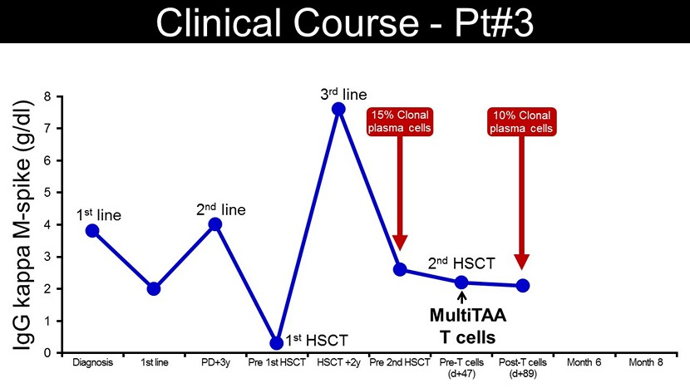
0 1 2 3 4 5 6 7 8 Diagnosis 1st line PD+3y Pre 1st HSCT HSCT +2y Pre 2nd HSCT Pre - T cells (d+47) Post - T cells (d+89) Month 6 Month 8 Clinical Course - Pt#3 2 nd line 3 rd line 1 st HSCT 2 nd HSCT 1 st line MultiTAA T cells 10% Clonal plasma cells 15% Clonal plasma cells IgG kappa M - spike (g/dl)

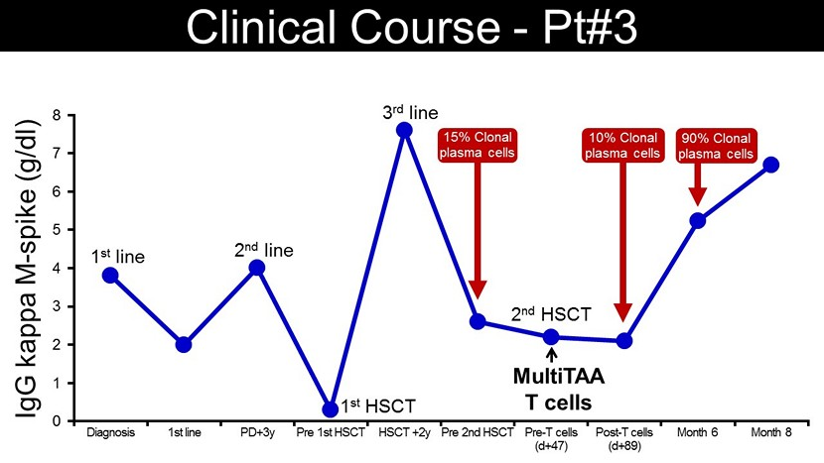
0 1 2 3 4 5 6 7 8 Diagnosis 1st line PD+3y Pre 1st HSCT HSCT +2y Pre 2nd HSCT Pre - T cells (d+47) Post - T cells (d+89) Month 6 Month 8 Clinical Course - Pt#3 2 nd line 3 rd line 1 st HSCT 2 nd HSCT 1 st line 90% Clonal plasma cells 10% Clonal plasma cells 15% Clonal plasma cells IgG kappa M - spike (g/dl) MultiTAA T cells

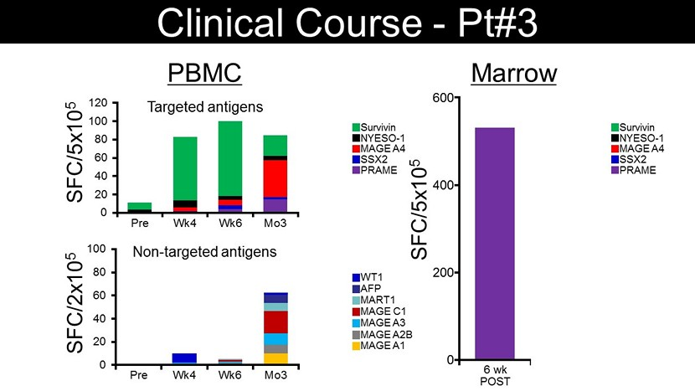
0 20 40 60 80 100 Pre Wk4 Wk6 Mo3 Mo6 SFC/2x10 5 MART1 MAGE C1 WT1 AFP MAGE A3 MAGE A2B MAGE A1 Non - targeted antigens 0 20 40 60 80 100 120 Pre Wk4 Wk6 Mo3 Mo6 SFC/5x10 5 MAGE A4 SSX2 Survivin NYESO - 1 PRAME Targeted antigens PBMC 6 mo POST SFC/5x10 5 Marrow 0 200 400 600 6 wk POST MAGE A4 SSX2 Survivin NYESO - 1 PRAME Clinical Course - Pt#3

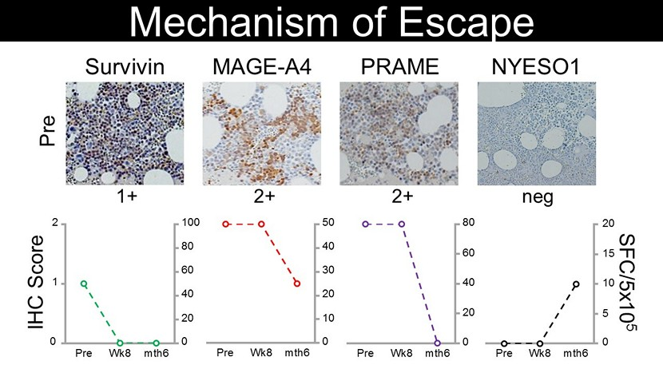
Pre Wk8 mth6 50 40 30 20 10 0 Pre Wk8 mth6 80 60 40 20 0 SFC/5x10 5 Pre Wk8 mth6 20 0 15 10 5 Pre Wk8 mth6 100 80 60 40 20 0 2 1 0 IHC Score MAGE - A4 2+ PRAME 2+ Survivin 1+ NYESO1 neg Pre Mechanism of Escape

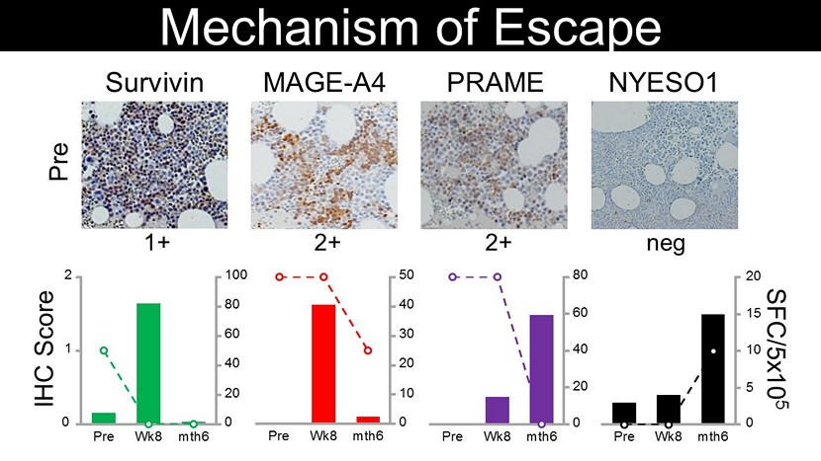
Pre Wk8 mth6 SFC/5x10 5 100 80 60 40 20 0 Pre Wk8 mth6 50 40 30 20 10 0 2 1 0 Pre Wk8 mth6 80 60 40 20 0 Pre Wk8 mth6 20 0 15 10 5 IHC Score MAGE - A4 2+ PRAME 2+ Survivin 1+ NYESO1 neg Pre Mechanism of Escape

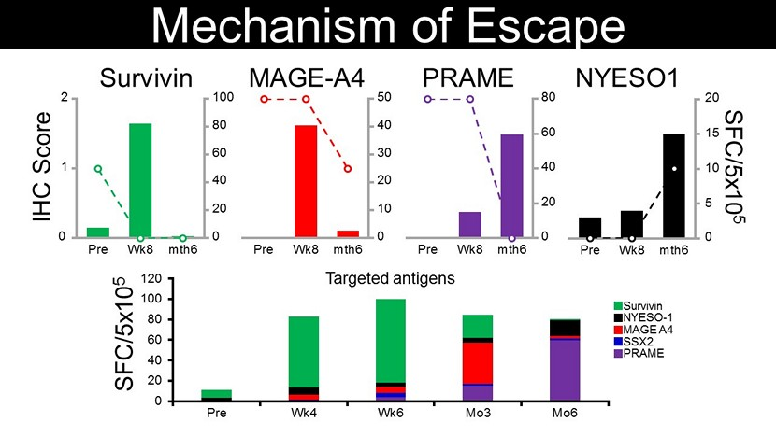
Pre Wk8 mth6 SFC/5x10 5 100 80 60 40 20 0 Pre Wk8 mth6 50 40 30 20 10 0 2 1 0 Pre Wk8 mth6 80 60 40 20 0 Pre Wk8 mth6 20 0 15 10 5 IHC Score 0 20 40 60 80 100 120 Pre Wk4 Wk6 Mo3 Mo6 SFC/5x10 5 MAGE A4 SSX2 Survivin NYESO - 1 PRAME Targeted antigens MAGE - A4 PRAME Survivin NYESO1 Mechanism of Escape

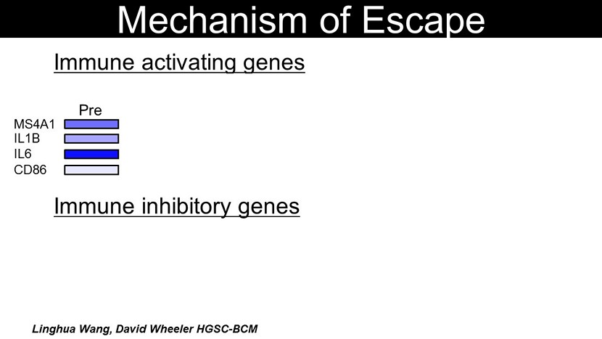
variable genes (n=1,828) MS4A1 IL1B CD86 CTLA4 LAG3 Pre wk6 mo3 mo6 IL6 PD1 SD mo3 MM cell proliferation (n=407) Fulciniti M et al, Blood Cancer J, 2016 Mitchell JS et al, Nat commun , 2016 Mechanism of Escape Pre wk6 mo3 mo6 SD PD SD PD Immune activating genes Immune inhibitory genes PD mo6 Linghua Wang, David Wheeler HGSC - BCM

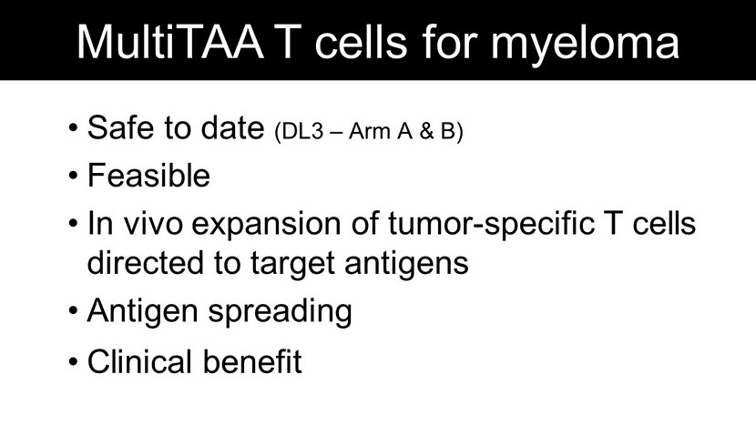
• Safe to date (DL3 – Arm A & B) • Feasible • In vivo expansion of tumor - specific T cells directed to target antigens • Antigen spreading • Clinical benefit MultiTAA T cells for myeloma

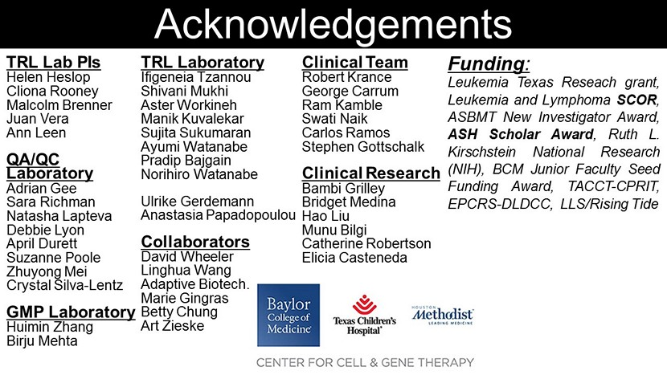
TRL Lab PIs Helen Heslop Cliona Rooney Malcolm Brenner Juan Vera Ann Leen QA/QC Laboratory Adrian Gee Sara Richman Natasha Lapteva Debbie Lyon April Durett Suzanne Poole Zhuyong Mei Crystal Silva - Lentz GMP Laboratory Huimin Zhang Birju Mehta Funding : Leukemia Texas Reseach grant, Leukemia and Lymphoma SCOR , ASBMT New Investigator Award, ASH Scholar Award , Ruth L . Kirschstein National Research (NIH), BCM Junior Faculty Seed Funding Award, TACCT - CPRIT, EPCRS - DLDCC, LLS/Rising Tide TRL Laboratory Ifigeneia Tzannou Shivani Mukhi Aster Workineh Manik Kuvalekar Sujita Sukumaran Ayumi Watanabe Pradip Bajgain Norihiro Watanabe Ulrike Gerdemann Anastasia Papadopoulou Collaborators David Wheeler Linghua Wang Adaptive Biotech. Marie Gingras Betty Chung Art Zieske Clinical Team Robert Krance George Carrum Ram Kamble Swati Naik Carlos Ramos Stephen Gottschalk Clinical Research Bambi Grilley Bridget Medina Hao Liu Munu Bilgi Catherine Robertson Elicia Casteneda Acknowledgements

Exhibit 99.2

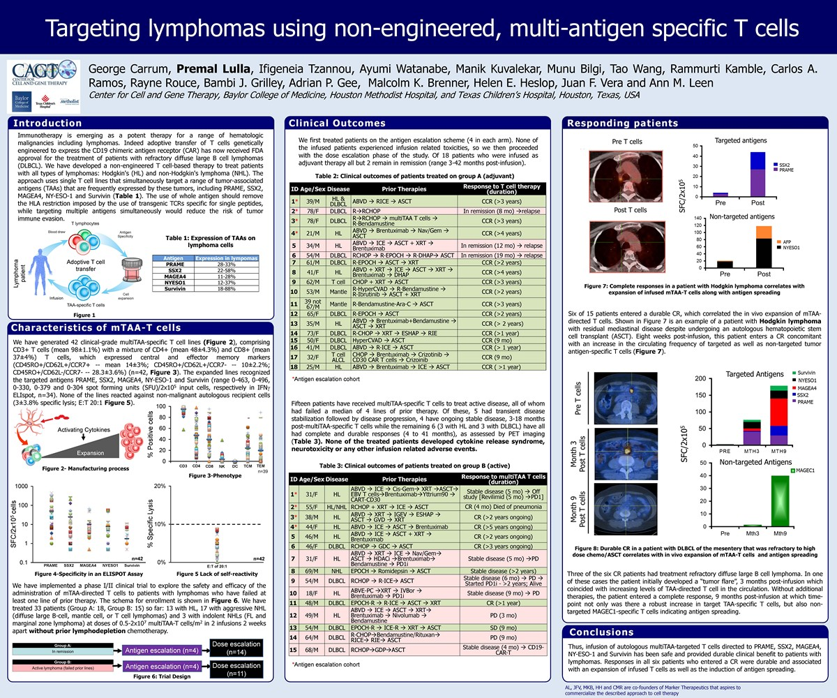

Exhibit 99.3



