TABLE OF CONTENTS

SCHEDULE 14A

Proxy Statement Pursuant to Section 14(a) of the Securities Exchange Act of 1934

(Amendment No. )

Filed by the Registrant

Filed by a Party other than the Registrant

☒

☐

Check the appropriate box:

- Preliminary Proxy Statement

- Confidential, for Use of the Commission Only (as permitted by Rule 14a-6(e)(2))

☒Definitive Proxy Statement

- Definitive Additional Materials

- Soliciting Material Pursuant to § 240.14a-12

Marker Therapeutics, Inc.

(Name of Registrant as Specified In Its Charter)

(Name of Person(s) Filing Proxy Statement if other than the Registrant)

Payment of Filing Fee (Check all boxes that apply):

- No fee required.

- Fee paid previously with preliminary materials

- Fee computed on table in exhibit required by Item 25(b) per Exchange Act Rules 14a-6(i)(1) and 0-11

TABLE OF CONTENTS


2450 Holcombe Blvd, Suite BCM-A, MS: BCM251

Houston, TX 77021

NOTICE OF SPECIAL MEETING OF STOCKHOLDERS

To Be Held On March 21, 2025

Dear Stockholder:

You are cordially invited to attend the Special Meeting of Stockholders of Marker Therapeutics, Inc., a Delaware corporation (the “Company”). The meeting will be held on Friday, March 21, 2025 at 9:00 a.m. Central Time and will be a virtual stockholder meeting through which you can listen to the meeting, submit questions and vote online. You must register for the virtual meeting via https://web.viewproxy.com/markertherapeutics/2025SM no later than 11:59 p.m. Eastern Time on Thursday, March 20, 2025. The meeting will be held for the following purposes:

- To approve, in accordance with Nasdaq Listing Rule 5635(d), the issuance of the shares issuable upon exercise of (i) Series A Warrants to acquire 5,031,250 shares of Common Stock (the “Private Placement Warrants”) and (ii) Series B Warrants to acquire 3,247,445 shares of Common Stock (the “Pre-Funded Warrants”, and together with the Private Placement Warrants, the “Warrants”).

- To conduct any other business properly brought before the meeting.

These items of business are more fully described in the Proxy Statement accompanying this Notice.

The record date for the Special Meeting is January 27, 2025. Only stockholders of record at the close of business on that date may vote at the meeting or any adjournment thereof.

​ | Important Notice Regarding the Availability of Proxy Materials | ​
 | for the Virtual Special Meeting of Stockholders
 | to Be Held on Friday, March 21, 2025 at 9:00 a.m. Central Time.
 | Register for the virtual Special Meeting
 | vía https://web.viewproxy.com/markertherapeutics/2025SM
 | The proxy statement and annual report to stockholders are available at
 | https://web.viewproxy.com/markertherapeutics/2025SM

By Order of the Board of Directors,

/s/ Juan Vera, M.D.

Juan Vera, M.D.

Secretary

Houston, TX

February 4, 2025

TABLE OF CONTENTS

​ You are cordially invited to attend the virtual Special Meeting. You will not be able to attend the Special​ Meeting in person. Whether or not you expect to attend the meeting, please complete, date, sign and return the enclosed proxy, or vote over the telephone or the internet as instructed in these materials, as promptly as possible in order to ensure your representation at the meeting. A return envelope (which is postage prepaid if mailed in the United States) has been provided for your convenience. Even if you have voted by proxy, you may still vote online if you attend the virtual Special Meeting. Please note, however, that if your shares are held of record by a broker, bank or other nominee and you wish to vote at the meeting, you must obtain a proxy issued in your name from that record holder.


TABLE OF CONTENTS​

Table of Contents

​ |  |  |  |  |  |  |  |  |  |  |  | ​​Page​
 | PROXY STATEMENT |  |  |  |  |  |  |  |  |  |  | ​​ |  |  |  | 1 | ​
 | QUESTIONS AND ANSWERS ABOUT THESE PROXY MATERIALS AND VOTING |  |  |  |  |  |  |  |  |  |  | ​​ |  |  |  | 1 | ​
PROPOSAL 1 TO APPROVE, IN ACCORDANCE WITH NASDAQ LISTING RULE 5635(D), THE
 |  | ISSUANCE OF THE SHARES ISSUABLE UPON EXERCISE OF PRIVATE PLACEMENT
 |  | WARRANTS TO ACQUIRE 5,031,250 SHARES OF COMMON STOCK AND PRE-FUNED
 |  | WARRANTS TO ACQUIRE 3,247,445 SHARES OF COMMON STOCK |  |  |  |  |  |  |  |  |  | ​​ | 6 |  |  |  | ​
SECURITY OWNERSHIP OF CERTAIN BENEFICIAL OWNERS AND MANAGEMENT AND
 |  | RELATED STOCKHOLDER MATTERS |  |  |  |  |  |  |  |  |  | ​​ | 9 |  |  |  | ​
 | HOUSEHOLDING OF PROXY MATERIALS |  |  |  |  |  |  |  |  |  |  | ​​ |  | 10 |  |  | ​
OTHER MATTERS |  |  |  |  |  |  |  |  |  |  |  | ​​ |  |  | 11 |  | ​


i

TABLE OF CONTENTS​

MARKER THERAPEUTICS, INC.

2450 Holcombe Blvd, Suite BCM-A, MS: BCM251
Houston, TX 77021

PROXY STATEMENT

FOR THE SPECIAL MEETING OF STOCKHOLDERS

MARCH 21, 2025

QUESTIONS AND ANSWERS ABOUT THESE PROXY MATERIALS AND VOTING

Why am I receiving these materials?

We have sent you these proxy materials because the Board of Directors (the “Board” or “Board of Directors”) of Marker Therapeutics, Inc. (sometimes referred to as the “Company” or “Marker”) is soliciting your proxy to vote at the Special Meeting of Stockholders, including at any adjournments or postponements of the meeting. You are invited to attend the Special Meeting to vote on the proposals described in this proxy statement. However, you do not need to attend the meeting to vote your shares. Instead, you may simply complete, sign and return the enclosed proxy card, or follow the instructions below to submit your proxy over the telephone or through the internet.

We intend to mail these proxy materials on or about February 4, 2025, to all stockholders of record entitled to vote at the Special Meeting.

How do I attend the Special Meeting?

The Special Meeting will be a virtual stockholder meeting through which you can listen to the meeting, submit questions and vote online. In order to attend the Special Meeting, you must first register at https://web.viewproxy.com/markertherapeutics/2025SM by 11:59 p.m. Eastern Time on Thursday, March 20, 2025. Please follow the instructions on the registration page. You will then receive a meeting invitation by email with your unique link to join the Special Meeting along with a password prior to the meeting date. We recommend that you log on a few minutes before the Special Meeting to ensure that you are logged in when the meeting begins. Information on how to vote online during the Special Meeting is discussed below.

We have decided to hold a virtual stockholder meeting to enable our stockholders to participate from any location around the world that is convenient to them. Stockholders that attend the virtual meeting will be afforded the same rights and opportunities to participate as they would at an in-person meeting. You will not be able to attend the Special Meeting in person.

Both stockholders of record and street name stockholders will be able to attend the Special Meeting via live audio webcast, submit their questions during the meeting and vote their shares electronically at the Special Meeting.

Who can vote at the Special Meeting?

Only stockholders of record at the close of business on January 27, 2025 will be entitled to vote at the Special Meeting. On this record date, there were 10,709,005 shares of common stock outstanding and entitled to vote.

Stockholder of Record: Shares Registered in Your Name

If on January 27, 2025, your shares were registered directly in your name with Marker’s transfer agent, Equiniti Trust Company, LLC, then you are a stockholder of record. As a stockholder of record, you may vote online during the meeting or vote by proxy. Whether or not you plan to attend the meeting, we urge you to fill out and return the enclosed proxy card or vote by proxy over the telephone or internet as instructed below to ensure your vote is counted. If you are a stockholder of record, your virtual control number will be on your Notice of Internet Availability of Proxy Materials or proxy card.

Beneficial Owner: Shares Registered in the Name of a Broker or Bank

If on January 27, 2025, your shares were held, not in your name, but rather in an account at a brokerage firm, bank or other similar organization, then you are the beneficial owner of shares held in “street name” and these

1

TABLE OF CONTENTS

proxy materials are being forwarded to you by that organization. The organization holding your account is considered to be the stockholder of record for purposes of voting at the Special Meeting. As a beneficial owner, you have the right to direct your broker, bank or other agent regarding how to vote the shares in your account. However, since you are not the stockholder of record, you may not vote your shares online during the Special Meeting unless you request and obtain a legal proxy from your broker, bank or other agent. During the registration process, you will be asked to upload or email the legal proxy provided to you by your broker, bank or other agent. You are also invited to attend the Special Meeting so long as you demonstrate proof of stock ownership. Instructions on how to demonstrate proof of stock ownership are posted at https://web.viewproxy.com/markertherapeutics/2025SM. On the day of the Special Meeting, if you are a beneficial holder, you may vote during the meeting only if, during registration and in advance of the meeting, you emailed or uploaded a copy of your legal proxy to VirtualMeeting@viewproxy.com as instructed below.

What am I voting on?

There is one matter scheduled for a vote:

- To approve, in accordance with Nasdaq Listing Rule 5635(d), the issuance of the shares issuable upon exercise of (i) Series A Warrants to acquire 5,031,250 shares of Common Stock (the “Private Placement Warrants”) and (ii) Series B Warrants to acquire 3,247,445 additional shares of Common Stock (the “Pre-Funded Warrants”, and together with the Private Placement Warrants, the “Warrants”).

What if another matter is properly brought before the meeting?

The Board of Directors knows of no other matters that will be presented for consideration at the Special Meeting. If any other matters are properly brought before the meeting, it is the intention of the persons named in the accompanying proxy to vote on those matters in accordance with their best judgment.

How do I vote?

For Proposal 1, you may vote “For” or “Against” or abstain from voting.

The procedures for voting are fairly simple:

Stockholder of Record: Shares Registered in Your Name

If you are a stockholder of record, you may vote online during the Special Meeting, vote by proxy using the enclosed proxy card, vote by proxy over the telephone or vote by proxy through the internet. Whether or not you plan to attend the meeting, we urge you to vote by proxy to ensure your vote is counted. You may still attend the meeting and vote online during the meeting even if you have already voted by proxy.

- To vote online during the meeting, you may vote using the link that will be provided on the virtual meeting screen, or you may visit www.AALvote.com/MRKRSM while the polls are open. In order to vote during the meeting, you will need your virtual control number, which will be on your Notice of Internet Availability of Proxy Materials or proxy card.

- To vote using the proxy card, simply complete, sign and date the enclosed proxy card and return it promptly in the envelope provided. If you return your signed proxy card to us before the Special Meeting, we will vote your shares as you direct.

- To vote over the telephone, dial toll-free 1-866-804-9616 using a touch-tone phone and follow the recorded instructions. You will be asked to provide the virtual control number from your Notice of Internet Availability of Proxy Materials or proxy card. Your telephone vote must be received by 11:59 p.m. Eastern Time on Thursday, March 20, 2025 to be counted.

- To vote through the internet, go to www.AALVote.com/MRKR to complete an electronic proxy card. Please have your enclosed proxy card available when you access the voting website and follow the prompts to vote your shares. Your internet vote must be received by 11:59 p.m. Eastern Time on Thursday, March 20, 2025 to be counted.

2

TABLE OF CONTENTS

Beneficial Owner: Shares Registered in the Name of Broker or Bank

If you are a beneficial owner of shares registered in the name of your broker, bank or other agent, you should have received a voting instruction form with these proxy materials from that organization rather than from Marker. Simply complete and mail the voting instruction form to ensure that your vote is counted. Alternatively, you may vote by telephone or over the internet as instructed by your broker or bank. To vote online during the Special Meeting, you must obtain a legal proxy from your broker, bank or other agent. Follow the instructions from your broker, bank or other agent included with these proxy materials, or contact that organization to request a proxy form. In advance of the Special Meeting, you will need to upload or email a copy of the legal proxy from your broker, bank or other agent to VirtualMeeting@viewproxy.com in order to vote at the Special Meeting. To vote online during the meeting, you may vote using the link that will be provided on the virtual meeting screen, or you may visit www.AALvote.com/MRKR while the polls are open. You will need your virtual control number, which will be assigned to you in your confirmation of registration email, in order to vote during the meeting.

​Internet proxy voting has been provided to allow you to vote your shares online, with procedures designed to​ ensure the authenticity and correctness of your proxy vote instructions. However, please be aware that you must bear any costs associated with your internet access, such as usage charges from internet access providers and telephone companies.


How many votes do I have?

On each matter to be voted upon, you have one vote for each share of common stock you own as of January 27, 2025.

If I am a stockholder of record and I do not vote, or if I return a proxy card or otherwise vote without giving specific voting instructions, what happens?

If you are a stockholder of record and do not vote by completing your proxy card, by telephone, through the internet or online during the Special Meeting, your shares will not be voted.

If you return a signed and dated proxy card or otherwise vote without marking voting selections, your shares will be voted:

• “For” the issuance of the shares issuable upon exercise of the Warrants.

If any other matter is properly presented at the meeting, your proxyholder (one of the individuals named on your proxy card) will vote your shares using his or her best judgment.

If I am a beneficial owner of shares held in street name and I do not provide my broker or bank with voting instructions, what happens?

Under stock exchange rules, brokers, banks and other securities intermediaries that are subject to such rules may use their discretion to vote your “uninstructed” shares with respect to matters considered to be “routine” under such rules, but not with respect to “non-routine” matters. In this regard, Proposals 1 and 2 are considered to be “non-routine” under such rules, meaning that your broker may not vote your shares on those proposals in the absence of your voting instructions.

If you are a beneficial owner of shares held in street name, in order to ensure your shares are voted in the way you would prefer, you must provide voting instructions to your broker, bank or other agent by the deadline provided in the materials you receive from your broker, bank or other agent.

Who is paying for this proxy solicitation?

We will pay for the entire cost of soliciting proxies. In addition to these proxy materials, our directors and employees may also solicit proxies in person, by telephone or by other means of communication. Directors and employees will not be paid any additional compensation for soliciting proxies. We may also reimburse brokerage firms, banks and other agents for the cost of forwarding proxy materials to beneficial owners.

3

TABLE OF CONTENTS

What does it mean if I receive more than one set of proxy materials?

If you receive more than one set of proxy materials, your shares may be registered in more than one name or in different accounts. Please follow the voting instructions on the proxy cards in the proxy materials to ensure that all of your shares are voted.

Can I change my vote after submitting my proxy?

Stockholder of Record: Shares Registered in Your Name

Yes. You can revoke your proxy at any time before the final vote at the meeting. If you are the record holder of your shares, you may revoke your proxy in any one of the following ways:

- You may submit another properly completed proxy card with a later date.

- You may grant a subsequent proxy by telephone or through the internet.

- You may send a timely written notice that you are revoking your proxy to Marker Therapeutics, Inc., Attention: Secretary at 2450 Holcombe Blvd, Suite BCM-A, MS: BCM251, Houston, TX 77021.

- You may attend the Special Meeting virtually and vote online. Simply attending the meeting virtually will not, by itself, revoke your proxy.

Your most current proxy card or telephone or internet proxy is the one that is counted.

Beneficial Owner: Shares Registered in the Name of Broker or Bank

If your shares are held by your broker, bank or other agent, you should follow the instructions provided by your broker, bank or other agent.

How are votes counted?

Votes will be counted by the inspector of election appointed for the meeting, who will separately count votes “For” and “Against,” abstentions and, if applicable, broker non-votes. Abstentions will be counted towards the vote total for the Proposal 1 and will have the same effect as “Against” votes. Broker non-votes will have no effect and will not be counted towards the vote total for Proposal 1.

What are “broker non-votes”?

A “broker non-vote” occurs when your broker submits a proxy for the meeting with respect to “routine” matters but does not vote on “non-routine” matters because you did not provide voting instructions on these matters. These un-voted shares are counted as “broker non-votes.” Proposal 1 is considered to be “non-routine” under stock exchange rules and we therefore expect broker non-votes on this proposal.

As a reminder, if you are a beneficial owner of shares held in street name, in order to ensure your shares are voted in the way you would prefer, you must provide voting instructions to your broker, bank or other agent by the deadline provided in the materials you receive from your broker, bank or other agent.

How many votes are needed to approve the proposal?

Proposal 1, the approval of the share issuance upon the exercise of the Warrants, will be considered to be approved if it receives “For” votes from the holders of a majority of shares present online at the meeting or represented by proxy and entitled to vote on the matter. If you “Abstain” from voting, it will have the same effect as an “Against” vote. Broker non-votes will have no effect.

What is the quorum requirement?

A quorum of stockholders is necessary to hold a valid meeting. A quorum will be present if stockholders holding at least one-third of the outstanding shares entitled to vote are present online at the virtual meeting or represented by proxy. On the record date, there were 10,709,005 shares outstanding and entitled to vote. Thus,

4

TABLE OF CONTENTS

the holders of 3,569,668 shares must be present online at the virtual meeting or represented by proxy at the meeting to have a quorum.

Abstentions and broker non-votes will be counted towards the quorum requirement. If there is no quorum, the holders of a majority of shares present online at the meeting at the virtual meeting or represented by proxy may adjourn the meeting to another date.

How do I ask a question at the Special Meeting?

Only stockholders of record as of January 27, 2025 may submit questions or comments at the Special Meeting. If you would like to submit a question, you must first register for the Special Meeting at https://web.viewproxy.com/markertherapeutics/2025SM by 11:59 p.m. Eastern Time on Thursday March 20, 2025 and, once you join the meeting, you can type your question in the questions/chat box in the meeting portal.

To help ensure that we have a productive and efficient meeting, and in fairness to all stockholders in attendance, you will also find posted our rules of conduct for the Special Meeting when you log in prior to the start of the Special Meeting. In accordance with the rules of conduct, we ask that you limit your remarks to one brief question or comment that is relevant to the Special Meeting or our business and that such remarks are respectful of your fellow stockholders and meeting participants. Our management may group questions by topic with a representative question read aloud and answered. In addition, questions may be ruled out of order if they are, among other things, irrelevant to our business, related to pending or threatened litigation, disorderly, repetitious of statements already made, or in furtherance of the speaker’s own personal, political or business interests. Questions will be addressed in the “Question and Answer” portion of the Special Meeting.

What do I do if I have technical difficulties in connection with the Special Meeting?

There will be technicians ready to assist you with any technical difficulties you may have accessing the Special Meeting live audio webcast. Please be sure to check in by 8:45 a.m. Central Time on March 21, 2025, the day of the meeting, so that any technical difficulties may be addressed before the Special Meeting live audio webcast begins. If you encounter any difficulties accessing the webcast during the check-in or meeting time, please email VirtualMeeting@viewproxy.com or call 1-866-612-8937.

Will a list of record stockholders as of the record date be available?

A list of our record stockholders as of the close of business on the record date will be made available to stockholders during the meeting. In addition, for the ten days prior to the date of the Special Meeting, the list will be available for examination by any stockholder of record for a legally valid purpose at our corporate headquarters during regular business hours.

How can I find out the results of the voting at the Special Meeting?

Preliminary voting results will be announced at the Special Meeting. In addition, final voting results will be published in a Current Report on Form 8-K that we expect to file within four business days after the Special Meeting. If final voting results are not available to us in time to file a Form 8-K within four business days after the meeting, we intend to file a Form 8-K to publish preliminary results and, within four business days after the final results are known to us, file an additional Form 8-K to publish the final results.

5

TABLE OF CONTENTS​

PROPOSAL NO. 1

APPROVAL, IN ACCORDANCE WITH NASDAQ LISTING RULE 5635(D), OF THE ISSUANCE OF COMMON STOCK UPON EXERCISE OF SERIES A WARRANTS AND PRE-FUNDED WARRANTS

We are seeking stockholder approval, for purposes of complying with Nasdaq Listing Rule 5635(d), for the issuance of (1) 5,031,250 shares of Common Stock issuable upon exercise of outstanding Series A Warrants, or Private Placement Warrants, issued on December 23, 2024 and (2) 3,247,445 shares of Common Stock issuable upon exercise of outstanding Series B Warrants, or Pre-Funded Warrants, issued on December 23, 2024.

BACKGROUND

On December 19, 2024, the Company entered into a securities purchase agreement (the “Securities Purchase Agreement”) with various investors for the issuance and sale in a private placement (the “Private Placement”) of (i) 1,783,805 shares of Common Stock par value $0.001 per share (the “Common Stock”),

- Series A Warrants to acquire 5,031,250 shares of Common Stock (the “Private Placement Warrants”) and (iii) Series B Warrants to acquire 3,247,445 additional shares of Common Stock (the “Pre-Funded Warrants” and together with the Private Placement Warrants, the “Warrants”).

The Private Placement closed on December 23, 2024. The gross proceeds to the Company from the Private Placement were approximately $16.1 million, before deducting placement agent fees and offering expenses payable by the Company. The Company intends to use the net proceeds received from the Private Placement for general corporate purposes and working capital, including to support the clinical advancement of the Company’s Phase 1 APOLLO study investigating MT-601, a multi-antigen recognizing (MAR) T cell product (formerly known as multiTAA-specific T cells), in patients with lymphoma who have relapsed after anti-CD19 chimeric antigen receptor (CAR)-T cell therapy or where anti-CD19 CAR-T cells are not an option.

Pursuant to the Securities Purchase Agreement, the Company is obligated to call a meeting of its stockholders to obtain stockholder approval for the issuance of the shares issuable upon exercise of the Warrants (the “Stockholder Approval”) within 90 days of the closing date. If the Stockholder Approval is not obtained at such meeting, the Company is required to cause an additional stockholder meeting to be held on or prior to the 180th day after the closing date, and, if despite the Company’s reasonable best efforts the Stockholder Approval is not obtained after such subsequent stockholder meeting, the Company is required to cause an additional stockholder meeting to be held semi-annual thereafter until such Stockholder Approval is obtained.

In connection therewith, the Company entered into voting agreements with certain stockholders pursuant to which such stockholders, who collectively own approximately 27% of the shares of Common Stock outstanding immediately prior to the closing of the Private Placement, agreed to vote in favor of the Private Placement.

The Warrants are exercisable at any time on or after the date that the Stockholder Approval is obtained, and are not exercisable prior thereto, in compliance with Nasdaq rules and regulations, and have a term of five years commencing upon the date that the Stockholder Approval is obtained. The Pre-Funded warrants are exercisable at a price of $0.001 per share and the Private Placement Warrants have an exercise price of $4.00 per share.

The Warrants provide for a cashless exercise feature after six months from the closing. However, the Series A Warrants can only be exercised on a cashless basis if there is no effective registration statement covering the Series A Warrants at the time of exercise.

None of the issuances of the shares of Common Stock, the Pre-Funded Warrants, the Private Placement Warrants, or the shares of Common Stock issuable upon exercise of the Warrants (the “Warrant Shares”) have been registered under the Securities Act of 1933, as amended (the “Securities Act”), or any state securities laws. The shares of Common Stock, the Pre-Funded Warrants and the Private Placement Warrants, were issued, and Warrant Shares will be issued, in reliance on the exemptions from registration provided by Section 4(a)(2) under the Securities Act and/or Regulation D promulgated thereunder. The investors who entered into to a Securities Purchase Agreement represented to the Company that they are each an accredited investor, as defined in Rule 501 of Regulation D promulgated under the Securities Act.

6

TABLE OF CONTENTS

Canaccord Genuity LLC acted as the Company’s lead placement agent and Brookline Capital Markets, a division of Arcadia Securities, LLC, acted as co-placement agent (collectively, the “Agents”) in connection with the Private Placement, pursuant to that certain engagement letter, dated as of June 14, 2024, between the Company and Canaccord Genuity LLC (the “Engagement Letter”). Pursuant to the Engagement Letter, the Company paid or agreed to pay the Agents a cash fee equal to (i) 6% of the aggregate gross proceeds of the Private Placement other than from certain identified investors (the “Reduced Fee Investors”), (ii) 3% of the first $5 million of aggregate gross proceeds of the Private Placement form the Reduced Fee Investors, and (iii) 6% of the aggregate gross proceeds of the Private Placement form the Reduced Fee Investors in excess of $5 million. In addition, the Company agreed to pay Wainwright certain expenses.

The foregoing descriptions of terms and conditions of the Securities Purchase Agreement, the Pre-Funded Warrants, the Private Placement Warrants, and the Registration Rights Agreement do not purport to be complete and are qualified in their entirety by the full text of the form of the Purchase Agreement, the form of the Pre-Funded Warrant, the form of Private Placement Warrant, and the form of the Registration Rights Agreement, which are attached hereto as Exhibits 10.1, 4.1, 4.2, and 10.2, respectively, to our Current Report on Form 8-K filed with the Securities and Exchange Commission (the “SEC”) on December 23, 2024.

Stockholders are urged to carefully read these documents.

REGISTRATION RIGHTS AGREEMENT

In connection with the Private Placement, the Company entered into a registration rights agreement (the “Registration Rights Agreement”), dated as of December 19, 2024, with the investors in the Private Placement, pursuant to which the Company agreed to prepare and file a registration statement with the SEC registering the resale of the shares of Common Stock issued in the Private Placement along with the shares of Common Stock underlying the Warrants no later than January 14, 2025, and to use its best efforts to have the registration statement declared effective as promptly as practical thereafter, and in any event no later than the earlier of (A) February 14, 2024 and (B) the second business day after the date the Company is notified by the SEC that the Registration Statement will not be reviewed or will not be subject to further review.

VOTING AGREEMENT

In connection Private Placement, the Company entered into voting agreements with certain stockholders pursuant to which such stockholders, who collectively own approximately 27% of the shares of Common Stock outstanding immediately prior to the closing of the Private Placement, agreed to vote in favor of this proposal.

REASONS FOR PROPOSAL NO. 1 – NASDAQ STOCKHOLDER APPROVAL REQUIREMENT

We are seeking stockholder approval for Proposal No. 1 because, pursuant to the Securities Purchase Agreement, we agreed to issue the Warrants in the Offering, and the Warrants are not exercisable unless and until we receive the Stockholder Approval for the issuance of the shares issuable upon exercise of the Warrants. Nasdaq Listing Rule 5635(d) requires stockholder approval in connection with a transaction, other than a public offering, involving the sale or issuance by the issuer of common stock (or securities convertible into or exchangeable for common stock) equal to 20% or more of the common stock or 20% or more of the voting power of such company outstanding before the issuance for a price that is less than the lower of: (i) the closing price of the common stock immediately preceding the signing of the binding agreement for the issuance of such securities and (ii) the average closing price of the common stock for the five trading days immediately preceding the signing of the binding agreement for the issuance of such securities. Because of Nasdaq Listing Rule 5635(d), the Warrants provide that they may not be exercised unless the Stockholder Approval is obtained.

POTENTIAL CONSEQUENCES IF PROPOSAL NO. 1 IS NOT APPROVED

The Board is not seeking the approval of our Stockholders to authorize our entry into or consummation of the transactions contemplated by the Securities Purchase Agreement, as the transactions have already been consummated and the Warrants have already been issued. We are only asking for approval to issue the Warrant

7

TABLE OF CONTENTS

Shares underlying the Warrants upon exercise thereof. The failure of our Stockholders to approve Proposal No. 1 will not negate the existing terms of the documents, which will remain binding obligations of the Company.

Our ability to successfully implement our business plans and growth strategy and ultimately maximize value for our Stockholders is dependent upon our ability to raise capital and satisfy our ongoing business needs and growth strategy, which we believe would be significantly and adversely affected if our Stockholders do not approve Proposal No. 1. The pricing and terms of the Offering were agreed upon by the investors based on obtaining the Stockholder Approval. Accordingly, the failure of our Stockholders to approve this Proposal No. 1 will mean that: (i) we cannot permit the exercise of the Warrants and (ii) may incur substantial additional costs and expenses. As a result, the Company may need to seek alternative sources of financing, which financing may not be available on advantageous terms, or at all, if we cannot demonstrate to investors that we are able to obtain stockholder approval, and which may result in the incurrence of significant additional transaction expenses.

If the Warrants cannot be exercised, we will not receive the net proceeds of any Warrants exercised for cash in the future. We currently expect to use such net proceeds, if any, for working capital and general corporate purposes, including to support the clinical advancement of the Company’s Phase 1 APOLLO study investigating MT-601, a multi-antigen recognizing (MAR) T cell product (formerly known as multiTAA-specific T cells), in patients with lymphoma who have relapsed after anti-CD19 chimeric antigen receptor (CAR)-T cell therapy or where anti-CD19 CAR-T cells are not an option.

In the event stockholder approval for Proposal No. 1 is not obtained at the Special Meeting, we will be required to call another meeting of stockholders within 180 days from the Closing Date. If, despite the Company’s reasonable best efforts the Stockholder Approval is not obtained after such subsequent stockholder meetings, the Company is required to cause an additional Stockholder Meeting to be held semi-annually thereafter until such Stockholder Approval is obtained. The costs and expenses associated with seeking such approval could materially adversely impact our ability to fund our operations and advance our clinical development plans.

POTENTIAL ADVERSE EFFECTS OF THE APPROVAL OF PROPOSAL NO. 1

If this Proposal No. 1 is approved, existing stockholders will suffer dilution in their ownership interests in the future upon the issuance of the Warrant Shares. Assuming the full exercise of the Warrants, an aggregate of 8,278,695 additional Shares will be outstanding, and the ownership interest of our existing stockholders would be correspondingly reduced. In addition, the sale into the public market of these Warrant Shares also could materially and adversely affect the market price of our Shares.

VOTE REQUIRED

Proposal No. 1, the approval of the share issuance upon the exercise of the Warrants, will be considered to be approved if it receives “For” votes from the holders of a majority of shares present online at the meeting or represented by proxy and entitled to vote on the matter. If you “Abstain” from voting, it will have the same effect as an “Against” vote. Broker non-votes will have no effect.

THE BOARD OF DIRECTORS RECOMMENDS THAT STOCKHOLDERS VOTE “FOR” THE AUTHORIZATION, FOR PURPOSES OF COMPLYING WITH NASDAQ LISTING RULE 5635(D), OF THE ISSUANCE OF WARRANT SHARES UNDERLYING THE WARRANTS.

8

TABLE OF CONTENTS​

SECURITY OWNERSHIP OF CERTAIN BENEFICIAL OWNERS AND MANAGEMENT

The following table sets forth certain information regarding the ownership of the Company’s common stock as of December 31, 2024 by: (i) each director and nominee for director; (ii) each named executive officer;
- all executive officers and directors of the Company as a group; and (iv) all those known by the Company to be beneficial owners of more than five percent of its common stock. Beneficial ownership, for purposes of this table, includes options and warrants to purchase common stock that are either currently exercisable or will be exercisable within 60 days of December 31, 2024.

​ | Beneficial Owner
5%​ or greater stockholders:
​ New Enterprise Associates⁽²⁾
Named​ executive officers and directors:
- David Eansor⁽³⁾
- Steven Elms⁽⁴⁾
- Juan Vera⁽⁵⁾

- John Wilson⁽⁶⁾

- Katharine Knobil⁽⁷⁾

- All executive officers and directors as a group 8 persons)

- Represents beneficial ownership of less than 1%.

​ |  | Beneficial Ownership⁽¹⁾ |  |  |  |  |  | ​
 | Number of |  |  |  | Percent of
​ ​ |  | Shares |  | ​ ​ | Total |  |  | ​
​ ​ | ​ | ​ | ​​ ​ |  | ​ | ​ | ​
​ ​ | ​1,625,678 |  | ​​ ​ |  | ​15.2% |  | ​
​ ​ | ​ | ​ | ​​ ​ |  | ​ | ​ | ​
​ ​ | ​ | 20,944 | ​​ ​ |  | ​ | * | ​
​ ​ | ​ | 337,588 | ​​ ​ |  | ​ 3.2% |  | ​
​ ​ | ​ | 398,824 | ​​ ​ |  | ​ 3.7% |  | ​
​ ​ | ​ | 790,450 | ​​ ​ |  | ​ 7.4% |  | ​
​ ​ | ​ | 28,650 | ​​ ​ |  | ​ | * | ​
​ ​ | ​​1,576,456 |  | ​​ ​ |  | ​​14.5% |  | ​

- This table is based upon information supplied by officers, directors and principal stockholders and Schedule 13D filed with the SEC. Unless otherwise indicated in the footnotes to this table and subject to community property laws where applicable, the Company believes that each of the stockholders named in this table has sole voting and investment power with respect to the shares indicated as beneficially owned. Applicable percentages are based on 10,707,295 shares outstanding on December 31, 2024, adjusted as required by rules promulgated by the SEC.

- This information has been obtained from a Schedule 13D/A filed on December 23, 2024, with the SEC by New Enterprise Associates 16, L.P. (“NEA 16”) and its affiliates. Consists of 1,625,678 shares of common stock held directly by NEA 16 (“NEA Partners 16”) is the sole general partner of NEA 16, and NEA 16 GP, LLC (“NEA 16 LLC”) is the sole general partner of NEA Partners 16. The managers of NEA 16 LLC are Forest Baskett, Ali Behbahani, Carmen Chang, Anthony A. Florence, Jr., Mohamad H. Makhzoumi, Scott D. Sandell, and Paul Walker (collectively, the “NEA 16 Managers”). NEA 16, NEA Partners 16, NEA 16 LLC and the NEA 16 Managers share voting and dispositive power with regard to the shares owned directly by NEA 16. The principal business address for all entities and individuals affiliated with NEA 16 is New Enterprise Associates, 1954 Greenspring Drive, Suite 600, Timonium, MD 21093.

- Consists of (a) 3,694 shares of common stock and (b) 17,250 shares of common stock issuable upon exercise of options within 60 days of December 31, 2024.

- Consists of (a) 2,968 shares of common stock held directly by Mr. Elms, (b) 325,370 shares of common stock held directly by Aisling Capital for which Mr. Elms shares voting and dispositive power, and
  - 9,250 shares of common stock issuable upon exercise of options within 60 days of December 31, 2024.

- Consists of (a) 267,184 shares of common stock, and (b) 131,640 shares of common stock issuable upon exercise of options within 60 days of December 31, 2024.

- Consists of (a) 781,200 shares of common stock, and (b) 9,250 shares of common stock issuable upon exercise of options within 60 days of December 31, 2024.

- Consists of (a) 150 shares of common stock and (b) 28,500 shares of common stock issuable upon exercise of options within 60 days of December 31, 2024.

9

TABLE OF CONTENTS​

HOUSEHOLDING OF PROXY MATERIALS

The SEC has adopted rules that permit companies and intermediaries, such as brokers, to satisfy the delivery requirements for Notices of Internet Availability of Proxy Materials or other Special Meeting materials with respect to two or more stockholders sharing the same address by delivering a single Notice of Internet Availability of Proxy Materials or other Special Meeting materials addressed to those stockholders. This process, which is commonly referred to as “householding,” potentially means extra convenience for stockholders and cost savings for companies.

We expect that a number of brokers with account holders who are Marker stockholders will be “householding” the Company’s proxy materials. A single Notice of Internet Availability of Proxy Materials will be delivered to multiple stockholders sharing an address unless contrary instructions have been received from the affected stockholders. Once you have received notice from your broker that they will be “householding” communications to your address, “householding” will continue until you are notified otherwise or until you revoke your consent. If, at any time, you no longer wish to participate in “householding” and would prefer to receive a separate Notice of Internet Availability of Proxy Materials, please notify your broker or us. Direct your written request to Marker Therapeutics, Inc., Attn: Secretary, 2450 Holcombe Blvd, Suite BCM-A, MS: BCM251, Houston, TX 77021. Stockholders who currently receive multiple copies of the Notices of Internet Availability of Proxy Materials at their addresses and would like to request “householding” of their communications should contact their brokers.

STOCKHOLDER PROPOSALS AND NOMINATIONS

To be considered for inclusion in the 2025 annual proxy materials, your written proposal must be received by our Secretary by December 30, 2024. If you wish to submit a proposal (including a director nomination) at the meeting that is not to be included in the 2025 annual proxy materials, you must do so not earlier than February 7, 2025 and not later than March 7, 2025. Stockholder proposals and director nominations should be addressed to Marker Therapeutics, Inc., Attention: Secretary, 2450 Holcombe Blvd, Suite BCM-A, MS: BCM251, Houston, TX 77021. Your notice to the Secretary must set forth information specified in our bylaws.

If you propose to bring business before an annual meeting of stockholders other than a director nomination, your notice must include, as to each matter proposed, the following: (1) a brief description of the business desired to be brought before such annual meeting and the reasons for conducting that business at the annual meeting, (2) the text of the proposal, including the text of any resolutions proposed for consideration and (3) any material interest you have in that proposal.

If you propose to nominate an individual for election as a director, your notice must also include, as to each person you propose to nominate for election as a director, the following: (1) all information related to such nominee that would be required to be disclosed in solicitations of proxies for the election of such nominee as a director pursuant to Regulation 14A under the Securities and Exchange Act of 1934, as amended (the “Exchange Act”), including such person’s written consent to being named in the proxy statement as a nominee and serving as a director, if elected, and (2) a description of all direct and indirect compensation and other material monetary arrangements, agreements or understandings during the past three years, and any other material relationship, if any, between or concerning you and your affiliates, on the one hand, and the proposed nominee or any of his or her affiliates, on the other hand. We may require any proposed nominee to furnish other information as we may reasonably require to determine the eligibility of the proposed nominee to serve as an independent director or that could be material to a reasonable stockholder’s understanding of the independence, or lack of independence, of the proposed nominee.

For more information, and for more detailed requirements, please refer to our bylaws filed as Exhibit 3.6 to our Current Report on Form 8-K (File No. 001-37939), filed with the SEC on October 17, 2018.

In addition to satisfying the foregoing requirements under our bylaws, to comply with the universal proxy rules, stockholders who intend to solicit proxies in support of director nominees other than our nominees must provide notice and the additional information required by Rule 14a-19 under the Exchange Act.

10

TABLE OF CONTENTS​

OTHER MATTERS

The Board of Directors knows of no other matters that will be presented for consideration at the Special Meeting. If any other matters are properly brought before the meeting, it is the intention of the persons named in the accompanying proxy to vote on such matters in accordance with their best judgment.

By Order of the Board of Directors,

/s/ Juan Vera, M.D.

Juan Vera, M.D.

Secretary

Dated: February 4, 2025

A copy of the Company’s Annual Report to the Securities and Exchange Commission on Form 10-K for the fiscal year ended December 31, 2023 is available without charge upon written request to Marker Therapeutics, Inc., Attention: Secretary, Marker Therapeutics, Inc., 2450 Holcombe Blvd, Suite BCM-A, MS: BCM251, Houston, TX 77054.

11

TABLE OF CONTENTS
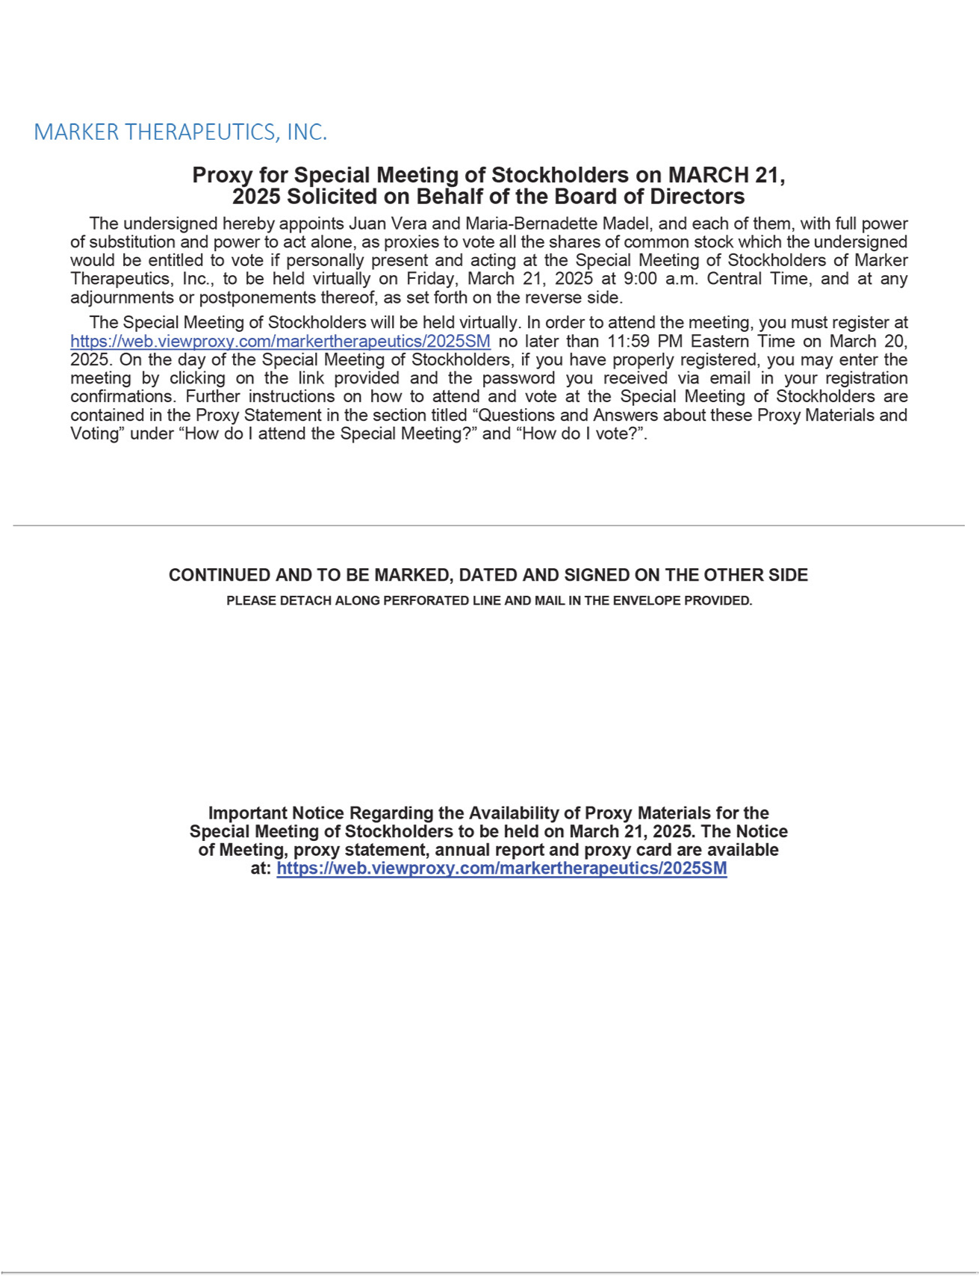

TABLE OF CONTENTS
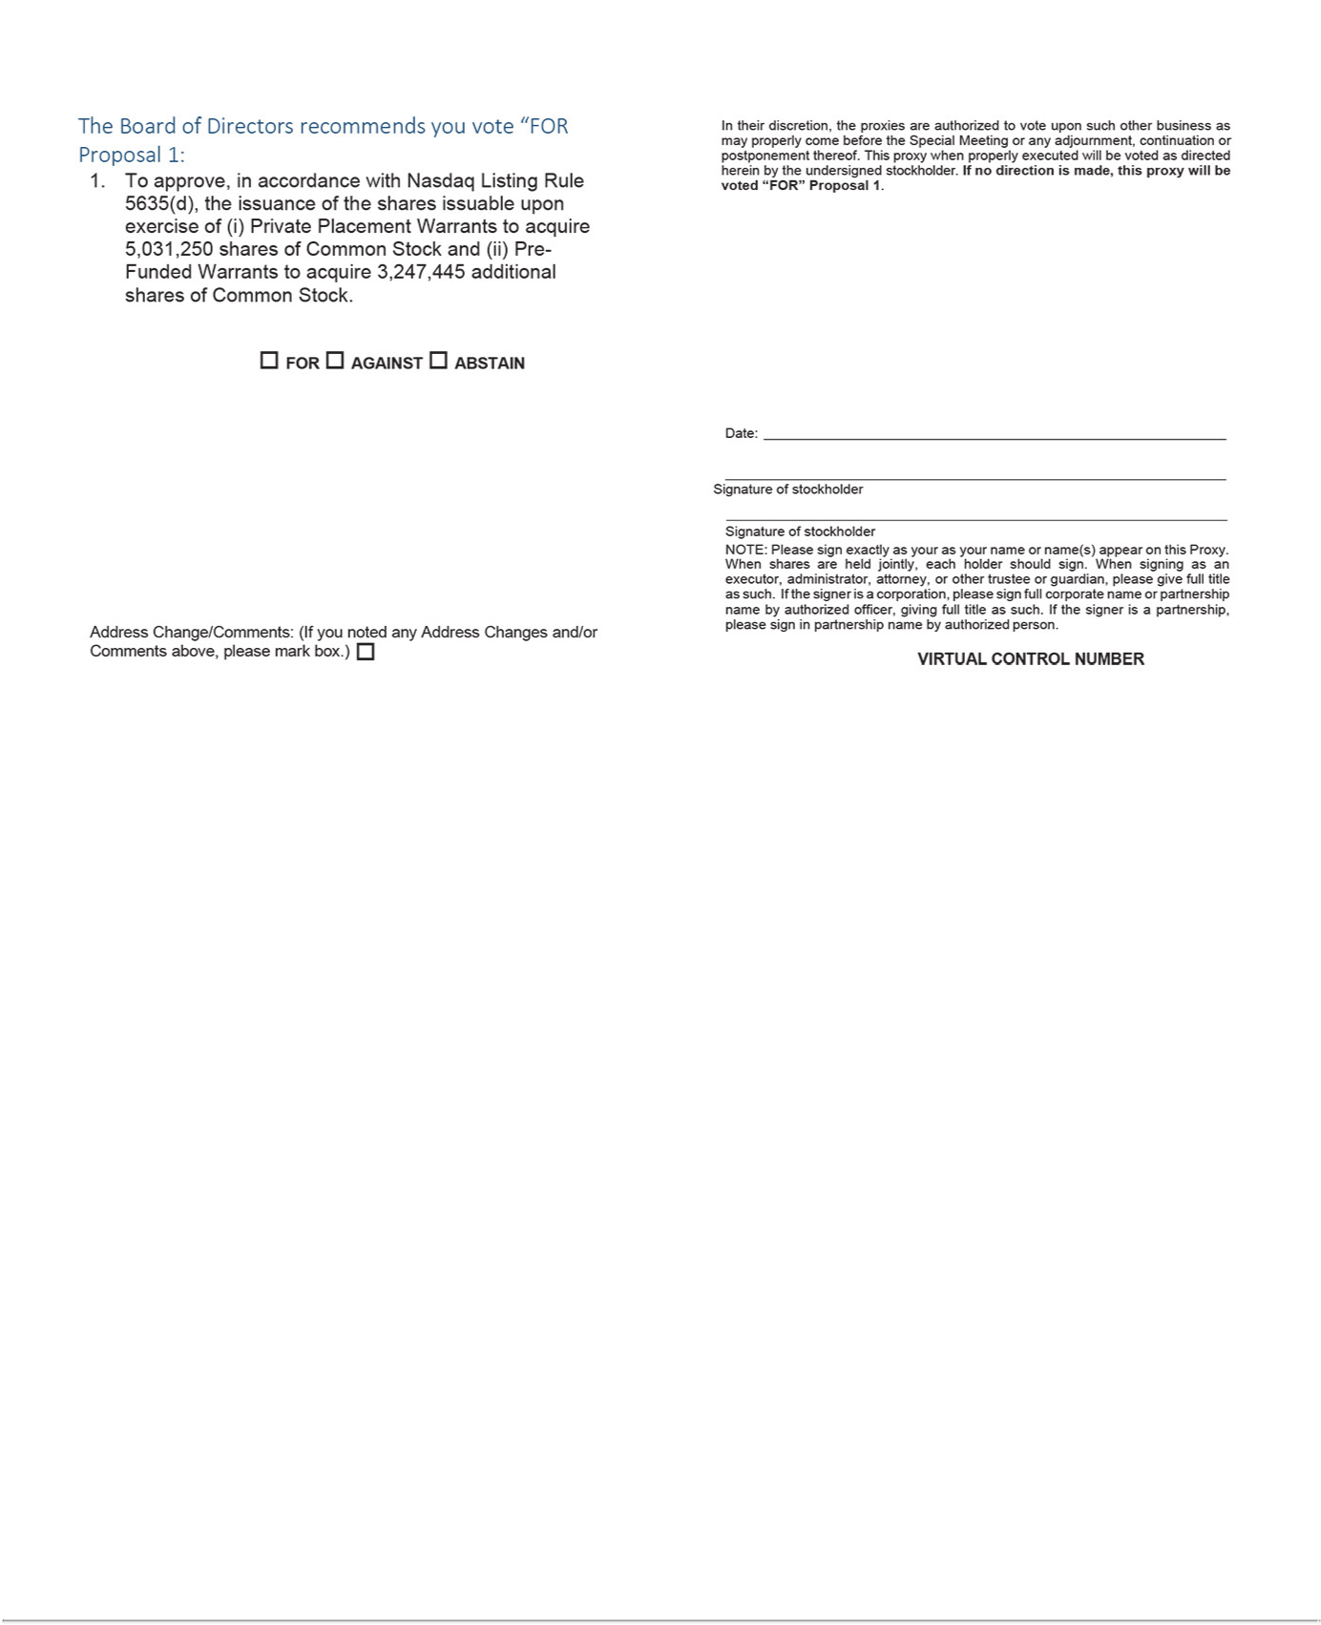

TABLE OF CONTENTS


